

CREDIT CARD FRAUD DETECTION USING MACHINE LEARNING
SecurePay AI: a Flask and React application that scores card transactions with three restricted-Boltzmann-machine classifiers
A project report submitted in partial fulfilment of the requirements for the award of the degree of
BACHELOR OF TECHNOLOGY
in
COMPUTER SCIENCE AND ENGINEERING
Submitted by
ARELLI PRAVEEN KUMAR | 23K91A0513
BANOTHU AJAY | 23K91A0529
D CHANDRIKA | 23K91A0557
BAIRAGONI VIJAY | 23K91A0525
Batch A4 (CSE-A)
Under the esteemed guidance of
KOTESHWAR RAO
[DESIGNATION]
DEPARTMENT OF COMPUTER SCIENCE AND ENGINEERING
TKR COLLEGE OF ENGINEERING & TECHNOLOGY (AN AUTONOMOUS INSTITUTION)
Medbowli, Meerpet, Balapur, Hyderabad, Telangana - 500 097
Academic year [ACADEMIC YEAR]

CERTIFICATE
This is to certify that the project report entitled "Credit Card Fraud Detection Using Machine Learning" is a bonafide record of the work carried out by ARELLI PRAVEEN KUMAR (23K91A0513), BANOTHU AJAY (23K91A0529), D CHANDRIKA (23K91A0557), BAIRAGONI VIJAY (23K91A0525), in partial fulfilment of the requirements for the award of the degree of Bachelor of Technology in Computer Science and Engineering, during the academic year [ACADEMIC YEAR], under my supervision.

Project Guide | Head of the Department | Principal
KOTESHWAR RAO | [HOD NAME] | [PRINCIPAL NAME]
[DESIGNATION] | Department of Computer Science and Engineering | TKR College of Engineering & Technology

External Examiner: [NAME AND SIGNATURE]
Place: [PLACE]
Date: [DATE]

DECLARATION
We hereby declare that the project report entitled "Credit Card Fraud Detection Using Machine Learning", submitted to the Department of Computer Science and Engineering, TKR College of Engineering & Technology, in partial fulfilment of the requirements for the award of the degree of Bachelor of Technology in Computer Science and Engineering, is a record of original work carried out by us under the guidance of KOTESHWAR RAO, [DESIGNATION]. The results embodied in this report have not been submitted to any other university or institution for the award of any degree or diploma.

ARELLI PRAVEEN KUMAR 23K91A0513
BANOTHU AJAY 23K91A0529
D CHANDRIKA 23K91A0557
BAIRAGONI VIJAY 23K91A0525

Place: [PLACE]
Date: [DATE]

ACKNOWLEDGEMENT
We express our sincere gratitude to our project guide, KOTESHWAR RAO, [DESIGNATION], for valuable guidance, encouragement and constructive suggestions throughout this project.
We thank [HOD NAME], Head of the Department of Computer Science and Engineering, for providing the facilities and support needed to complete this work, and [PRINCIPAL NAME], Principal, TKR College of Engineering & Technology, for the encouragement given to us.
We thank the project coordinators and all faculty and staff members of the department for their help, and our families and friends for their constant support.
We also acknowledge the authors of the base paper, whose work on quantum-assisted restricted Boltzmann machines this project builds on, and the maintainers of the open-source software used in it (Flask, React, Vite, NumPy, pandas, scikit-learn, imbalanced-learn, XGBoost and Matplotlib).

ARELLI PRAVEEN KUMAR
BANOTHU AJAY
D CHANDRIKA
BAIRAGONI VIJAY

ABSTRACT
Credit card fraud causes large losses and erodes customer trust. Fixed rules are learned and bypassed by fraudsters and raise false alarms, and learning systems face class imbalance: genuine transactions vastly outnumber fraudulent ones, so a model can score a high accuracy while finding almost no fraud. This project builds SecurePay AI, a working fraud-screening application, and measures it honestly. It follows the base paper [1], which trains a Gaussian-Bernoulli restricted Boltzmann machine classifier three ways: persistent contrastive divergence (PCD), simulated-annealing sampling (SAS) and quantum sampling (QS). Quantum hardware was not available, so the quantum sampler is simulated classically and is only quantum-inspired. The pipeline one-hot encodes, z-scores, filters correlated columns, undersamples to 50/50, keeps 18 features and splits 80/20. A Flask API with 16 routes and a React interface offer single checks, CSV bulk screening, analytics, model comparison and a retraining lab; the three probabilities are averaged and mapped to approve, challenge or decline bands at 40 % and 70 %.
All results use a synthetic, balanced dataset of 39,000 transactions, so they are not comparable with the base paper's real-data figures. On the 1,600-row held-out split the ensemble reaches 94.6% accuracy, 92.5% recall and F1 94.5% (ROC-AUC 0.986); SAS and QS reach F1 94.4% and 94.3%, while the shipped PCD model flags almost every transaction (accuracy 58.8%). Logistic regression, random forest and XGBoost score F1 96.7%, 96.3% and 96.5% on the same split, so the simple baselines are better here. Five retrainings of PCD give F1 69.2 +/- 23.1, while SAS gives 94.4 +/- 0.1. A code review found that the bulk-upload route silently skips feature scaling; on a fresh batch accuracy falls from 94.8% to 50.2%. A single check takes a median 17 ms. No real transaction data, quantum hardware or user study was used.
Keywords: credit card fraud, machine learning, restricted Boltzmann machine, class imbalance, undersampling, SMOTE, simulated annealing, Flask, React.

TABLE OF CONTENTS
CERTIFICATE i
DECLARATION ii
ACKNOWLEDGEMENT iii
ABSTRACT iv
TABLE OF CONTENTS v
LIST OF FIGURES viii
LIST OF TABLES x
LIST OF ABBREVIATIONS xi
CHAPTER 1: INTRODUCTION 1
1.1 Domain and Background 1
1.2 Motivation 1
1.3 Problem Statement 1
1.4 Need for the System 2
1.5 Objectives 2
1.6 Scope 3
1.7 Contributions 3
1.8 Limitations and Assumptions 4
1.9 Organisation of the Report 5
CHAPTER 2: LITERATURE SURVEY 6
2.1 Overview 6
2.2 Base Paper Analysis 6
2.3 Related Work 9
2.4 Datasets and Algorithms Used in the Literature 10
2.5 Summary of the Surveyed Work 11
2.6 Strengths and Limitations of the Surveyed Work 11
2.7 Research Gap 12
CHAPTER 3: FEASIBILITY STUDY 13
3.1 Technical Feasibility 13
3.2 Economic Feasibility 13
3.3 Operational Feasibility 14
3.4 Schedule Feasibility 14
3.5 Advantages and Constraints 15
CHAPTER 4: SYSTEM REQUIREMENTS AND ANALYSIS 16
4.1 Existing System and its Limitations 16
4.2 Proposed System and its Advantages 17
4.3 Functional Requirements 17
4.4 Non-functional Requirements 18
4.5 Hardware Requirements 18
4.6 Software Requirements 18
4.7 User Roles and Constraints 19
4.8 Requirement Analysis 19
CHAPTER 5: SYSTEM DESIGN 21
5.1 Design Goals and Architecture 21
5.2 High-Level Workflow 22
5.3 Data Flow Diagrams 22
5.4 UML Models 24
5.5 Persistence Design 25
5.6 Core Algorithms 26
5.7 Module Design 28
5.8 API Design 28
5.9 User Interface Design 29
5.10 Design Decisions and Trade-offs 31
CHAPTER 6: METHODOLOGY AND SOFTWARE IMPLEMENTATION 32
6.1 Overall methodology 32
6.2 Dataset 32
6.3 Preprocessing 33
6.4 Algorithm choice and justification 34
6.5 Mathematical formulation 35
6.6 Model architecture and training 38
6.7 Decision logic 39
6.8 Application architecture 39
6.9 API design 40
6.10 Security and error handling 40
6.11 Installation and execution 41
CHAPTER 7: SYSTEM TESTING 42
7.1 Testing strategy 42
7.2 Unit-level checks 42
7.3 Integration testing 43
7.4 Functional testing 43
7.5 Security testing 44
7.6 Validation and edge cases 44
7.7 Performance testing 45
7.8 User acceptance 46
7.9 Limits of the testing 46
CHAPTER 8: RESULTS AND OUTPUT SCREENS 47
8.1 Output screens 47
8.2 Data and pipeline 49
8.3 Model performance on the held-out split 50
8.4 Threshold and calibration 50
8.5 Training behaviour and stability 51
8.6 Comparison with standard classifiers 52
8.7 Behaviour when fraud is rare 52
8.8 Comparison with the base paper 53
8.9 Sample inputs and outputs, and the serving defect 54
8.10 Success and failure analysis 55
8.11 Limitations of the results 56
8.12 Objectives versus outcomes 56
CHAPTER 9: CONCLUSION 58
9.1 Summary of the work 58
9.2 Objectives against outcomes 58
9.3 Key findings 58
9.4 Comparison with the base paper 59
9.5 Practical applications 59
9.6 Known limitations 60
CHAPTER 10: FUTURE SCOPE 61
10.1 Improvements to the existing system 61
10.2 Additional features 61
10.3 Scalability and deployment 62
10.4 Further research 62
10.5 Suggested roadmap 62
REFERENCES 63
APPENDIX A: IMPORTANT CODE 65
A.1 Preprocessing pipeline (`backend/preprocessing.py`) 65
A.2 Prediction by free energy (`backend/rbm_classifier.py`) 65
A.3 Simplified annealing sampler (`backend/samplers.py`) 66
A.4 Ensemble decision and risk band (`predict_single`) and the scaling step that fails silently (`predict_batch`) 66
APPENDIX B: INSTALLATION AND USER GUIDE 67
B.1 Requirements and installation 67
B.2 Starting the application 67
B.3 Using the screens 67
B.4 Troubleshooting and reproducing the measurements 68
APPENDIX C: ADDITIONAL SCREENS 69
C.1 Landing page, dark theme and dashboard 69
C.2 Analytics: time, amount and card signals 69
C.3 Feature importance and dark verify screen 70
C.4 Model lab after a real retraining run 70
C.5 Error states and mobile layout 71

LIST OF FIGURES
Figure 1: System architecture of SecurePay AI: four tiers over local files; there is no SQL database and no external service. 21
Figure 2: High-level workflow: the build path creates the model files and the score path uses them. 22
Figure 3: DFD level 0: two kinds of user exchange transactions, scores and reports with the application, which reads and writes local files. 23
Figure 4: DFD level 1: six processes and four data stores. 23
Figure 5: DFD level 2: the five steps of process 3.0 (POST /api/predict_single). 24
Figure 6: Class and module diagram of the Python backend. 24
Figure 7: Sequence diagram of POST /api/predict_single with mode ensemble. 25
Figure 8: Use-case diagram: seven use cases and two conceptual roles. 25
Figure 9: File-based persistence: relations are produced by code, not by foreign keys. 26
Figure 10: Flowchart of preprocessing and training: three modes share the pipeline and differ in how the model expectation is sampled. 27
Figure 11: Flowchart of scoring in the bulk route: the dashed boxes show the scaler step that fails silently. 28
Figure 12: Verify page after the large online example: probability, recommended action, per-model bars and risk bands. 30
Figure 13: Bulk verification of the bundled sample: a warning that every row was flagged, and metrics against the Class column. 30
Figure 14: Model comparison: metrics at each model's best epoch, with the paper's training times kept apart from the times measured here. 31
Figure 15: Synthetic dataset: class balance, transaction amount by class, and fraud rate by merchant category and by channel. 33
Figure 16: Structure of the GRBMC (visible, hidden and label layers) and the three negative-phase samplers. 38
Figure 17: Median and 95th-percentile response time of each API route (127.0.0.1, Flask development server, this PC). 45
Figure 18: Dashboard: dataset counts, best F1, loaded models and fraud rate by merchant category. 47
Figure 19: Verify: the high-risk example scored by the ensemble, with the risk meter and each model's probability. 47
Figure 20: Bulk verification: the 20-row sample file after upload, with 20 of 20 rows flagged and 50.0 % accuracy. 47
Figure 21: Analytics, tab Where: fraud rate by merchant category and by channel. 47
Figure 22: Model comparison, Comparison tab: metrics at each model's best epoch, with the paper's training time and the time measured here. 48
Figure 23: Model comparison, Training curves tab: per-epoch F1 of PCD, SAS and QS. 48
Figure 24: Model comparison, QUBO matrix tab: the 220 x 220 matrix of the PCD model, top-left 40 x 40 block. 49
Figure 25: Model lab: training state of each model and the three steps dataset, preprocessing and training. 49
Figure 26: Synthetic dataset: class balance, amount distribution by class and fraud rate by merchant category and channel. 50
Figure 27: Confusion matrices of the three shipped models and the ensemble on the 1,600-row test split. 50
Figure 28: Precision, recall and F1 against the decision threshold for the ensemble and the PCD model. 51
Figure 29: Final-epoch F1 and recall of the three trainers over five seeds. 51
Figure 30: F1 of the RBM models and the standard classifiers on the 1,600-row split and on the 39,000-row file. 52
Figure 31: Precision and recall by model and balancing strategy when fraud is 1 % of the stream. 53
Figure 32: F1 of the base paper (real Stone data) and of this project (synthetic data). The data differ, so the bars are not directly comparable. 54
Figure 33: Effect of the skipped scaling in the batch route: accuracy, recall and false alarms as served and with correct scaling. 55
Figure 34: Landing page, dark theme. 69
Figure 35: Dashboard, dark theme. 69
Figure 36: When: fraud rate by hour. 69
Figure 37: How much: amount bands. 69
Figure 38: Card signals. 69
Figure 39: Features: importance of the 18 selected inputs. 70
Figure 40: Verify, dark theme: 68.4 % (medium). 70
Figure 41: Model lab after retraining: metric tiles and confusion matrices; PCD predicts every row legitimate. 70
Figure 42: Dashboard with the API stopped. 71
Figure 43: Bulk upload of an empty file. 71
Figure 44: Mobile dashboard. 71
Figure 45: Mobile verify. 71
Figure 46: Mobile bulk. 71

LIST OF TABLES
Table 1: Abbreviations used in this report xi
Table 2: How each objective was addressed (details in Chapter 8) 2
Table 3: Base paper results (its Table 1, read from the paper) 7
Table 4: Base paper compared with this project 8
Table 5: Datasets in the surveyed work 10
Table 6: Algorithms used in the surveyed work and in this project 10
Table 7: Literature survey table 11
Table 8: How SecurePay AI addresses the gaps 12
Table 9: Technical feasibility checks and what was measured 13
Table 10: Cost drivers: this project against the base paper's setup 14
Table 11: Planned project phases 14
Table 12: Reported results of the base paper (its Table 1, real data, test set) 16
Table 13: Functional requirements and where they are implemented 17
Table 14: Non-functional requirements, targets and measured values 18
Table 15: Hardware: measurement machine and minimum 18
Table 16: Software stack 18
Table 17: User roles 19
Table 18: Requirement priority and objective traceability 20
Table 19: Main risks and how each was handled 20
Table 20: Persisted entities 26
Table 21: Backend modules and their real size 28
Table 22: API routes 29
Table 23: Pages and the API calls behind them 29
Table 24: Design decisions, reasons and costs 31
Table 25: Columns of the synthetic transaction file 33
Table 26: Preprocessing steps and the data shapes they produce 33
Table 27: Hyper-parameters of the three trainers as coded 38
Table 28: What the paper describes and what this project implements 38
Table 29: Error handling and security review 40
Table 30: Run steps 41
Table 31: Test layers, the evidence behind each and its status 42
Table 32: Smoke-test checks by group (scripts/smoke_test.py) 43
Table 33: Edge-case probes and what the API returned (answers shortened) 44
Table 34: Shipped models on the 1,600-row held-out split (threshold 0.5) 50
Table 35: GRBMC retrained over five seeds (final epoch, mean +/- standard deviation, percent) 51
Table 36: Standard classifiers and the RBM models on the same balanced split 52
Table 37: 1 % fraud variant: precision, recall, F1, PR-AUC and mean error counts per 7,800 test rows (threshold 0.5) 53
Table 38: Base paper (real data) and this project (synthetic data), best epoch by F1 54
Table 39: Live responses of the single-transaction route and offline recomputation 54
Table 40: Batch route: fresh 2,000-row balanced batch, as served and with correct scaling (ensemble) 55
Table 41: Objectives and measured outcomes 56
Table 42: The six objectives and what was achieved 58
Table 43: Roadmap from prototype to pilot 62
Table 44: Common problems 68

LIST OF ABBREVIATIONS
Table 1: Abbreviations used in this report
Abbreviation | Expansion
API | Application Programming Interface
AUC | Area Under the Curve
CD | Contrastive Divergence
CSV | Comma-Separated Values
CORS | Cross-Origin Resource Sharing
CPU | Central Processing Unit
DFD | Data Flow Diagram
ER | Entity-Relationship
FN | False Negative
FP | False Positive
GRBM | Gaussian-Bernoulli Restricted Boltzmann Machine
GRBMC | GRBM Classifier
HTTP | Hypertext Transfer Protocol
JSON | JavaScript Object Notation
LR | Logistic Regression
ML | Machine Learning
NISQ | Noisy Intermediate-Scale Quantum
PCD | Persistent Contrastive Divergence
PR | Precision-Recall
QA | Quantum Annealing
QS | Quantum Sampling (quantum-inspired in this project)
QUBO | Quadratic Unconstrained Binary Optimization
RBM | Restricted Boltzmann Machine
REST | Representational State Transfer
RF | Random Forest
ROC | Receiver Operating Characteristic
SA | Simulated Annealing
SAS | Simulated-Annealing Sampling
SMOTE | Synthetic Minority Over-sampling Technique
TN / TP | True Negative / True Positive
UI | User Interface
UML | Unified Modeling Language
XGB | Extreme Gradient Boosting

CHAPTER 1: INTRODUCTION

1.1 Domain and Background
A credit card payment passes through several parties: the cardholder, the merchant, the acquiring bank and the issuing bank. Each of them can lose money when a card is used without the holder's consent, and each of them must decide, within the time of a single payment, whether to approve the transaction, ask the cardholder for extra proof or decline it. Card fraud is therefore both a financial problem and a real-time decision problem. The decision is taken for every payment, almost all payments are genuine, and a wrong decision in either direction has a price: a missed fraud is a direct loss, while a blocked genuine payment costs the bank a customer's goodwill and an analyst's time.
The central difficulty of the learning approach is class imbalance. Genuine transactions vastly outnumber fraudulent ones: the real dataset behind the base paper holds about 145 million transactions of which only about 19 thousand are fraud [1], a fraud rate near 0.013 %. A classifier trained naively on such data can reach an accuracy above 99.9 % by predicting every transaction as genuine and still detect no fraud at all. For this reason accuracy is a poor yardstick, and the literature recommends precision, recall, F1 and precision-recall analysis [16], [14]. Resampling methods such as SMOTE [12], Tomek links [13] and random undersampling are used to rebalance the training data, but they have their own pitfalls, which the base paper reports from experience and which this project measures (Chapter 8).

1.2 Motivation
Three observations motivate the project. First, published studies explore individual classifiers and sampling methods separately; what a team that wants to deploy a fraud model needs is a compared and tuned pipeline, measured on recall and F1 rather than accuracy. This is the gap recorded in the batch literature survey.
Second, the quantum-assisted result of the base paper is attractive but out of reach: it depends on a proprietary dataset and, for its best figures, on hours of simulator or cloud quantum time [1]. The motivating question for this project is therefore practical: how much of the method survives when it is rebuilt on a laptop with a classical simulation of the sampler, and how does it compare with the plain classifiers that every data-science team already knows?

1.3 Problem Statement
• Fraudulent transactions are rare, so standard classifiers reach high accuracy by predicting everything as genuine.
• Rule-based systems raise many false alarms and block legitimate customers.
• Fraud patterns change continuously, so a fixed rule set becomes obsolete quickly.
• Missing a fraud costs far more than reviewing a false alarm, yet most models treat both errors equally.

1.4 Need for the System
A machine learning system that handles severe class imbalance and maximises fraud recall while keeping false alarms acceptable. Four needs follow from the problem statement.
1. Imbalance handling. The training procedure must not let the majority class dominate, and the evaluation must report the metrics that matter for the minority class.
2. Recall first, precision second. Missing a fraud costs more than reviewing a false alarm, so the operating point should favour recall while keeping false alarms tolerable. The threshold or the risk band must therefore be adjustable and its effect visible.
3. Adaptability. Fraud patterns change, so the system must be retrainable on new data without code changes.
4. Usability. The decision must be available to a non-programmer through an interface, with a risk score, a risk band and a per-model breakdown that make the decision explainable.

1.5 Objectives
1. Acquire a benchmark credit card transaction dataset and quantify the degree of class imbalance.
2. Apply preprocessing including scaling, feature selection and stratified train-test splitting.
3. Balance the training data using SMOTE and compare it against random undersampling.
4. Train Logistic Regression, Random Forest and XGBoost classifiers on the balanced data.
5. Evaluate using precision, recall, F1-score and ROC-AUC rather than accuracy alone.
6. Deploy the best model behind an interface that flags a transaction as genuine or fraudulent.
Table 2: How each objective was addressed (details in Chapter 8)
No. | Objective (short) | Status | What was done
1 | Benchmark dataset and imbalance | Partly met | A synthetic 39,000-row file (50 % fraud) imitating the base paper's balanced set; a 1 % fraud variant for the imbalance study. No public benchmark was used.
2 | Preprocessing | Met | One-hot encoding, z-scoring, correlation filter, importance-based selection of 18 features and a stratified 80/20 split.
3 | SMOTE versus undersampling | Met in scripts | Compared with class weights and no resampling in scripts/run_experiments.py; the interface uses undersampling.
4 | LR, RF and XGBoost | Met in scripts | Trained on the same split in the experiment script; the product itself ships the three RBM classifiers.
5 | Precision, recall, F1, ROC-AUC | Met | Reported for every model, with confusion matrices, threshold sweeps and a five-seed study.
6 | Deploy behind an interface | Met, with a defect | Flask API with 16 routes and a React interface; scaling is skipped in the serving path (Chapter 7).

1.6 Scope
Inside the scope. Generation and exploration of a synthetic card-transaction dataset; the preprocessing pipeline; the GRBMC with its three training methods; an ensemble and a three-band decision rule; a REST API; a web interface with a dashboard, a single-transaction check, CSV bulk screening, analytics, a model comparison view and a retraining lab; scripts that measure accuracy, precision, recall, F1, ROC-AUC, latency and the effect of imbalance; and the documentation set.
Outside the scope. Real cardholder data, any quantum hardware, streaming ingestion from a payment switch, user accounts and authentication, a database, regulatory compliance (for example PCI DSS), model monitoring in production, and explanation of individual decisions beyond the per-model probabilities. These are listed again as limitations in Section 1.8 and as future work in Chapter 10.

1.7 Contributions
1. A working end-to-end application. SecurePay AI scores a single transaction in a median of 17 ms through the API, screens a CSV file in one request and lets the analyst retrain the models from the browser.
2. A classical reconstruction of the base paper's three-trainer comparison. The GRBMC, the PCD gradient, an annealing sampler and a quantum-inspired sampler are implemented in plain numpy, trained in seconds on 39,000 synthetic rows, and compared on a held-out split of 1,600 transactions. The ensemble reaches an F1 of 94.5% (SAS 94.4%, QS 94.3%).
3. An honest measurement of what the method does and does not do. The PCD model scores a ROC-AUC of 0.986 but, at the default threshold, flags almost every transaction (accuracy 58.8%); its F1 over five seeds is 69.2 +/- 23.1, against 94.4 +/- 0.1 for SAS. Logistic regression, random forest and XGBoost reach an F1 of 96.7%, 96.3% and 96.5% on the same split, so on this synthetic data the simple baselines are stronger.
4. An imbalance study. With fraud reduced to 1 % of the stream, logistic regression without resampling reaches a precision of 0.95, while random undersampling drops it to 0.20 with 302 false alarms per 7,800 transactions.
5. An audit of the serving path. Feature scaling is silently skipped in the prediction routes; on a fresh balanced batch of 2,000 transactions the ensemble's accuracy falls from 94.8% to 50.2%. The defect is documented and quantified rather than hidden.
6. Reproducibility. Every number in this documentation set is produced by scripts in the project (scripts/run_experiments.py, scripts/measure_latency.py, scripts/smoke_test.py) and written to experiments/.

1.8 Limitations and Assumptions
• Synthetic data. The 39,000 transactions were generated by a script that shifts a handful of features for fraud. The classes are far easier to separate than real fraud, so the absolute figures say little about performance on real traffic, and they cannot be compared with the base paper's figures obtained on 145 million real transactions.
• Quantum-inspired, not quantum. The quantum sampler is a classical simulation of a transverse-field tunnelling step. No quantum annealer was used, and no quantum advantage is claimed.
• Small training scale. The product trains on an 8,000-row sample (6,400 training rows). The SAS and QS trainers use a 3,000-row subsample per epoch and a short annealing schedule, so they are heavily simplified relative to the base paper's hours-long runs.
• Optimistic epoch selection. The per-epoch history that the interface shows is evaluated on the test split, so its best epoch is chosen on test data. The primary numbers in this report use the final epoch.
• Mild leakage. Feature selection and undersampling are performed before the train-test split; with a balanced synthetic file the effect is small, but it is not zero.
• No operational validation. There is no authentication, no database, no monitoring, no pytest suite (only a 20-check smoke test) and no study with real analysts.
Assumptions. The anonymised columns V1 to V22 stand for numeric behavioural features, labels are correct, the 50/50 balance of the training file is a design choice imitating the base paper (not a statement about real fraud rates), and the application runs on one local machine.

1.9 Organisation of the Report
The remaining chapters follow the order of the work: Chapter 2 surveys the literature and the base paper; Chapter 3 judges feasibility; Chapter 4 sets out the requirements; Chapter 5 gives the design; Chapter 6 explains the methodology and implementation; Chapter 7 reports testing; Chapter 8 presents the results and output screens; Chapters 9 and 10 give the conclusion and future scope. References and three appendices (important code, installation and user guide, additional screens) follow.

CHAPTER 2: LITERATURE SURVEY

2.1 Overview
The batch literature survey lists five works. The first is the base paper [1]. The second to fourth are a 2025 paper on credit card fraud detection with PySpark, a 2025 paper on e-commerce security and card fraud, and a 2025 article titled simply Credit Card Fraud Detection; the fifth is a 2024 study that compares an artificial neural network with XGBoost [4]. The batch survey gives only titles, years and sources for them. We were able to verify the base paper (read in full) and the ANN and XGBoost study (publisher page), but not the other three items (references [7], [8], [9]); they are therefore listed in the reference list with a note and are not used as evidence anywhere in this report.

2.2 Base Paper Analysis

2.2.1 Problem and data
The base paper [1], published in IEEE Access in 2026, asks whether restricted Boltzmann machines (RBMs) whose training is assisted by quantum annealing can detect fraud better than their classically trained counterparts. Its dataset was provided by a Brazilian payment company and covers about 145 million transactions collected over three months, of which about 19 thousand are fraud. The data is anonymised under Brazilian data-protection law, so neither cardholder information nor balances are disclosed.

2.2.2 Method
The model is a Gaussian-Bernoulli RBM classifier (GRBMC): a visible layer of continuous features, a layer of binary hidden units and a label layer that is attached to the hidden units like an extension of the visible layer [27], [28]. Training minimises the negative log-likelihood by stochastic gradient descent; the gradient has a data term that is easy to compute and a model term that requires samples from the model's own distribution. Three ways of obtaining those samples are compared: (i) classical persistent contrastive divergence (PCD) with Gibbs sampling [24], [23]; (ii) simulated-annealing-assisted training (SAS), in which the energy function is written as a quadratic unconstrained binary optimisation (QUBO) problem and sampled with D-Wave's path-integral simulator [29]; and (iii) quantum sampling (QS) on real D-Wave hardware, where repeated anneals give samples of the Boltzmann distribution [30], [31]. Because the visible units are Gaussian, a binary expansion is needed to write the model as a QUBO, which increases the number of variables and is the reason the authors restrict the number of features.
The preprocessing follows advice from the payment company's anti-fraud team: one-hot encoding of categorical fields (the best of several encodings tried), z-score normalisation of numeric fields, removal of the most correlated features and removal of the least important features according to a CatBoost model [21]. Four balancing strategies were tried. SMOTE [12] made the model learn mostly from synthetic points, Tomek links [13] reduced the data to a few hundred rows, and the two combinations suffered the same problems, so the authors used manual random undersampling: all fraud rows plus an equal number of random genuine rows, giving a shuffled 39-thousand-row set with a 50/50 split and an 80/20 train-test split.

2.2.3 Reported results
Table 2.1 reproduces the base paper's Table 1, which gives the metrics at the optimum epoch of each 50-epoch training run, selected by F1 and measured on the test split.
Table 3: Base paper results (its Table 1, read from the paper)
Method | Accuracy | Precision | Recall | F1 | Training time
Classical PCD | 84 % | 86 % | 81 % | 83 % | 2 minutes
Simulated-annealing sampling | 85 % | 94 % | 82 % | 88 % | 4 hours
Quantum sampling (D-Wave) | 85 % | 91 % | 79 % | 84 % | 1.8 hours

The authors conclude that the annealing-assisted models, which use only 65 hidden units and small batches, match or slightly exceed the classical model, which needs 200 hidden units and large batches, and that performance and run time are in a trade-off: the classical model trained in two to three minutes, the simulated-annealing model in about four hours (a figure the authors attribute partly to Python-from-Julia overhead on Windows) and the quantum model in about 1 hour 50 minutes. They state that whether the advantage is universal or specific to their data is an open question, and name quantum kernels for support vector machines, the quantum approximate optimisation algorithm and deep belief networks as future work.

2.2.4 Strengths
• A real, very large dataset provided by a payment company, with preprocessing agreed with its fraud team.
• A clear comparison of three training procedures on identical data, epochs and metrics, with the hyper-parameters tuned separately for each.
• An honest account of what failed: SMOTE, Tomek links and their combinations, oscillating annealing curves, diverging learning rates on quantum samples.
• The first-class use of F1, precision and recall instead of accuracy alone.

2.2.5 Weaknesses and open points
• The data is private, so the work cannot be repeated by others and no public baseline is available.
• No non-RBM classifier is trained on the same data, so the paper cannot say whether an RBM is a good choice for fraud at all; the strongest baselines for tabular data are boosted trees [20].
• Each result is a single training run and the reported epoch is the best one on the test split, which favours the models whose curves oscillate most.
• The differences between methods are small (F1 of 83, 88 and 84 %), and no confidence interval or seed study is given.
• The quantum runs were limited by access to the hardware, and some epochs of the quantum run could not be evaluated.

2.2.6 What this project adopts and what it changes
Table 4: Base paper compared with this project
Aspect | Base paper | This project
Data | Real, 145 M transactions, 19 k fraud, balanced to 39 k | Synthetic, 39,000 rows generated by synthetic_data.py, 50/50
Model | GRBMC | GRBMC (same layers, same 200/65 hidden units, same batch sizes)
Trainers | PCD, simulated annealing, real quantum annealer | PCD, a simplified annealing sampler, a quantum-inspired classical simulation
Preprocessing | One-hot, z-score, correlation filter, CatBoost importance, manual undersampling | Same steps; random-forest importance is used when CatBoost is not installed
Epochs and time | 50 epochs; 2 min to 4 h | 20 epochs; 3.4 to 4.4 s per trainer on the shipped models
Baselines | None | Logistic regression, random forest, XGBoost, a hand-written rule
Seeds and imbalance | Single run; 50/50 only | Five seeds; a 1 % fraud variant
Delivery | Notebook-level study | Flask API (16 routes) and React interface with bulk screening

The project therefore adopts the model, the preprocessing recipe and the hyper-parameters of the base paper, and changes the data, the sampling hardware, the scale and the evaluation. Because the data and the hardware differ, the numbers of the two works are never compared as if they measured the same thing.

2.3 Related Work

2.3.1 Rule-based and learning-based detection
Early card-fraud systems relied on expert rules. Learning-based detection replaced them as labelled data became available. Bhattacharyya et al. compared logistic regression, support vector machines and random forests on real card data and found that nonlinear ensemble methods were generally stronger [5]. Dal Pozzolo et al. describe the practical issues that separate fraud modelling from ordinary classification: sampling bias, delayed labels and changing fraud patterns [6]. Carcillo et al. show that unsupervised outlier scores and supervised classifiers complement each other in large-scale systems [10]. These studies agree that how a model fails matters as much as its overall accuracy, which is the stance taken in this project.

2.3.2 Ensembles and boosting
Tree ensembles are the usual strong baselines on tabular data. Random forests average many decorrelated trees [19], and XGBoost fits trees sequentially to the residual errors with regularisation [20]. Aburbeian and Ashqar combine SMOTE with a tuned random forest on a Kaggle set of 94,682 online transactions and report an accuracy of about 98 % and an F1 of about 98 % [2]; they note that earlier studies often reported only accuracy. Shi compares an ANN with XGBoost on imbalanced card data and finds that both reach an accuracy of about 99.96 %, so that only the F1 on the fraud class separates them, in favour of XGBoost [4]. Han and Wu study 480 fusion configurations of seven classifiers on the IEEE-CIS benchmark (590,540 transactions, 3.5 % fraud) under a leakage-free 60/20/20 protocol; the best fusion of random forest, XGBoost and LightGBM reaches an AUC-ROC of 0.9405, an AUPRC of 0.6699 and an F1 of 0.6373, with a gain over the best single model that is small but whose bootstrap interval excludes zero [3]. Their experiment with synthetic fraud generated by a GAN is a negative result: the augmentation degraded both the single models and the fusion. The practical message for this project is that the plain tree and linear baselines are strong and must be part of any fair comparison, which the base paper does not provide.

2.3.3 Handling class imbalance
He and Garcia survey learning from imbalanced data [14], and Fernandez et al. give a book-length treatment [15]. The main families are data-level methods (oversampling, undersampling and their combinations), algorithm-level methods (class weights, cost-sensitive learning) and threshold moving. SMOTE interpolates between minority-class neighbours to create synthetic examples [12]; Tomek links remove majority points that form a pair with a minority point across the class boundary [13]; random undersampling discards majority points. Dal Pozzolo et al. show that undersampling biases the posterior probabilities of a classifier and that the probabilities must be recalibrated if they are used as probabilities [11]. This explains, in hindsight, a result of our own imbalance study (Chapter 8): after undersampling, every classifier's recall rises but its precision collapses on a stream with 1 % fraud. The imbalanced-learn library provides the resamplers used here [33].

2.3.4 Evaluation metrics
With a rare positive class, accuracy and ROC curves can look excellent while the model is of little use; the precision-recall plot is more informative [16], [34], ROC analysis is standard [17], and Powers discusses the biases of precision, recall and F-measure [18]. This project reports precision, recall, F1 and ROC-AUC for every model, PR-AUC for the imbalance study and confusion matrices.

2.3.5 Restricted Boltzmann machines, annealing and quantum-assisted training
An RBM is a two-layer energy-based model that learns a probability distribution over its inputs [22]. Training needs samples from the model, which are obtained by Gibbs sampling; contrastive divergence runs a short chain starting at the data [23], and persistent contrastive divergence keeps the chain alive between updates [24]. Hinton's practical guide collects the tricks that make RBM training work [25], Fischer and Igel give a tutorial introduction [26], and Larochelle et al. show how to turn an RBM into a classifier by adding a label layer [27]. Gaussian-Bernoulli RBMs, which accept continuous inputs, are known to be hard to train, and Liao et al. propose remedies [28].

2.4 Datasets and Algorithms Used in the Literature
Table 5: Datasets in the surveyed work
Dataset | Size and fraud rate | Used by
Private payment-company data (Brazil) | 145 M transactions, about 19 thousand fraud (about 0.013 %); balanced to 39 thousand | Base paper [1]
Kaggle online-transaction set | 94,682 transactions; 20 features, partly PCA-masked | Aburbeian and Ashqar [2]
IEEE-CIS Fraud Detection (Kaggle, 2019) | 590,540 transactions; 3.5 % fraud; 434 columns after merging | Han and Wu [3]
Imbalanced card data (publisher page) | Not stated in the abstract | Shi [4]
Synthetic file generated by this project | 39,000 transactions, 50 % fraud; plus a 1 % fraud variant | This project

Table 6: Algorithms used in the surveyed work and in this project
Algorithm | Role | Where it appears
Gaussian-Bernoulli RBM classifier | Probabilistic classifier trained by sampling | Base paper; this project's product
PCD, simulated annealing, quantum sampling | Ways to obtain the model-term samples | Base paper; this project (simplified, classical)
Logistic regression | Linear baseline | Bhattacharyya et al.; this project's experiments
Random forest | Bagged trees; importance ranking | Aburbeian and Ashqar; Han and Wu; this project (importance filter and baseline)
XGBoost | Boosted trees | Shi; Han and Wu; this project's experiments
SMOTE, Tomek links, random undersampling | Rebalancing | Base paper; this project's experiments and pipeline
CatBoost importance | Feature selection | Base paper; replaced by random-forest importance when CatBoost is absent

2.5 Summary of the Surveyed Work
Table 7: Literature survey table
Work | Year | Approach | Data and reported result | Limitation
Neto et al. (base paper) | 2026 | Gaussian RBM classifier trained with classical PCD, simulated-annealing sampling and D-Wave quantum sampling | Real Stone data, 145 M transactions, about 19 thousand fraud, balanced to 39 thousand; F1 83 / 88 / 84 % (PCD / SAS / QS) | One proprietary dataset; no public baselines; hours of training; no deployable interface
Aburbeian and Ashqar | 2023 | Random forest with SMOTE and hyper-parameter tuning | 94,682 online transactions; accuracy about 98 %, F1 about 98 % | Resampled data scored; accuracy-led comparison on a small public set
Han and Wu | 2026 | Combinatorial fusion of seven classifiers, validation-stage subset and rule selection | IEEE-CIS, 590,540 transactions, 3.5 % fraud; AUC 0.9405, AUPRC 0.6699, F1 0.6373 | Gain over best single model is small; CTGAN augmentation hurt
Shi | 2024 | ANN compared with XGBoost on imbalanced card data | Both about 99.96 % accuracy; XGBoost higher F1 on the fraud class | Accuracy is uninformative at this imbalance; no deployment
Bhattacharyya et al. | 2011 | Logistic regression, SVM and random forest compared | Nonlinear ensemble methods generally stronger than linear ones on card transactions (as summarised by Han and Wu) | Older study; no deployment or imbalance-strategy comparison
Dal Pozzolo et al. | 2018 | Realistic fraud modelling: delayed labels, concept drift, alert precision | Discusses sampling bias, delayed labels and changing fraud patterns in real card streams | Addresses data issues, not model training cost or a usable interface
Carcillo et al. | 2021 | Unsupervised outlier scores added to supervised classifiers | Unsupervised anomaly scores and supervised classifiers complement each other in large-scale systems | Not a single compact model; no deployable interface
This project | 2026 | GRBMC with PCD, SAS and a quantum-inspired sampler, ensembled; Flask and React interface | Synthetic 39,000 rows; ensemble F1 94.5%, SAS 94.4%, QS 94.3%, PCD 70.9% (accuracy 58.8%) | Synthetic data; simulated sampler; baselines are stronger; batch route skips scaling

2.6 Strengths and Limitations of the Surveyed Work
Strengths. The literature agrees on the correct problem framing (imbalance, cost asymmetry, drift), supplies strong and cheap baselines, and gives a toolbox of resampling and evaluation methods. The base paper adds a distinctive model family and an unusually candid account of failed balancing strategies.
Limitations. Accuracy-led reporting persists in the smaller studies; resampled data is sometimes scored; the strongest published RBM results rest on private data and on hardware or simulators that few teams can use; comparisons with plain baselines are missing in the base paper; and almost no study delivers a deployable interface. Reported differences between methods are often a few percentage points from a single run, so conclusions about their ranking are fragile.

2.7 Research Gap
Table 8: How SecurePay AI addresses the gaps
Gap | Response in this project
1 Separate classifiers and samplers | Single pipeline in which the RBM trainers, three baselines and four imbalance strategies are compared on the same split (Chapter 8)
2 Accuracy-led evaluation | Precision, recall, F1, ROC-AUC, confusion matrices, threshold sweeps and PR-AUC; recall is the headline for fraud
3 Base-paper RBM only on private data | Same model and hyper-parameters rebuilt on a public-code synthetic dataset so that anyone can repeat the experiments
4 Quantum hardware out of reach | Quantum-inspired classical sampler, with its instability measured over five seeds
5 Behaviour at low fraud rates | A 1 % fraud variant with no resampling, class weights, SMOTE and undersampling
6 No deployable live scoring | Flask API and React interface with a risk band; median 17 ms per check; its defects are reported

In short, the research gap is a compared, tuned pipeline, evaluated on recall and F1 rather than accuracy and deployable for live scoring. The project fills it with an honest finding that is not the one the base paper's direction suggests: on this synthetic data the three simple baselines (F1 96.7%, 96.3% and 96.5%) are stronger than the RBM ensemble (F1 94.5%), and the RBM's practical interest lies in its probabilistic structure and in the study of its training methods rather than in raw accuracy.

CHAPTER 3: FEASIBILITY STUDY
Feasibility was settled partly by analysis and partly by building the system and measuring it on the development machine, so most entries carry a measured value; where a question could not be settled with the data and hardware available, the entry says so.

3.1 Technical Feasibility
The technical risk lay in four places: training a restricted Boltzmann machine classifier without a graphics card or quantum computer, reproducing the three training strategies of the base paper [1] in a form that runs in seconds, handling imbalance with standard libraries, and serving scores fast enough for a payment decision. The development machine is a Windows 11 desktop with an Intel Core i5-12500 (6 cores, 12 threads) and 15.7 GB of RAM, with no graphics processor in use:
Table 9: Technical feasibility checks and what was measured
Question | Measurement | Verdict
Can a GRBM classifier be trained without special hardware? | numpy implementation; 20 epochs take about 4.0 s (PCD), 4.9 s (SAS) and 4.2 s (QS) on 6,400 training rows | Feasible
Is the simulated quantum sampler usable? | classical simulation of a transverse-field tunnelling flip inside the SA sweeps; no quantum processor is involved | Feasible, but only quantum-inspired
Is the trained model accurate enough to be useful? | ensemble accuracy 94.6%, precision 96.5%, recall 92.5%, F1 94.5% on 1,600 held-out synthetic rows | Feasible on synthetic data
Do all three trainers give a usable decision at 0.5? | SAS F1 94.4% and QS F1 94.3%; the shipped PCD model flags almost every row (accuracy 58.8%, recall 100.0%) | Partly: PCD needs a threshold or retraining
Can the data pipeline be built from standard libraries? | pandas, scikit-learn and imbalanced-learn; the whole 39,000-row pipeline runs in 8.2 s | Feasible
Can predictions be served fast enough? | median 16.9 ms and 95th percentile 32.5 ms per single check; 29.9 ms for a 20-row CSV (Flask development server, 127.0.0.1) | Feasible
Can a modern interface be built without a database? | React and Vite front end (3,574 lines of source) over 16 Flask routes; state lives in CSV, pickle and JSON files | Feasible for a prototype

Two risks were not removed: the base paper's real dataset is proprietary, so results rest on a synthetic generator and cannot be carried over to real card traffic; and its hours of annealing-based training become seconds here only because the sampler is a short heuristic approximation (10 sweeps, 16 reads, a 3,000-row subsample per epoch), a weaker experiment.

3.2 Economic Feasibility
The project used only free, open-source software on a computer the team already owned, so no purchase, licence or cloud fee was needed. No monetary figures are given because none were measured; the comparison with the base paper's setup is qualitative.
Table 10: Cost drivers: this project against the base paper's setup
Item | This project | Base paper's setup
Quantum processing time | none; the sampler is simulated on the CPU | paid cloud access to D-Wave quantum processors through the Leap programme
Training data | synthetic file generated locally in a few seconds | 145 million real transactions from a payment company
Software | Python, Flask, React, scikit-learn, imbalanced-learn, XGBoost, Matplotlib (all open source) | Julia package for RBM training and D-Wave client libraries
Hardware | one desktop CPU, 15.7 GB RAM | workstation plus quantum cloud service
Training time | about 4-5 s per model | 2 minutes, 4 hours and 1.8 hours reported

The saving hides a risk: a real deployment would need real labelled data, a security review, monitoring and a staffed review queue, none of which are part of this project or costed here.

3.3 Operational Feasibility
Two kinds of people must be served: a merchant or analyst checking one transaction, and a risk-operations user screening a file and studying the models. The React interface covers both with six screens (dashboard, verify, bulk verification, analytics, model comparison, retraining lab) and a landing page, and one run.bat starts both servers on ports 8304 and 5304. Results are a score, a risk band and a plain-language action (approve, challenge with 3-D Secure, decline and alert).
• Setup and maintenance: one pip install -r requirements.txt, one npm install, then run.bat; no database; the models are three pickle files and three JSON histories that the Model lab retrains in seconds.
• Failure handling and gaps: an offline dashboard state and a readable bulk-upload error exist; there is no login, audit trail or alert delivery, all needed before real use.

3.4 Schedule Feasibility
Five overlapping phases; the week ranges are the planned allocation for a semester project, not recorded dates.
Table 11: Planned project phases
Phase | Planned weeks | Main outputs
1. Study and requirements | 1-2 | base paper reading, literature survey, objectives, problem statement
2. Data and pipeline | 3-4 | synthetic generator, one-hot, z-score, correlation filter, undersampling, feature selection
3. Models and training | 5-7 | GRBMC, PCD, SA and quantum-inspired samplers, evaluation, retraining lab
4. Application | 7-10 | Flask API, React interface, bulk screening, analytics, model comparison
5. Measurement and documentation | 10-12 | experiments, smoke test, latency, diagrams, reports

Each phase depended only on the previous one and a full training run takes seconds; the schedule risk was the interface, rebuilt once as a React front end over the original Flask routes.

3.5 Advantages and Constraints

3.5.1 Advantages
• No quantum hardware, GPU, paid service or proprietary data is needed to run or retrain the system.
• Fast scoring: a median of 17 ms per transaction and 30 ms for a 20-row file on the development machine.
• A complete working path from data generation to a decision screen, with a read-only API smoke test that passes 20 of 20 checks.
• Every number in the project documents is regenerated by scripts (run_experiments.py, measure_latency.py), so results can be re-checked.

3.5.2 Constraints
• All results come from a synthetic, balanced dataset; they say how the pipeline behaves, not how it would perform on real card traffic.
• The quantum sampler is a classical simulation; nothing here supports a claim about quantum advantage.
• Simple baselines are better on the same data: logistic regression F1 96.7%, random forest 96.3% and XGBoost 96.5% against 94.5% for the ensemble.
• The batch-prediction route skips feature scaling because of a swallowed exception; on a fresh batch accuracy is 50.2% as served and 94.8% when scaling is applied.
• The Flask development server, absent authentication and file-based state limit the system to a single-user prototype.

CHAPTER 4: SYSTEM REQUIREMENTS AND ANALYSIS
This chapter describes the starting situation, the proposed system and its requirements; FR and NFR identifiers are used again in the design and testing chapters.

4.1 Existing System and its Limitations

4.1.1 How fraud is screened today
Card issuers and merchants traditionally screen transactions with rule engines: a transaction is flagged when fixed conditions fire, such as a high amount, a card that is not present, a country that does not match the card, or an unusual hour. Flagged transactions are declined or sent to an analyst. Research systems replace the rules with classifiers. Published studies compare logistic regression, support vector machines, random forests and boosted trees [5], [2], [4], handle imbalance with SMOTE [12] or undersampling [13], [15], and combine models by fusion [3]. The base paper [1] adds a different family, the restricted Boltzmann machine classifier trained with annealing-based samplers.
Table 12: Reported results of the base paper (its Table 1, real data, test set)
Trainer | Accuracy % | Precision % | Recall % | F1 % | Training time
PCD (classical) | 84 | 86 | 81 | 83 | 2 minutes
SAS (simulated annealing) | 85 | 94 | 82 | 88 | 4 hours
QS (quantum sampling) | 85 | 91 | 79 | 84 | 1.8 hours

4.1.2 Limitations of the existing approaches
• Static rules cannot adapt to new fraud behaviour, are easy for fraudsters to probe, and raise false alarms that block genuine customers.
• Accuracy-led evaluation hides the problem: with fraud at about 0.013 % of the base paper's transactions [1] or 3.5 % of IEEE-CIS [3], a model that never flags anything looks excellent.
• Resampling pitfalls: the base paper found SMOTE and Tomek links poor when the fraud class was extremely small and fell back on manual undersampling.
• Reproducibility: the base paper's data is proprietary and its best trainers needed hours on a simulator or paid quantum cloud time.
• No operational layer: most studies end in a notebook; there is no interface that returns a risk band for a live transaction.

4.2 Proposed System and its Advantages

4.2.1 Proposed system
SecurePay AI is a Flask and React application around a Gaussian-Bernoulli RBM classifier. The pipeline one-hot encodes merchant and channel, z-scores the 24 numeric columns, filters correlation above 0.95, undersamples to 50/50, keeps the 18 features a random forest ranks highest and splits 80/20. Three classifiers are trained (PCD with 200 hidden units and batches of 512; simulated-annealing and quantum-inspired samplers with 65 hidden units and batches of 32); their fraud probabilities are averaged, the label is fraud above 0.5, and the risk band is low below 0.4, medium from 0.4 to 0.7 and high above 0.7 (approve, challenge with 3-D Secure, decline and alert).

4.2.2 Advantages over the existing approaches
• Runs on a CPU; no quantum cloud access or proprietary data is required.
• Returns a score, a band, an action and the probability of each of the three models, so a user can see where they disagree.
• Offers single checks, CSV bulk screening, analytics, model comparison and an in-app retraining lab; every experiment is a script that regenerates its numbers.

4.3 Functional Requirements
Table 13: Functional requirements and where they are implemented
ID | Requirement | Implemented in
FR-1 | Show dataset size, class balance and fraud patterns by merchant, channel, hour, amount and card signals | GET /api/dataset_info, /api/dataset_stats; Dashboard and Analytics pages
FR-2 | Generate a synthetic transaction dataset of a chosen size | POST /api/generate_dataset (500-50,000 rows per class); Model lab
FR-3 | Preprocess the data: one-hot, z-score, correlation filter, balancing (manual, SMOTE or Tomek) and top-k feature selection | POST /api/preprocess; Model lab
FR-4 | Train the three RBM classifiers with a chosen number of epochs and hidden units and record per-epoch metrics | POST /api/train, GET /api/train_status; Model lab
FR-5 | Compare the three trainers per epoch and at the best epoch; show feature importance and the QUBO matrix | GET /api/comparison, /api/model_history, /api/feature_importance, /api/qubo; Model comparison page
FR-6 | Score one transaction from a form with ensemble or single-model choice and return probability, label, risk band and per-model probabilities | POST /api/predict_single; Verify page
FR-7 | Score a CSV file, add predicted class, probability and risk per row, report metrics when a Class column exists, and allow export | POST /api/predict_batch, GET /api/export_predictions, /api/sample_batch; Bulk page
FR-8 | Report service health and the models that are loaded | GET /api/health; status chip in the interface
FR-9 | Show a clear offline or error state when the backend or an upload fails | front-end error and empty states

4.4 Non-functional Requirements
Table 14: Non-functional requirements, targets and measured values
ID | Requirement | Target | Measured
NFR-1 | Single-transaction response time | under 100 ms | median 16.9 ms, p95 32.5 ms
NFR-2 | 20-row CSV screening time | under 1 s | median 29.9 ms
NFR-3 | Analytics page data time (full dataset aggregates) | under 1 s | median 50.1 ms
NFR-4 | Retraining time in the lab | under 1 minute | 4.0 / 4.9 / 4.2 s for 20 epochs (PCD / SAS / QS)
NFR-5 | Runs on a CPU-only PC with 8 GB RAM | no GPU or quantum hardware | met (measured on 15.7 GB; no lower-memory test made)
NFR-6 | Reproducibility of reported numbers | scripted | met: run_experiments.py, measure_latency.py
NFR-7 | Correct scoring of raw input | scaled features at serving time | not met: the batch route skips scaling (accuracy 50.2% as served, 94.8% scaled)
NFR-8 | Security: authentication, authorisation, transport encryption | required before real use | not implemented
NFR-9 | Usability: responsive layout, light and dark theme | desktop and phone widths | met (screens captured at 1440 px and 360 px, both themes)

The response-time targets are the project's own, not a payment-network standard; the measurements use the Flask development server on 127.0.0.1 and describe this prototype, not a production deployment.

4.5 Hardware Requirements
Table 15: Hardware: measurement machine and minimum
Item | Measurement machine | Practical minimum
Processor | Intel Core i5-12500, 6 cores / 12 threads | any 64-bit dual-core CPU
Memory | 15.7 GB RAM | 4 GB free (data 18 MB, models under 4 MB)
Graphics / quantum hardware | none used | none needed
Storage | about 21 MB for data and models plus front-end packages | 500 MB including node_modules
Operating system | Windows 11 Pro | Windows 10/11, Linux or macOS
Browser | Chrome (captures at 1440 x 900 and 360 x 780) | current Chrome, Edge or Firefox

The minimum column is a reasoned estimate from file sizes, not a tested configuration; only the measurement machine was actually used.

4.6 Software Requirements
Table 16: Software stack
Layer | Software | Version
Language | Python | 3.11.9
Web framework | Flask, Flask-Cors | 3.1.0, 5.0.0
Numerics and data | numpy, pandas, scipy, joblib | 1.26.4, 2.2.1 installed (2.2.2 pinned), 1.13.0, 1.4.2
Machine learning | scikit-learn, imbalanced-learn | 1.5.0, 0.12.4
Baselines (experiments only) | XGBoost | 2.0.3
Plots | matplotlib, seaborn | 3.9.0, 0.13.2
Front end | React, React Router, Vite, Recharts | see frontend/package.json
Tooling | Node.js and npm for the front end; Playwright for screenshot capture | -

requirements.txt pins pandas 2.2.2 but 2.2.1 is installed; the experiments ran on the installed versions. The pickled pipeline in models/ was written with a newer pandas and cannot be unpickled here, so the backend rebuilds an identical pipeline from the CSV at start-up.

4.7 User Roles and Constraints

4.7.1 User roles
Table 17: User roles
Role | Typical goal | Screens used
Merchant or customer-service agent | check one transaction and get a decision and reason | Verify
Risk analyst | screen an exported file, study fraud patterns, compare models | Bulk, Analytics, Model comparison, Dashboard
Model owner | regenerate data, preprocess and retrain the models | Model lab

There is no login or role separation: every visitor can reach every route, including the ones that regenerate the dataset and overwrite the saved models. This is a constraint of a single-user prototype, not a feature.

4.7.2 Constraints and assumptions
• The data are synthetic; fraud signals were put into the generator by its authors, so separability is an assumption of the data and not a finding about fraud.
• The shipped file is 50/50 by construction; the 1 % fraud variant is generated separately by the experiments and is not exposed in the interface.
• One user at a time on the Flask development server; metrics use a 0.5 threshold and no cost-sensitive threshold is configured; no personal or real card data are stored or processed.

4.8 Requirement Analysis

4.8.1 Prioritisation and traceability to the objectives
Requirements were ranked by how much of the batch objectives they carry; this explains why the product centres on scoring and comparison while the baseline classifiers named in the objectives live in an experiment script and not in the interface.
Table 18: Requirement priority and objective traceability
Requirement | Priority | Objective served | Status
FR-6 single scoring, FR-7 bulk scoring | Must | 6 (deploy behind an interface) | built; serving defect documented
FR-3 preprocessing, FR-4 training | Must | 2, 3 (preprocessing and balancing) | built; SMOTE and Tomek selectable by API
FR-5 model comparison | Must | 5 (evaluate beyond accuracy) | built
FR-1 dataset and analytics | Should | 1 (quantify the imbalance) | built; data are synthetic
FR-2 data generation | Should | 1 | built
FR-8, FR-9 health and error states | Should | 6 | built
Logistic regression, random forest, XGBoost comparison | Must (objective 4) | 4 | done in run_experiments.py, not in the interface
Authentication, audit log, alert delivery | Could | none | not built

4.8.2 Data requirements
A record needs Amount, Time, Merchant_Category, Transaction_Type, Card_Present, Country_Match, the anonymised V1 to V22 and, when labels exist, Class. The shipped file has 39,000 rows (19,500 fraud, 19,500 genuine); in the generator fraudulent amounts average 368.20 against 85.21, fraud is more often online or card-not-present, and five anonymised features are shifted. A single-transaction request may omit any field: missing numeric fields take the dataset mean and categorical ones the most common value, which is how the Verify form can ask for only nine of the 28 inputs.

4.8.3 Analysis of risks to the requirements
Table 19: Main risks and how each was handled
Risk | Effect on requirements | Handling
Synthetic data are easier than real fraud | accuracy figures overstate real performance | stated in every results chapter; base-paper comparison flagged as not comparable
PCD model unstable and poorly thresholded | NFR on correct scoring at 0.5 fails for PCD | reported with five seeds (F1 69.2 +/- 23.1); the ensemble and the threshold sweep are shown
Serving skips scaling | NFR-7 not met | documented with measured effect; fix proposed as future work
No authentication | NFR-8 not met | stated as a constraint; single-user prototype
Pickled pipeline written by a newer pandas | start-up could fail on another machine | backend rebuilds the same pipeline from the CSV

In sum, the functional requirements are met and the weak points, correctness of the bulk serving path and security, are visible in the tables above; coverage is reviewed again in Chapters 7 and 8.

CHAPTER 5: SYSTEM DESIGN
This chapter turns the requirements of Chapter 4 into a design: architecture, workflow, data flow, UML models, persistence, core algorithms, modules, API and interface. Every diagram was drawn from the code in backend/ and frontend/src/, and where the code departs from good practice the chapter says so.

5.1 Design Goals and Architecture
Four goals shaped the design: a product-grade face on a research model (verdict, risk band and action instead of training curves), reproducibility on an ordinary CPU with no quantum hardware or cloud account, graceful behaviour when the API or a model file is missing, and simple operation (one launcher, two ports, a few files). The base paper [1] offered no interface, so this layer is ours.
The architecture has four tiers over local files: a React and Vite single-page application on port 5304, a Flask 3.1 service on port 8304 with 16 routes and JSON error bodies, plain Python model modules (preprocessing, the RBM classifier, two samplers, the training loop, evaluation, the data generator) and a data tier of a CSV, a pickled pipeline, three pickled models, three JSON histories and the last batch-prediction CSV. Nothing leaves the machine.
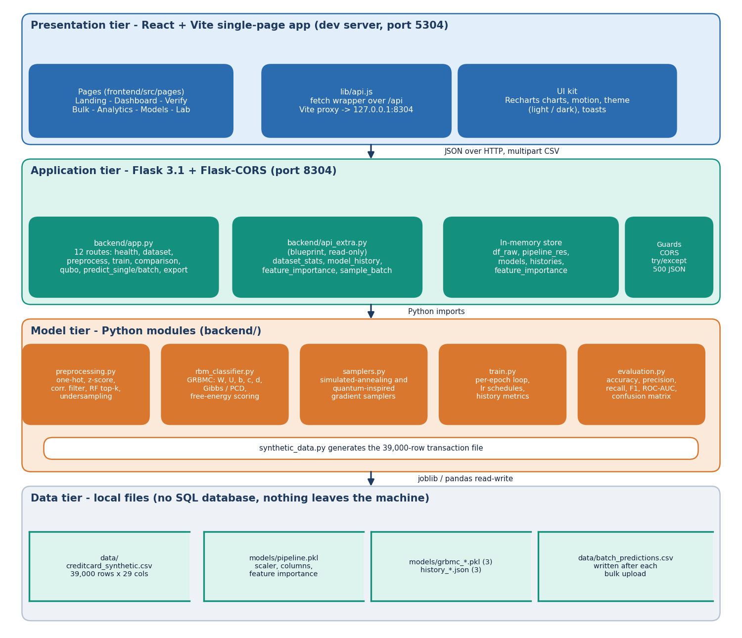
Figure 1: System architecture of SecurePay AI: four tiers over local files; there is no SQL database and no external service.
State lives in one in-memory dictionary, store, shared by all requests without locking, which suits a single-user demonstration but would have to change before several workers were used.

5.2 High-Level Workflow
The build path generates or loads data, preprocesses it, keeps the 18 most important columns, splits 80/20, trains the three classifiers and saves files and histories; it runs from seed_models.py or the Model lab. The score path completes the form values or CSV rows with defaults, one-hot encodes, aligns to the 18 columns, scores with the three models, averages and maps to a risk band. The orange step marks the stage that misbehaves in the bulk route (Section 5.6).
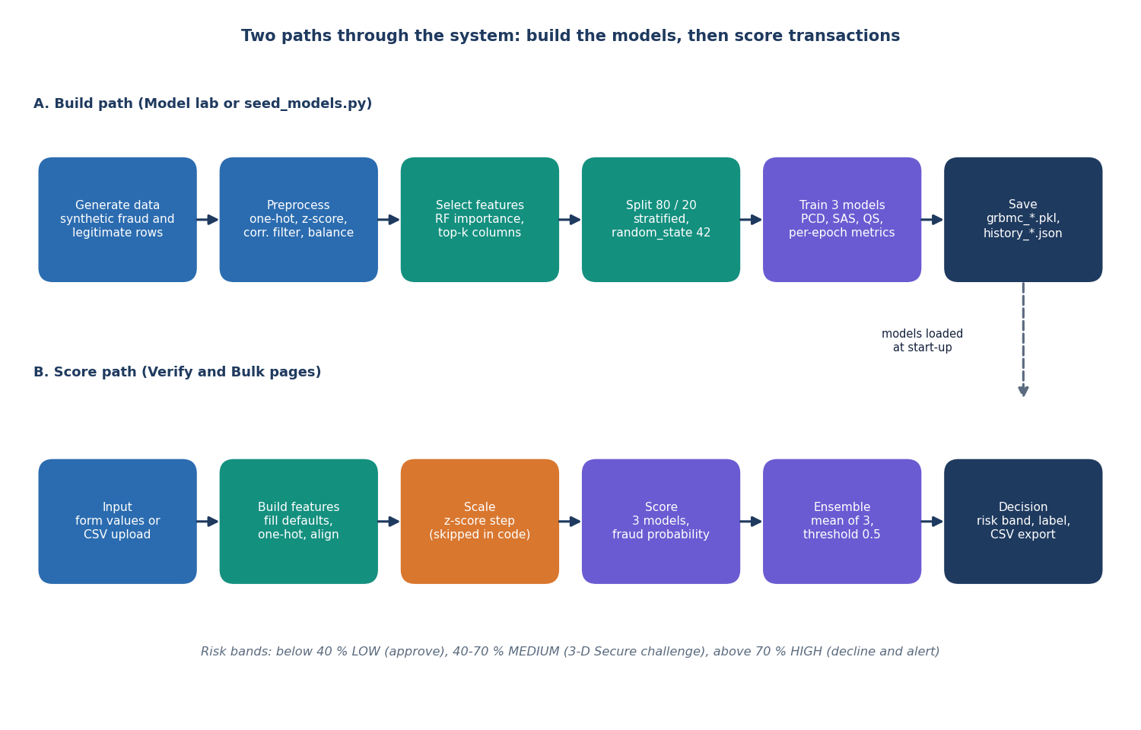
Figure 2: High-level workflow: the build path creates the model files and the score path uses them.

5.3 Data Flow Diagrams

5.3.1 Level 0 and level 1
At level 0 SecurePay AI is one process: a merchant or analyst sends transaction fields or a CSV file and receives a score, risk level and decision; a risk-operations user requests retraining and views analytics. There is no login, so the roles are conceptual, and no external entity.
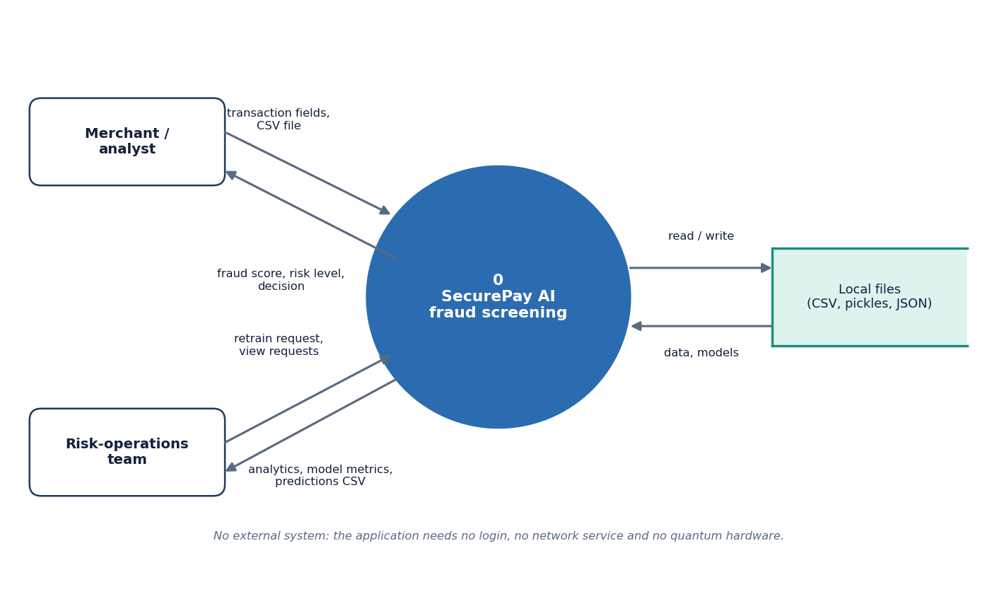
Figure 3: DFD level 0: two kinds of user exchange transactions, scores and reports with the application, which reads and writes local files.
Level 1 has six processes: generate and preprocess data (1.0), train (2.0), score one transaction (3.0), score a CSV batch (4.0), analytics and model reports (5.0) and export (6.0), over four stores: dataset (D1), pipeline (D2), models and histories (D3) and batch predictions (D4).
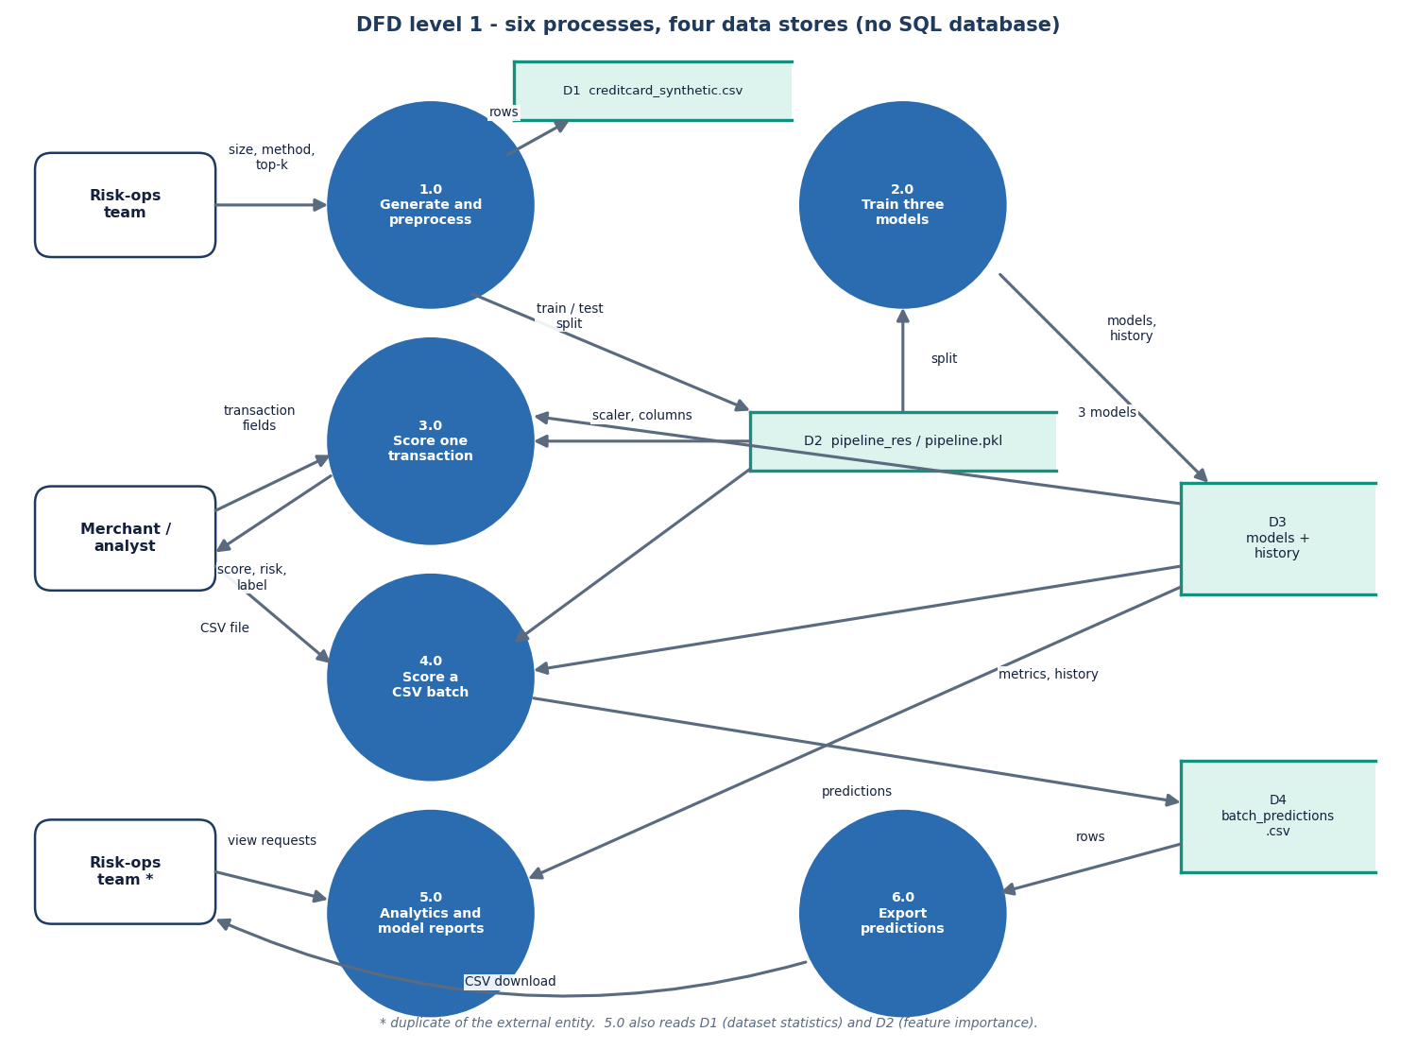
Figure 4: DFD level 1: six processes and four data stores.

5.3.2 Level 2: scoring one transaction
Level 2 expands process 3.0: validate and fill defaults (3.1), align columns and scale numeric columns (3.2), score with the three models (3.3), average and threshold at 0.5 (3.4) and assign the risk band at 0.4 and 0.7 (3.5). This route scales correctly; the bulk route does not (Section 5.6).
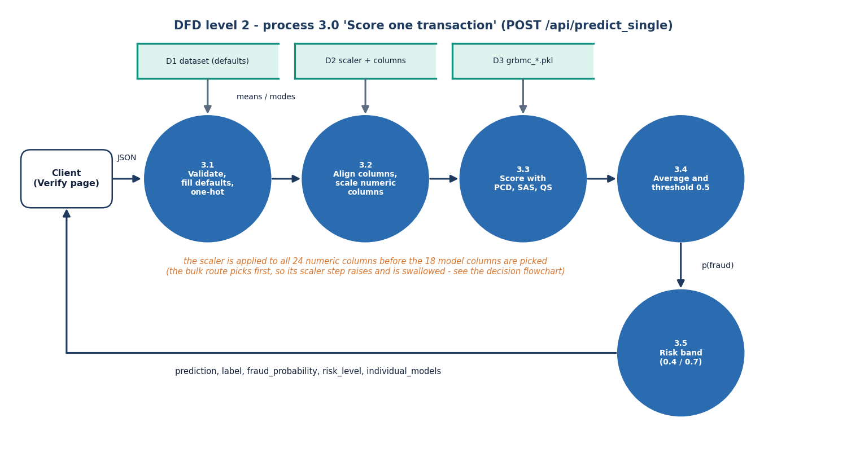
Figure 5: DFD level 2: the five steps of process 3.0 (POST /api/predict_single).

5.4 UML Models
Only one class exists: GRBMC holds the weights W and U, the biases b, c and d and a persistent chain, and offers gibbs_step, pcd_step, train_epoch, predict_proba and get_qubo_matrix. The other modules are function collections; train creates and trains a GRBMC and calls the samplers, the Flask module owns the store, and api_extra only reads it.
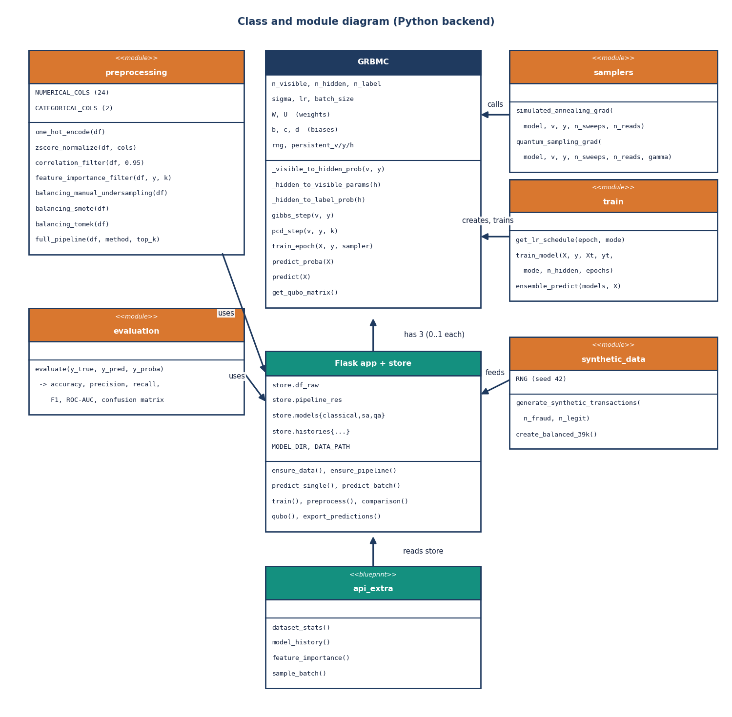
Figure 6: Class and module diagram of the Python backend.
The sequence diagram follows one click on Run fraud check: the Verify page posts the form, the Vite proxy forwards it, predict_single builds the feature vector, asks the three models for predict_proba, averages and returns a JSON object. The API call alone has a median of 17 ms (95th percentile 32 ms).
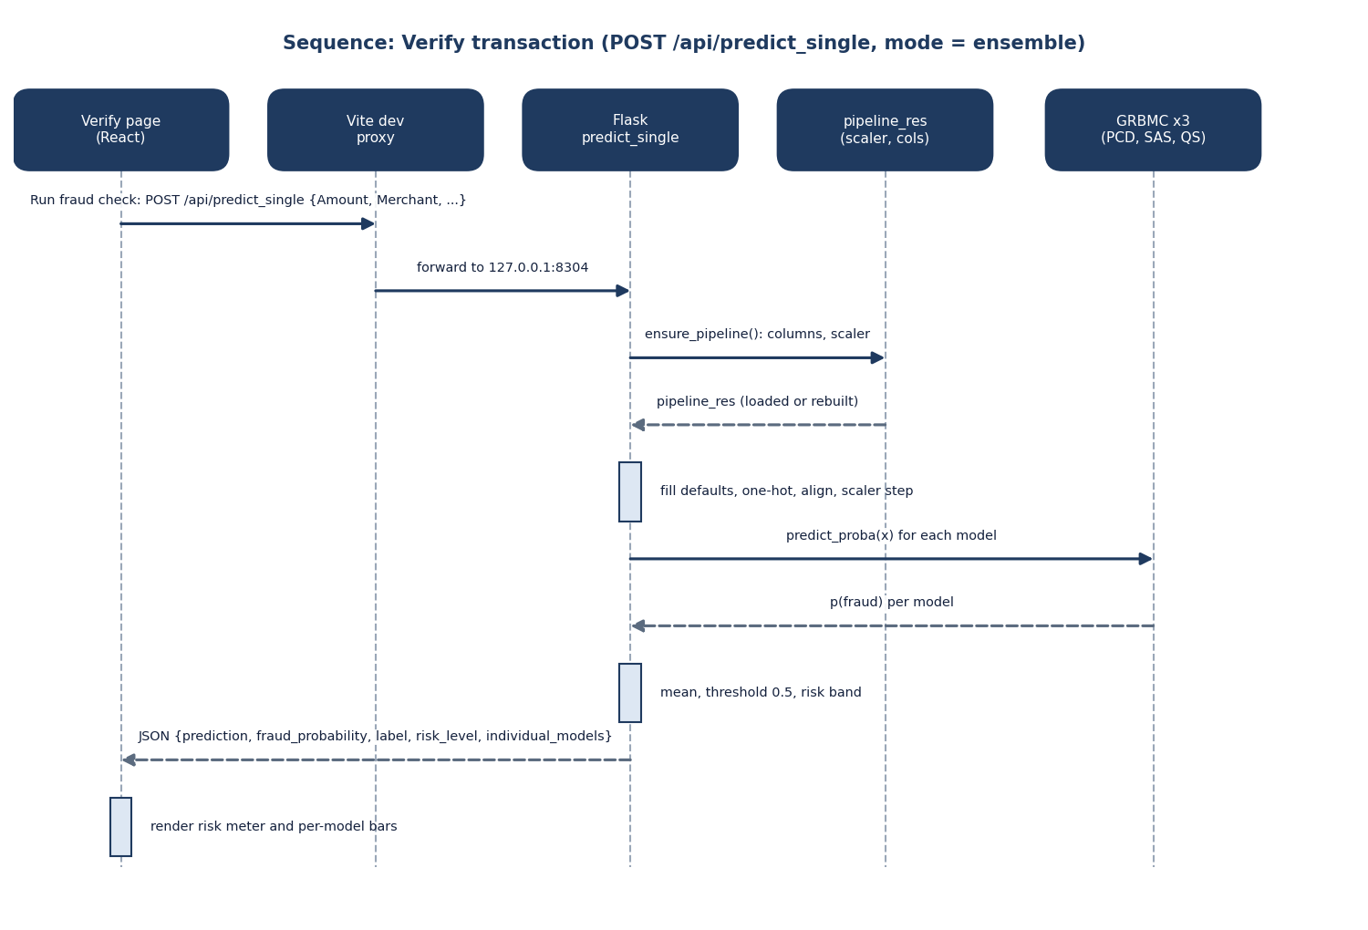
Figure 7: Sequence diagram of POST /api/predict_single with mode ensemble.
The seven use cases are verify, bulk-verify, download predictions, view analytics, compare models, retrain in the Model lab and download the sample CSV; without authentication nothing enforces the two roles.
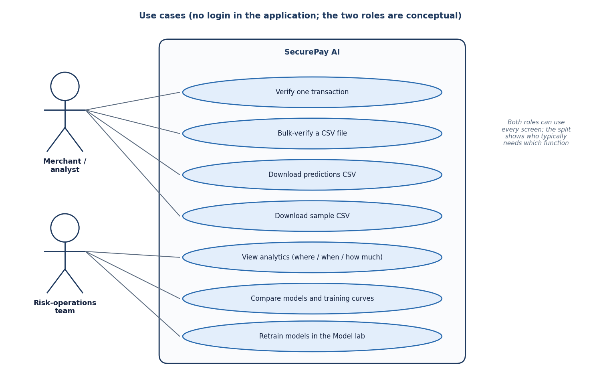
Figure 8: Use-case diagram: seven use cases and two conceptual roles.

5.5 Persistence Design
SecurePay AI has no SQL database. The base paper's data is proprietary and the project works on a generated file, so persistence is file-based and the entity view shows files and the code paths that relate them, not tables and keys.
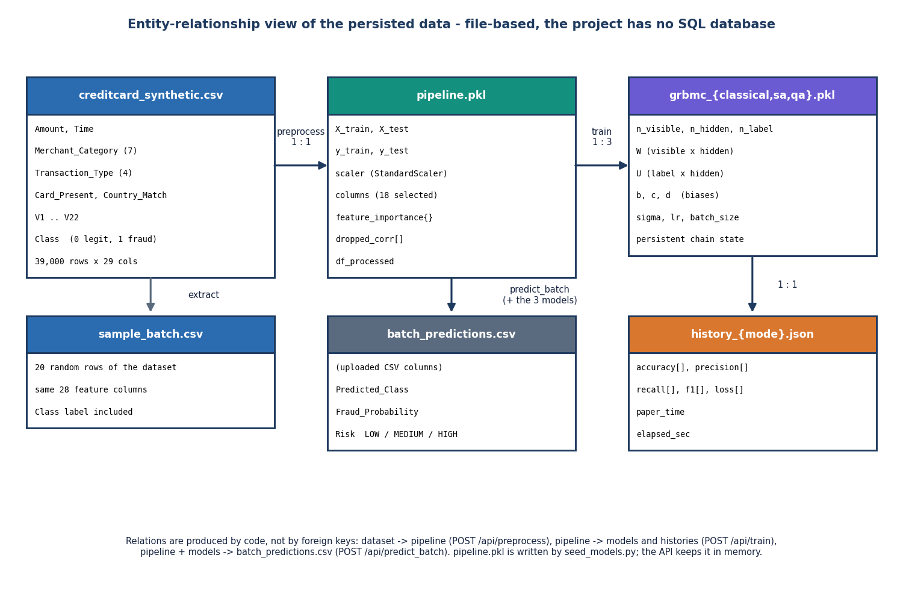
Figure 9: File-based persistence: relations are produced by code, not by foreign keys.
Table 20: Persisted entities
Entity (file) | Written by | Contents
data/creditcard_synthetic.csv | synthetic_data.py, generate_dataset | 39,000 rows x 29 columns, Class label
models/pipeline.pkl | seed_models.py only | Train and test split, fitted scaler, 18 column names, importances
models/grbmc_*.pkl (3) | seed_models.py, train | W, U, b, c, d, sigma, learning rate, chain state
models/history_*.json (3) | seed_models.py, train | Per-epoch accuracy, precision, recall, F1, loss, seconds
data/batch_predictions.csv | predict_batch | Uploaded columns plus prediction, probability, risk

Two hazards follow. pipeline.pkl is written only by seed_models.py, so retraining in the lab can leave a stale pipeline on disk (the lab warns when the feature count differs). And in the measuring environment pipeline.pkl could not be unpickled (different pandas version); the API rebuilt it from the same 8,000-row sample and reproduced the stored models' results exactly, which shows why a pickle is fragile.

5.6 Core Algorithms
The build flowchart lists the steps in code order. Balancing and feature selection happen before the train-test split, as in the base paper [1], so the random forest that ranks the features sees rows that later form the test set; with a balanced synthetic file the effect is small, but it is leakage.
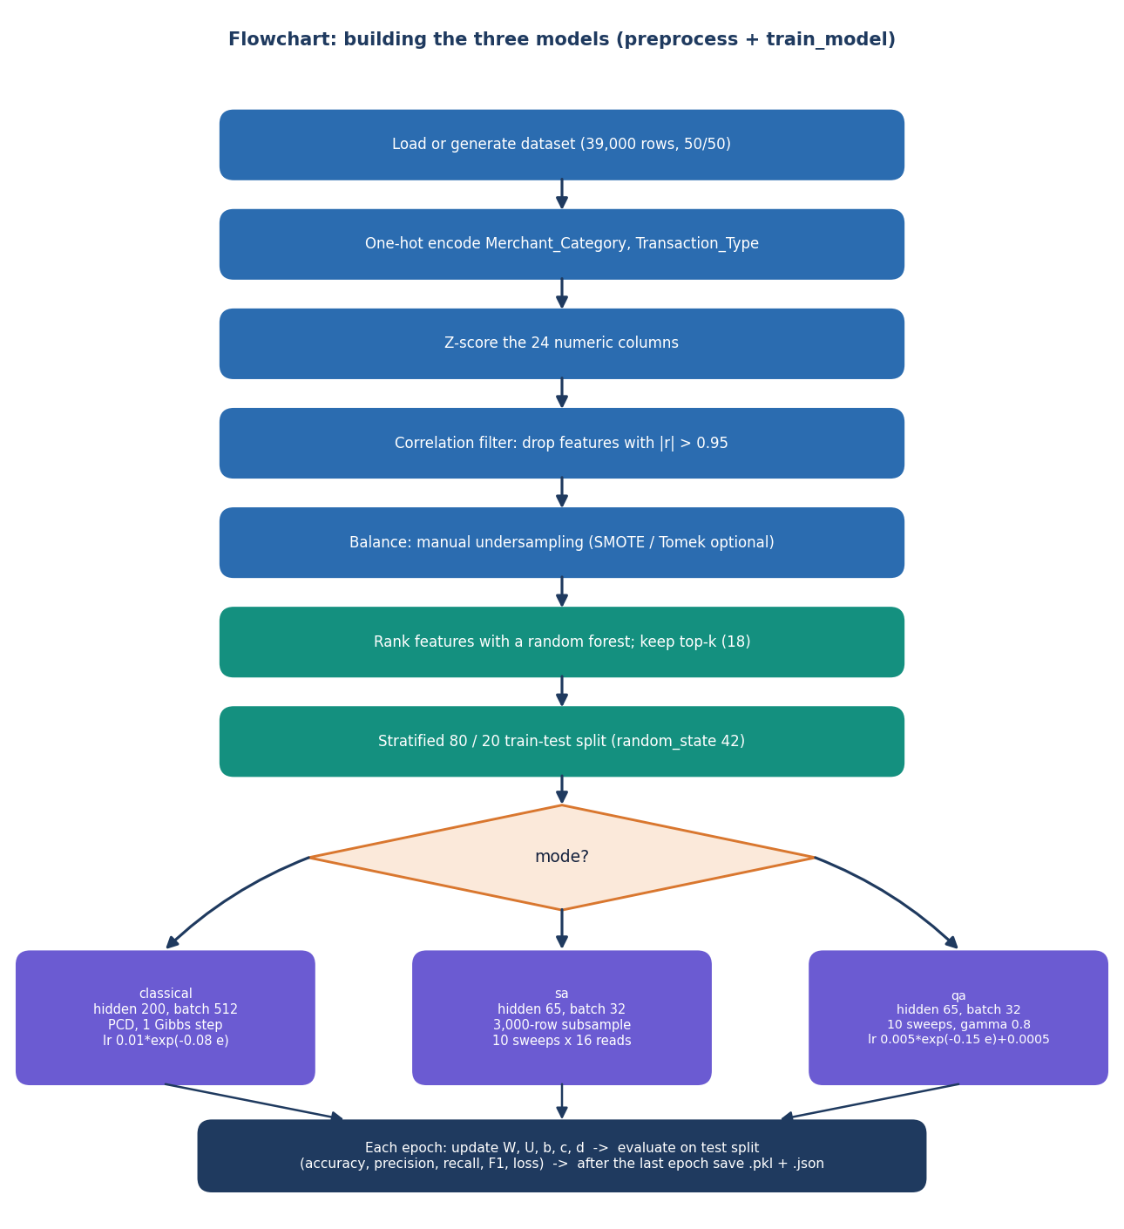
Figure 10: Flowchart of preprocessing and training: three modes share the pipeline and differ in how the model expectation is sampled.
The classifier is a Gaussian-Bernoulli RBM with a label layer: p(h=1 | v, y) = sigmoid(b + vW/sigma + yU), and prediction compares the free energy of the two labels and applies a softmax. Training moves the parameters along the difference between a data term and a model term, and the three trainers differ only in how they sample the model term.
ΔW = lr · ( ⟨v hᵀ⟩data − ⟨v hᵀ⟩model ) / ( batch · σ ) (1)
• PCD: one Gibbs step on a persistent chain, 200 hidden units, batch 512, learning rate 0.01·exp(−0.08·epoch).
• SAS: 16 reads and 10 sweeps with inverse temperature rising from 0.5 to 10, 65 hidden units, batch 32, 3,000-row subsample per epoch.
• QS: schedule s from 0 to 1, A = 0.8(1 − s), B = s, tunnelling flips with probability 0.3·A; a classical simulation, 65 hidden units, batch 32.
SAS and QS follow the idea of the base paper's annealing-assisted training but are simplified approximations (the hidden field uses the batch-mean visible vector and only a few sweeps run); they are not the D-Wave or path-integral samplers, and their training times of a few seconds are not comparable with the paper's hours.
Scoring must reproduce the training preprocessing. predict_single scales the full row first and selects the 18 columns afterwards, which is correct. predict_batch selects first, so it calls the scaler on only 13 of the 24 columns it was fitted on; scikit-learn raises, a bare except: pass swallows it and the models receive unscaled values. On a fresh 2,000-row batch the ensemble's accuracy is 50.2% as served and 94.8% scaled. The defect is documented, not fixed.
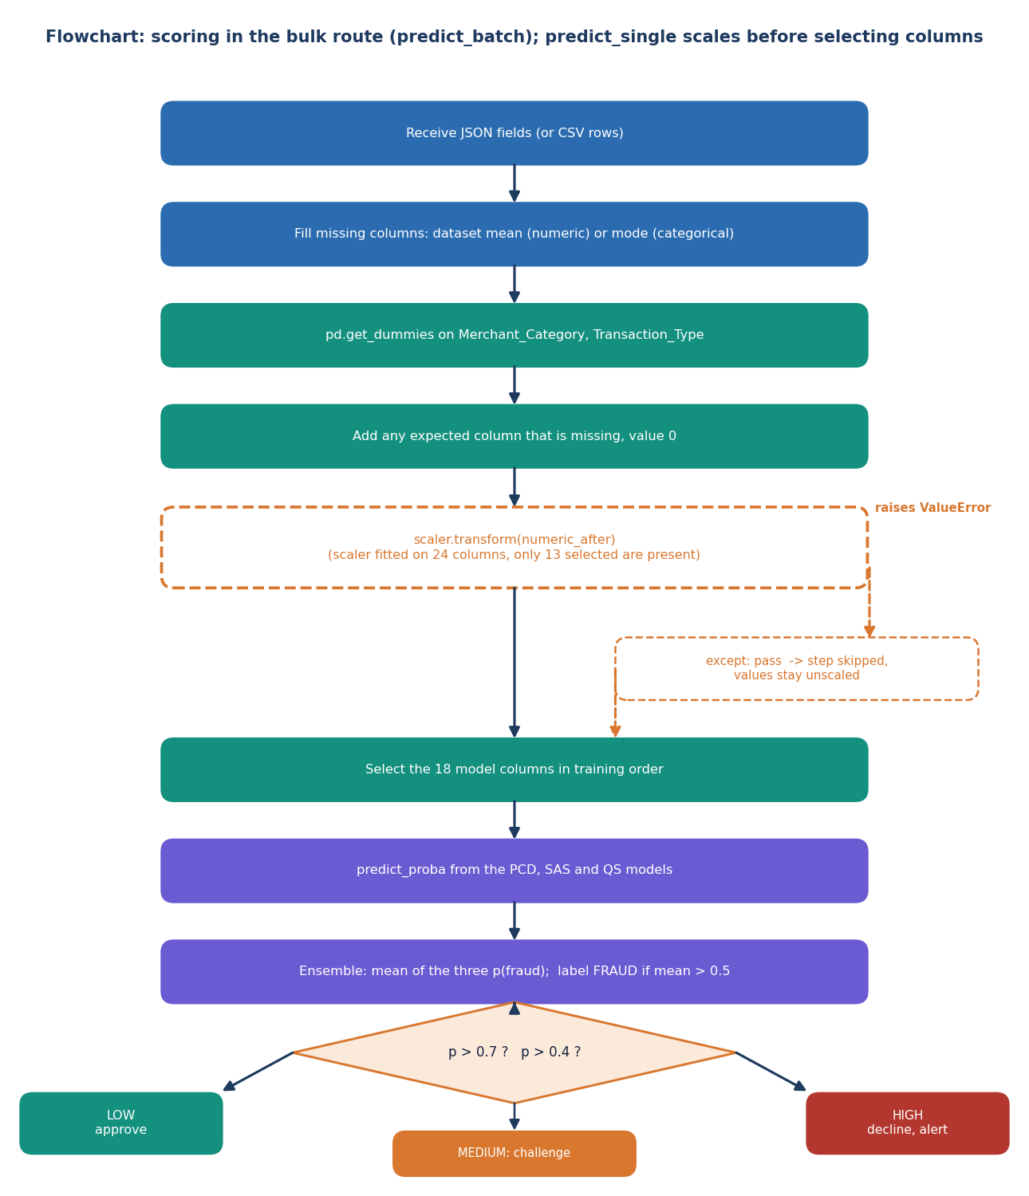
Figure 11: Flowchart of scoring in the bulk route: the dashed boxes show the scaler step that fails silently.

5.7 Module Design
The backend (1,338 lines) has eight modules with one responsibility each; preprocessing never imports the classifier, rbm_classifier knows nothing about Flask and train is the only module that connects them, which let the experiments of Chapter 8 run without the server. The frontend adds 3,574 lines: seven lazily loaded pages, a small UI kit and the API client.
Table 21: Backend modules and their real size
Module | File | Responsibility | Lines
Flask application | backend/app.py | Routes, in-memory store, loading, JSON errors | 502
Read-only API | backend/api_extra.py | Analytics and history endpoints | 110
Preprocessing | backend/preprocessing.py | Encoding, scaling, filters, balancing, split | 157
Classifier | backend/rbm_classifier.py | GRBMC, Gibbs and PCD steps, probability, QUBO | 197
Samplers | backend/samplers.py | Annealing-style and quantum-inspired gradients | 150
Training loop | backend/train.py | Epochs, schedules, per-epoch evaluation | 126
Evaluation | backend/evaluation.py | Accuracy, precision, recall, F1, ROC-AUC | 20
Data generator | backend/synthetic_data.py | Synthetic 39,000-row file | 76

5.8 API Design
The API has 16 routes. Bodies are JSON except the CSV upload and two downloads; a missing upload or untrained model returns 400 or 404 with an error message, any other exception is caught and returned as HTTP 500, and CORS allows every origin. predict_single fills missing fields with the dataset mean or mode, and predict_batch drops extra columns and zero-fills missing ones.
Table 22: API routes
Method | Path | Purpose | Response fields
GET | /api/health | Liveness, loaded models | status, models_trained[]
POST | /api/generate_dataset | Regenerate the synthetic file | rows, fraud, legit
GET | /api/dataset_info | Size, columns, first rows | rows, columns, head
POST | /api/preprocess | Run the pipeline (manual, smote, tomek) | columns, shapes, importance
POST | /api/train | Train chosen modes and save | history, metrics, config
GET | /api/train_status | Epochs and best F1 per mode | per-mode summary
GET | /api/comparison | Table at each best-F1 epoch | Accuracy ... TotalTime
GET | /api/qubo | QUBO matrix of a model | shape, Q (40x40), stats
POST | /api/predict_single | Score one transaction | prediction, probability, risk_level
POST | /api/predict_batch | Score a CSV upload | rows, preview, metrics
GET | /api/export_predictions | Last predictions CSV | CSV or 404
GET | /api/dataset_stats | Analytics over the dataset | by_merchant, by_hour, ...
GET | /api/model_history | Per-epoch histories | mode -> history
GET | /api/feature_importance | Importance ranking, columns | importance[], columns
GET | /api/sample_batch | 20-row sample CSV | CSV
GET | / | Legacy Flask page (fallback) | HTML

5.9 User Interface Design
The interface is a banking risk dashboard, not a research notebook: a calm palette, rounded cards and one accent colour, with risk encoded by colour, word and meter position. Light and dark themes, an offline pill with retry, skeleton loading and reduced-motion handling are built in; mobile views are in Appendix C.
Table 23: Pages and the API calls behind them
Route | Page | Content | API calls
/ | Landing | Hero, how it works, risk signals | -
/app | Dashboard | KPI tiles, fraud rate by merchant, model F1 | health, dataset_stats, comparison
/app/verify | Verify | Nine-field form, presets, verdict, risk meter, per-model bars | predict_single
/app/bulk | Bulk | File drop, counts, metrics, preview, downloads | predict_batch, export_predictions
/app/analytics | Analytics | Where, when, how much, card signals | dataset_stats
/app/models | Model comparison | Comparison, curves, features, QUBO map | comparison, model_history, qubo
/app/lab | Model lab | Dataset, preprocessing, training with confirmations | generate_dataset, preprocess, train

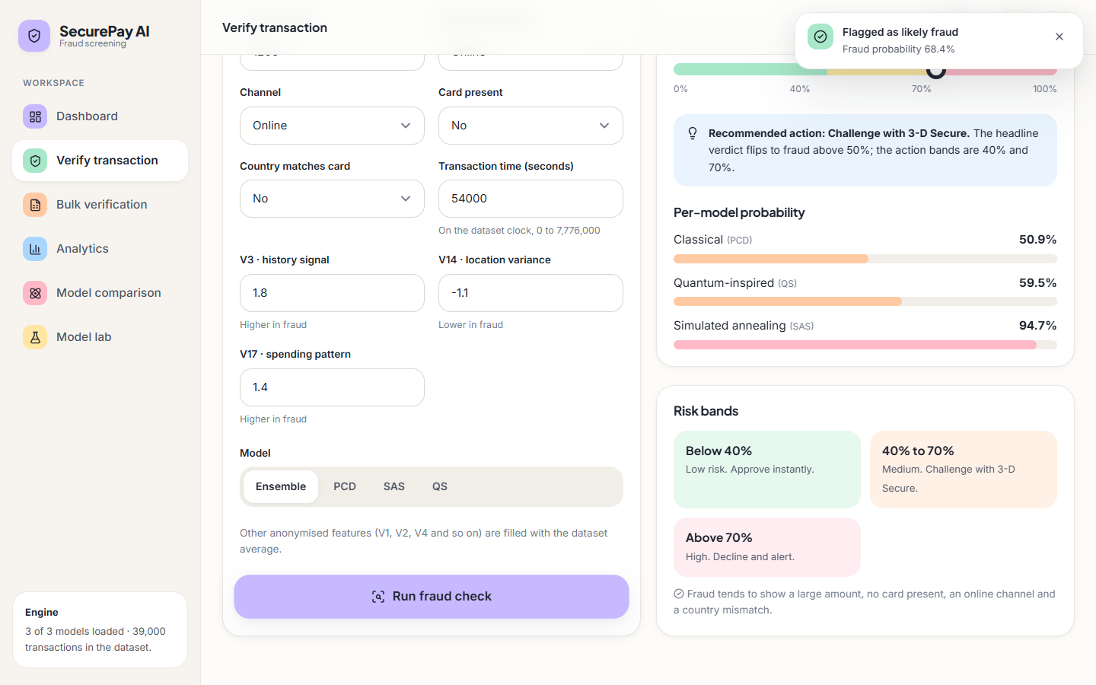
Figure 12: Verify page after the large online example: probability, recommended action, per-model bars and risk bands.
Verify has two presets so that a first-time user sees both outcomes in two clicks; the headline flips at 50 % while the action bands sit at 40 % and 70 %. The three anonymised features carry friendly names (history signal, location variance, spending pattern) chosen for the demonstration; the data is synthetic, so they have no real meaning.
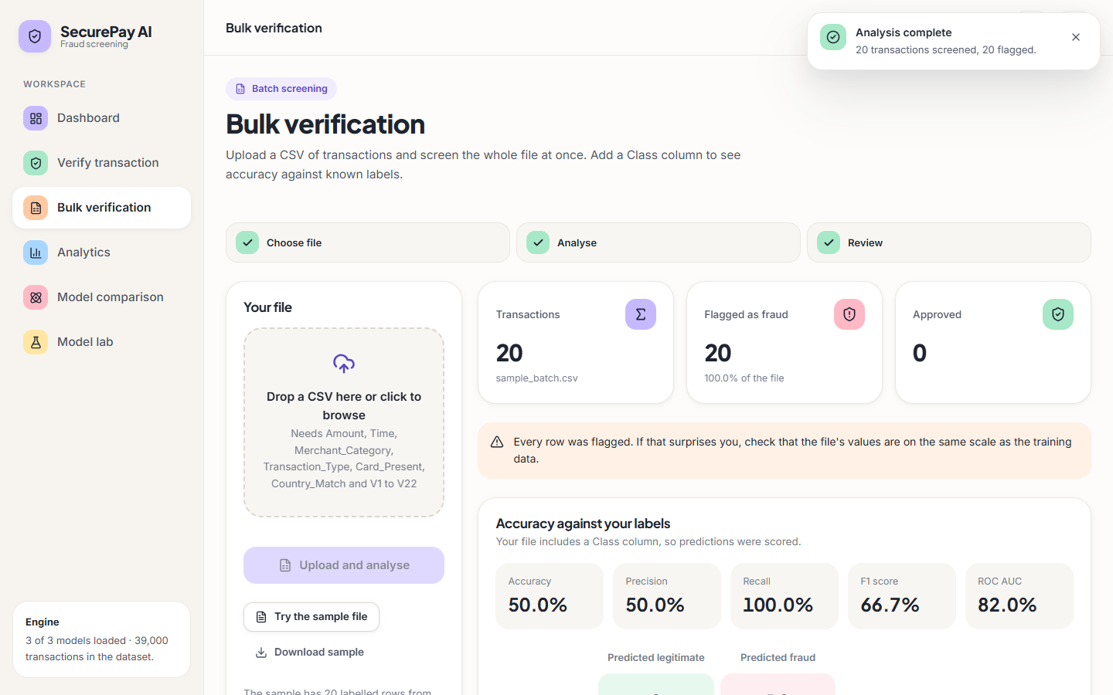
Figure 13: Bulk verification of the bundled sample: a warning that every row was flagged, and metrics against the Class column.
Bulk warns when every row of a file of five or more is flagged; the screenshot shows it firing on the bundled sample, the visible symptom of the scaling defect of Section 5.6.
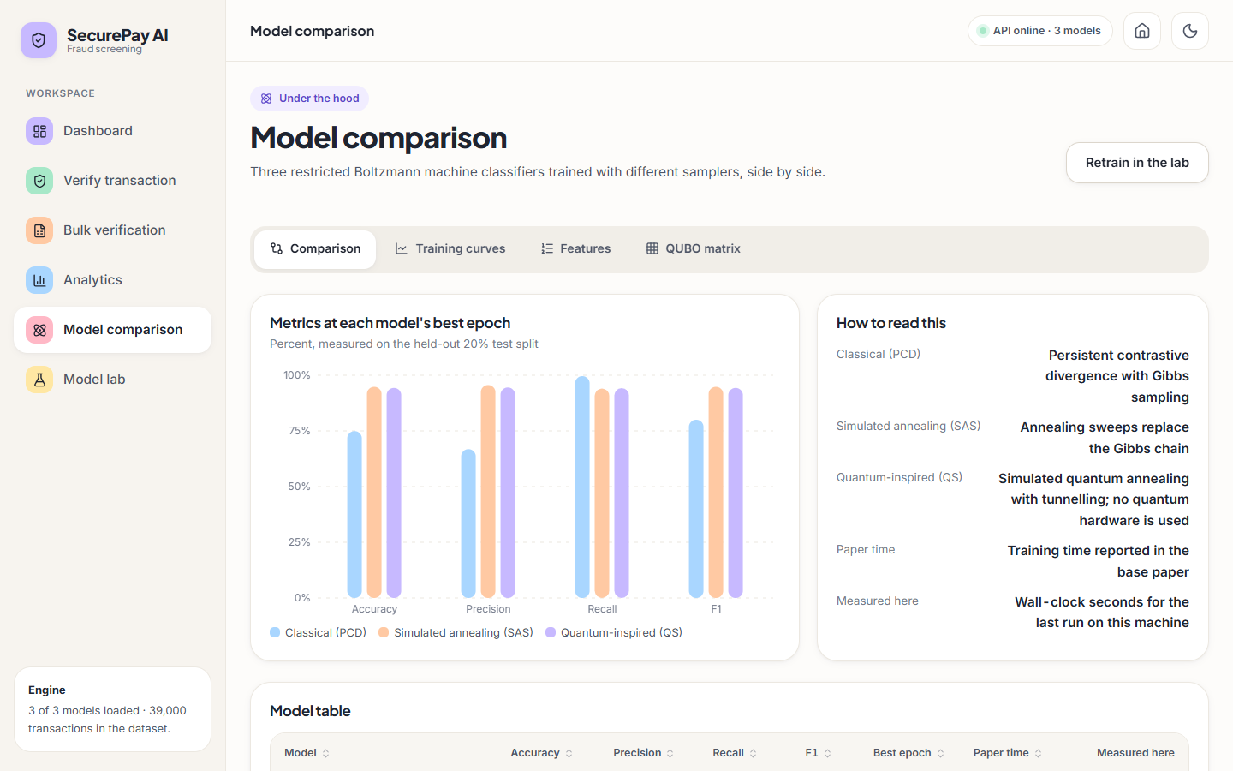
Figure 14: Model comparison: metrics at each model's best epoch, with the paper's training times kept apart from the times measured here.
The Model lab regenerates data, rebuilds the pipeline and retrains, with range checks, a confirmation before each destructive step and a warning when the feature count changes.

5.10 Design Decisions and Trade-offs
Table 24: Design decisions, reasons and costs
Decision | Reason | Cost accepted
Numpy RBM, simulated samplers | Runs in seconds on a laptop; no quantum hardware or cloud time | Simplified samplers; only quantum-inspired
Ensemble of three, threshold 0.5 | One probability and three bands; smooths unstable PCD | Poorly calibrated PCD still pulls the mean
Manual undersampling to 50/50 | Base paper found SMOTE and Tomek unhelpful | Discards rows; false alarms at 1 % fraud (Chapter 8)
Synthetic dataset | Base paper's data is proprietary | Figures describe the generator, not real fraud
File persistence, in-memory store | No server to run; files are inspectable | No locking, fragile pickles
Broad try/except around the scaler | Meant to tolerate missing columns | Silently disables scaling in the bulk route
Dev server, debug on, no authentication | Convenient for a demonstration | Not for production

The main weaknesses (the silent scaling failure, pre-split feature selection and a shared store) are prototype shortcuts, not architectural limits, and each can be removed without changing the structure drawn in this chapter.

CHAPTER 6: METHODOLOGY AND SOFTWARE IMPLEMENTATION

6.1 Overall methodology
SecurePay AI follows the base paper [1]: a Gaussian-Bernoulli RBM classifier (GRBMC) is trained on a balanced set of card transactions with three ways of estimating the negative phase - persistent contrastive divergence (PCD), simulated-annealing sampling (SAS) and quantum sampling (QS). The project adds a re-runnable preprocessing pipeline, an ensemble, a three-band decision rule, a REST API, a web application and a measured comparison against conventional classifiers, in seven steps:
1. Acquire data. Generate a synthetic, balanced file of 39,000 transactions that imitates the paper's balanced set (the real data is proprietary).
2. Preprocess. One-hot encode the categorical fields, z-score the numeric fields, drop highly correlated columns, balance the classes, rank the features with a random forest and keep the 18 best, then split 80/20 with stratification.
3. Train. Fit three GRBMC models (PCD, SAS, QS) epoch by epoch, scoring the held-out split after every epoch and writing the metric history to disk.
4. Decide. Average the three fraud probabilities and map the result to approve, challenge or decline.
5. Serve. Expose the pipeline and the models through a Flask API with 16 routes and a React interface.
6. Evaluate. Report precision, recall, F1 and ROC-AUC rather than accuracy alone, against Logistic Regression, Random Forest and XGBoost, across five random seeds, across decision thresholds and on a variant with 1 % fraud.
7. Document. Regenerate every number in the documentation from experiments/metrics.json so that nothing is typed by hand.
The three trainers share one model class and one prediction rule and differ only in how the negative phase is sampled. The SAS and QS samplers are simplified classical approximations in NumPy, not the paper's path-integral simulator and not quantum hardware (Section 6.6), so QS is called quantum-inspired throughout.

6.2 Dataset
The base paper's data are 145 million real transactions (about 19 thousand fraud), undersampled manually to a 39 thousand-row 50/50 set [1]. That data is not public, so backend/synthetic_data.py generates a synthetic file of the same size and balance with a seeded generator (seed 42): 39,000 rows and 29 columns, 19,500 fraudulent and 19,500 legitimate. No licence restriction applies.
Table 25: Columns of the synthetic transaction file
Column(s) | Type | Legitimate class | Fraudulent class
Amount | continuous | |N(80, 60)| (mean 85.21 in the file) | |N(350, 250)| (mean 368.20 in the file)
Time | integer seconds, 0 to 7,776,000 | uniform over 90 days | uniform over 90 days
Merchant_Category | 7 categories | mostly Grocery 25 %, Restaurant 20 %, Fuel 15 %, Online 15 % | mostly Online 35 %, Electronics 25 %, Travel 15 %
Transaction_Type | Chip, Contactless, Online, Swipe | Chip 40 %, Contactless 30 %, Online 20 %, Swipe 10 % | Online 60 %, Contactless 15 %, Swipe 15 %, Chip 10 %
Card_Present | 0 / 1 | present in 80 % of rows | present in 30 % of rows
Country_Match | 0 / 1 | match in 95 % of rows | match in 60 % of rows
V1 ... V22 | continuous, standard normal | N(0, 1); V1 raised slightly with Amount | N(0, 1) with shifts on V3 (+1.5), V7 (-1.2), V10 (+1.0), V14 (-0.8), V17 (+1.3)
Class | 0 / 1 | 0 = legitimate | 1 = fraud

V1 to V22 imitate anonymised principal-component features and carry no meaning beyond the listed shifts; the interface names for V3, V14 and V17 (history signal, location variance, spending pattern) are friendly labels, not real attributes. Because the classes come from different distributions the problem is easier than real fraud (Chapter 8).
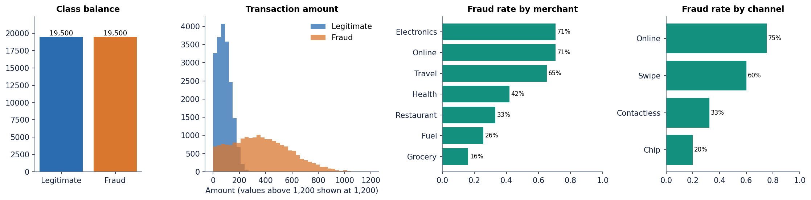
Figure 15: Synthetic dataset: class balance, transaction amount by class, and fraud rate by merchant category and by channel.
The base paper found SMOTE and Tomek links poor on a tiny minority class and used manual undersampling [1], [12], [13]. To see a realistic imbalance the experiment script also builds a 39,000-row variant with 1 % fraud (390 rows), used only for evaluation in Chapter 8.

6.3 Preprocessing
full_pipeline in backend/preprocessing.py is applied to an 8,000-row random sample (random_state = 42) and follows Section III-A of the base paper [1].
Table 26: Preprocessing steps and the data shapes they produce
Step | What the code does | Shape afterwards
1. Sample | df.sample(8000, random_state=42) from the 39,000-row file | 8,000 x 29 (28 features + Class)
2. One-hot encoding | pd.get_dummies on Merchant_Category (7) and Transaction_Type (4), float dtype | 8,000 x 38 (37 features + Class)
3. Z-score | StandardScaler fitted on the 24 numeric columns (Amount, Time, V1 to V22); the 2 binary and 11 dummy columns stay 0/1 | unchanged
4. Correlation filter | drop any column whose absolute correlation with an earlier column exceeds 0.95 | no column dropped (37 features)
5. Balancing | manual (default): keep all fraud rows and a random legitimate sample of size min(n_fraud, n_legit); smote and tomek are optional | 8,000 rows (the sample is already balanced, so nothing is removed)
6. Feature ranking | random forest (200 trees, seed 42) on the balanced set; keep the 18 highest importances | 8,000 x 18 + Class
7. Split | train_test_split(test_size = 0.2, stratify = y, random_state = 42) | train 6,400 x 18 (3,218 fraud); test 1,600 x 18 (805 fraud)

Z-score. Gaussian visible units expect zero mean and unit variance, so each numeric column x becomes
z = (x - μ) / s (2)
where μ and s come from the 8,000-row sample. The fitted scaler is stored in models/pipeline.pkl for the serving code; Section 6.10 describes a defect in how the batch route uses it.
Feature ranking. The base paper ranks features with CatBoost [21]; it is not installed here, so feature_importance_filter falls back to a random forest [19] (this is what ran). The strongest features are Amount, V3, Card_Present, V17, V7, Country_Match, V10, Transaction_Type_Online, V14 and Transaction_Type_Chip; the weakest of the 18 kept are included only because 18 slots are requested.
Order of operations. Scaling, balancing and feature ranking are fitted on the whole sample before the split, so test rows influence the scaler and the ranking. The effect is small on this balanced synthetic file but it is a leak; the 1 % experiments in Chapter 8 split first and fit on the training rows only.

6.4 Algorithm choice and justification
• Why a GRBM classifier. An RBM is an energy-based network whose energy can be written as a QUBO problem [1], [22], [26]; a label layer turns it into a classifier [27] and Gaussian visible units read z-scored features [28]. It is small (a few thousand weights), trains in seconds on a CPU and gives a probability that can be thresholded.
• Why three trainers. Contrastive divergence approximates the negative phase with Gibbs sampling [23], [24], [25]; replacing the chain by an annealing sampler is the idea the paper tests on a D-Wave simulator and hardware [30], [31]. One code base keeps data, model class and evaluation identical.
• Why simulate. Quantum hardware was not available, so the sampler is a classical program with an annealing schedule and a tunnelling term; it keeps the structure of the paper's experiment but cannot test its quantum-advantage claim, and none is made [1].
• Why an ensemble. The three models make different errors (Chapter 8); averaging gives a smoother score and lets the interface show per-model scores.
• Why also run LR, RF and XGBoost. The batch objectives ask for them [4], [2], [20]; scripts/run_experiments.py trains them on the same split so the RBM is judged against standard baselines. They are not part of the shipped application.
Why undersample. Undersampling to 50/50 keeps only real transactions, as the base paper chose after SMOTE and Tomek failed [1], [12], [13], [14], but it distorts the posterior probability unless recalibrated [11]; Chapter 8 measures this on the 1 % variant.

6.5 Mathematical formulation

6.5.1 The Gaussian-Bernoulli RBM classifier
Let v be the n_v = 18 Gaussian visible units, h the n_h binary hidden units and y a one-hot label (two units); W and U join the visible and label units to the hidden layer and c, b, d are the biases. Following Appendix A of the paper [1], extended with the label layer, the energy is
E(v, h, y) = Σᵢ (vᵢ − cᵢ)² / (2σ²) − Σⱼ bⱼ hⱼ − Σᵢⱼ (vᵢ / σ) Wᵢⱼ hⱼ − Σₖ dₖ yₖ − Σₖⱼ yₖ Uₖⱼ hⱼ (3)
with p(v, h, y) = exp(−E) / Z (Z is intractable) and σ = 1 in the code. The sampling conditionals are
p(hⱼ = 1 | v, y) = sigmoid( bⱼ + Σᵢ vᵢ Wᵢⱼ / σ + Σₖ yₖ Uₖⱼ ) (4)
p(v | h) = N( c + σ W h , σ² ) p(y = k | h) = softmaxₖ( dₖ + Σⱼ Uₖⱼ hⱼ ) (5)

6.5.2 Prediction by free energy
Classification compares the two label hypotheses through the free energy with the hidden units summed out (predict_proba):
F(v, y) = − Σᵢ cᵢ vᵢ / σ − Σₖ dₖ yₖ − Σⱼ ln( 1 + exp( bⱼ + Σᵢ vᵢ Wᵢⱼ / σ + Σₖ yₖ Uₖⱼ ) ) (6)
P(fraud | v) = exp(−F(v, 1)) / ( exp(−F(v, 0)) + exp(−F(v, 1)) ) (7)
The visible term is linear in v (the exact Gaussian term is quadratic) and cancels in the ratio, so the simplification does not change the prediction. A transaction is labelled fraud when P(fraud | v) > 0.5. The probability is not calibrated, which is why the shipped PCD model (ROC-AUC 0.986) flags almost every transaction at 0.5 (Chapter 8).

6.5.3 Training by persistent contrastive divergence
The gradient is the difference between a data (positive) and a model (negative) expectation [22], [25]; for a batch of m rows, with positive hidden probabilities p⁺ and negative statistics (v⁻, y⁻, p⁻) from a sampler,
ΔW = (vᵀ p⁺ − (v⁻)ᵀ p⁻) / (m σ) ΔU = (yᵀ p⁺ − (y⁻)ᵀ p⁻) / m (8)
Δb = mean(p⁺ − p⁻) Δc = mean(v − v⁻) / σ² Δd = mean(y − y⁻) (9)
θ ← θ + η Δθ (10)
Classically the negative statistics come from a persistent Gibbs chain advanced by one full Gibbs step after every update [24]. The logged loss is a pseudo reconstruction error used for monitoring only.

6.5.4 Simulated-annealing sampling (SAS)
SAS (simulated_annealing_grad) replaces the Gibbs step by 10 sweeps over 16 reads, with inverse temperature rising linearly from 0.5 to 10. In each sweep (twice) the hidden field of every read is computed from the mean visible vector of the batch and a random 5 % of the hidden units are resampled:
fᵣ = b + (v̄ W) / σ + yᵣ U hᵣ ← Bernoulli( sigmoid( 2 β fᵣ ) ) at the flipped positions (11)
Labels are redrawn for 30 % of the reads from softmax(β(d + hᵣUᵀ)); each read's visible vector is drawn from p(v | hᵣ) and the 16 reads are averaged into one negative-phase vector repeated for every row. This keeps the paper's idea of annealing towards a Boltzmann sample but is not its path-integral simulator: there is no replica coupling and the negative phase is a mean, not a set of samples.

6.5.5 Quantum-inspired sampling (QS)
QS (quantum_sampling_grad) follows the shape of H(s) = A(s) H_D + B(s) H_P [1]; over ten values of s from 0 to 1 with γ = 0.8,
A(s) = γ (1 − s) B(s) = s β_eff = 0.5 + 2 B(s) P(tunnel) = 0.3 A(s) (12)
p(hⱼ = 1) = sigmoid( 2 β_eff B(s) fⱼ ) p̃(y) = (1 − 0.2 A) softmax( B (d + h Uᵀ) ) + 0.2 A / 2 (13)
In each sweep a hidden bit is replaced by a fair coin flip with probability 0.3 A(s) (the stand-in for tunnelling) and otherwise sampled from the tempered sigmoid; the label draw is blended with uniform noise in proportion to A(s). Reads are averaged as for SAS. Nothing here runs on, or simulates the state of, quantum hardware.

6.5.6 QUBO form
The energy can be written as a QUBO f(x) = xᵀ Q x over x = (v, y, h) [1]; GRBMC.get_qubo_matrix builds the matrix that the Model comparison page shows as a heat map:
Q = − [ diag(c) 0 ½W ; 0 diag(d) ½Uᵀ ; ½Wᵀ ½U diag(b) ] (14)
It has 220 rows for the PCD model and 85 for SAS and QS and is used only for display; a hardware run would also need a binary expansion of the Gaussian units, which this project does not implement.

6.5.7 Learning-rate schedules and the ensemble
train.py sets the learning rate at the start of epoch t (from 0): PCD and SAS decay exponentially and QS follows the paper's Eq. (15):
η_PCD(t) = η_SAS(t) = 0.01 exp(−0.08 t) η_QS(t) = 0.005 exp(−0.15 t) + 0.0005 (15)
The ensemble probability of the application is the mean of the three model probabilities, P_ens = (P_PCD + P_SAS + P_QS) / 3, and the decision is fraud when P_ens > 0.5.

6.5.8 Evaluation metrics
With TP, FP, TN and FN the counts of the confusion matrix and fraud as the positive class, the project reports [18]
precision = TP / (TP + FP) recall = TP / (TP + FN) F1 = 2 · precision · recall / (precision + recall) accuracy = (TP + TN) / (TP + TN + FP + FN) (16)
ROC-AUC is the area under the recall-against-false-positive-rate curve [17]; on the 1 % variant average precision is added because it is more informative for a rare positive class [16], [34]. Thresholded figures use 0.5 unless stated.

6.6 Model architecture and training
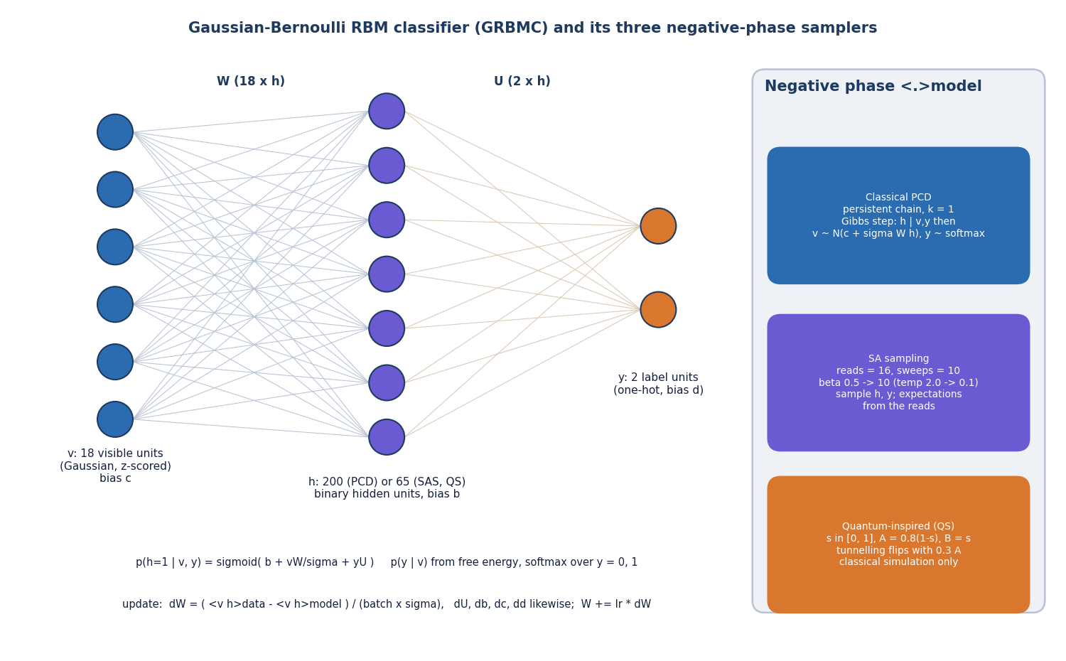
Figure 16: Structure of the GRBMC (visible, hidden and label layers) and the three negative-phase samplers.
All models read the 18 selected features and have two label units; sizes, batches and samplers follow the paper's search (200 hidden units and a large batch for PCD, 65 and small batches for SAS and QS [1]).
Table 27: Hyper-parameters of the three trainers as coded
Setting | PCD (classical) | SAS | QS (quantum-inspired)
Visible / hidden / label units | 18 / 200 / 2 | 18 / 65 / 2 | 18 / 65 / 2
Batch size | 512 (min with training rows) | 32 | 32
Rows used per epoch | all 6,400 | 3,000 (stratified sample, new each epoch) | 3,000 (as SAS)
Negative phase | persistent Gibbs chain, 1 step | 10 sweeps x 2 updates, 16 reads, mean | 10 sweeps, 16 reads, mean, tunnelling
Learning rate | 0.01 exp(-0.08 t) | 0.01 exp(-0.08 t) | 0.005 exp(-0.15 t) + 0.0005
Wall-clock (mean of 5 seeds, 20 epochs) | 4.0 s | 4.9 s | 4.2 s
Time reported in the base paper | 2 minutes | 4 hours | 1.8 hours

/api/train takes a list of modes, an epoch count and a hidden-unit count (the lab limits epochs to 1-50); PCD widens 65 hidden units to 200 and the batch to 512, as in the paper. The shipped histories come from a 20-epoch run through the API and agree with the saved models.
Training takes seconds here, not the paper's hours (4 h for SAS, 1.8 h for hardware sampling): those reflect a D-Wave simulator and a cloud queue, whereas these samplers are vectorised NumPy with at most 3,000 rows per epoch. The Model comparison page labels the paper's time and the measured time separately.
Table 28: What the paper describes and what this project implements
Aspect | Base paper | This project
Data | 145 M real transactions, about 19 thousand fraud, balanced to 39 thousand | 39,000 synthetic transactions, 50/50
Balancing | manual undersampling (SMOTE, Tomek failed) | manual undersampling by default; SMOTE and Tomek available
Classical trainer | PCD with Gibbs sampling (QARBoM.jl) | PCD with one Gibbs step (NumPy)
Annealing trainer | D-Wave simulated annealing, PIMC-style sweeps | NumPy annealing with batch-mean field and averaged reads
Quantum trainer | real D-Wave quantum annealer through cloud access | classical simulation with a tunnelling-flip term; no hardware
Model selection | highest-F1 epoch on the test set | final epoch is the primary figure here; best epoch is also stored

Choosing the highest-test-F1 epoch, as the paper's Table 1 does, reads the test set and flatters the model. The project stores both numbers and treats the final epoch as primary; they agree for SAS and QS and differ strongly for PCD (best epoch 12 with F1 80.0%, final F1 70.9%).

6.7 Decision logic
Above 0.7 the risk level is HIGH (decline and alert), from 0.4 to 0.7 MEDIUM (challenge with 3-D Secure) and below 0.4 LOW (approve). The FRAUD or LEGITIMATE label flips separately at 0.5, so a MEDIUM transaction can be labelled fraud. The cut-offs are fixed, not tuned. At 0.5 the ensemble has precision 96.5% and recall 92.5%; at 0.7 it flags nothing on the held-out split, so the HIGH band is rarely reached by the averaged score on this data.

6.8 Application architecture
SecurePay AI has three tiers: a React single-page application built with Vite (port 5304), a Flask 3.1 service (port 8304; backend/app.py and backend/api_extra.py) to which Vite proxies every /api request, and a data tier of one in-memory store backed by data/creditcard_synthetic.csv, models/pipeline.pkl, models/grbmc_*.pkl and models/history_*.json. There is no SQL database (architecture and sequence diagrams: Chapter 5).
At start-up the backend loads the CSV, tries pipeline.pkl and, if that fails, rebuilds the pipeline from the 8,000-row sample, then loads the saved models and histories. On the development PC the saved pipeline could not be unpickled by the installed pandas, so it was rebuilt at every start; because every step is seeded this reproduces the shipped models' metrics exactly.
The pages are a landing page, Dashboard, Verify transaction (risk score, action band, per-model probabilities), Bulk verification (CSV upload and download), Analytics (four tabs), Model comparison (comparison, training curves, features, QUBO matrix) and the Model lab (generate, preprocess, retrain). A header badge polls /api/health every 30 seconds and an offline screen replaces the data when the API is unreachable.

6.9 API design
The API is plain JSON over HTTP with no versioning; sixteen routes are registered (twelve in app.py, four read-only extras in api_extra.py). Chapter 5 tabulates them. In short: GET /api/health, /api/dataset_info, /api/dataset_stats, /api/model_history, /api/feature_importance, /api/train_status, /api/comparison, /api/qubo, /api/export_predictions and /api/sample_batch read state; POST /api/generate_dataset, /api/preprocess and /api/train change it (training is synchronous and overwrites the model files); POST /api/predict_single scores one transaction and POST /api/predict_batch scores an uploaded CSV. A single-transaction exchange looks like this:
POST /api/predict_single
{"Amount": 1200, "Merchant_Category": "Online", "Transaction_Type": "Online",
"Card_Present": 0, "Country_Match": 0, "Time": 54000, "V3": 1.8, "V14": -1.1, "V17": 1.4}

200 {"prediction": 1, "fraud_probability": 0.684, "label": "FRAUD", "risk_level": "MEDIUM",
"individual_models": {"classical": 0.509, "sa": 0.947, "qa": 0.595}}

The numbers are those captured in the Verify screen of Chapter 8. Errors are returned as {"error": message} with status 400 (no file), 404 (unknown or untrained model) or 500 (any exception).

6.10 Security and error handling
The application is a prototype for a controlled demonstration; the table lists what exists and what does not, and the first row is a functional defect, not only a security matter.
Table 29: Error handling and security review
Area | What the code does | Consequence
Feature scaling at serving time | in predict_batch, scaler.transform is applied to the selected numeric columns only (the columns are selected before scaling); the scaler was fitted on 24, so scikit-learn raises and a bare except: pass swallows the error. predict_single scales before selecting and is correct | for bulk uploads the models receive raw Amount, V values and so on; on a fresh 2,000-row balanced batch accuracy is 50.2% as served against 94.8% when scaling is applied, and sample_batch.csv is flagged 20 of 20
Authentication and authorisation | none | anyone who can reach port 8304 can regenerate the dataset and retrain or overwrite the models
CORS | CORS(app) allows every origin | any web page can call the API from a browser
Model files | loaded with joblib.load (pickle) | a tampered pickle can run code on load, so the models/ folder must be trusted
Errors | try/except in the main routes returns JSON 500 with the message | clients see a readable error; internal paths can leak in messages

The React client shows a toast on failure, an explicit error state on the Bulk page and an API offline screen on the Dashboard. The scaling defect was found by reading the code and confirmed with scripts/run_experiments.py; it is documented and not fixed, and Chapter 10 lists the fix (scale with the full numeric column list and fail loudly).

6.11 Installation and execution
The project needs Python 3.11 and Node.js. Python dependencies are pinned in requirements.txt (Flask 3.1.0, Flask-Cors 5.0.0, NumPy 1.26.4, pandas 2.2.2, scikit-learn 1.5.0, SciPy 1.13.0, imbalanced-learn 0.12.4, Matplotlib 3.9.0, seaborn 0.13.2, joblib 1.4.2, openpyxl 3.1.5); the measurement scripts also use XGBoost 2.0.3, which the application does not need.
Table 30: Run steps
Step | Command | Result
1. Install Python packages | pip install -r requirements.txt | backend dependencies
2. Generate data and models (only if missing) | python backend/synthetic_data.py then python seed_models.py | 39,000-row CSV; three models; pipeline.pkl (about 45 s)
3. Start both servers | run.bat (or run.ps1) | Flask on 8304 and Vite on 5304; the browser opens
4. Or start them by hand | python backend/app.py and, in frontend, npm install then npm run dev -- --host 127.0.0.1 | same result
5. Check the API | python scripts/smoke_test.py http://127.0.0.1:8304 | 20/20 checks pass (read-only)
6. Reproduce the numbers | python scripts/run_experiments.py and python scripts/measure_latency.py | experiments/metrics.json, experiments/latency.json

Ports come from .env and vite.config.js reads the same file. A single check takes a median of 17 ms through the Flask development server on 127.0.0.1 (95th percentile 32 ms) and a 20-row bulk upload 30 ms; use 127.0.0.1 rather than localhost on the development PC, where the name lookup adds about two seconds per call. Only the retraining lab takes noticeable time, because /api/train runs inside one request.

CHAPTER 7: SYSTEM TESTING

7.1 Testing strategy
Testing was organised in layers that follow the data: the numbers the models produce, the API routes, probes with unusual input, response time, and a walk-through of every screen. Everything ran against the real code and the real files in models/ and data/; nothing was mocked.
The effort was uneven and the report says so. The one automated suite in the project is the API smoke test scripts/smoke_test.py, which passed 20 of 20 checks. There is no pytest suite, no coverage measurement and no continuous-integration job. Section 7.9 states what the testing cannot show.
Table 31: Test layers, the evidence behind each and its status
Layer | Evidence | Status
Unit-level | metric assertions in scripts/run_experiments.py; documentation verifier | partial, no unit-test suite
Integration | smoke test through the Vite proxy and Flask, models loaded from disk | 20/20 passed
Functional | 20 named API checks and a walk-through of the six screens | passed
Security | code review plus probes of upload, CORS and error handling | findings recorded, not fixed
Validation and edge cases | 19 real probes against the running API | defects found
Performance | 100 timed calls per route on this PC | measured
User acceptance | no user study; screenshots only | not performed

Test environment and data. One Windows 11 PC (Intel Core i5-12500, 15.7 GB, no GPU) with Python 3.11, Flask 3.1, scikit-learn 1.5, pandas 2.2 and NumPy 1.26. The data were the 39,000-row synthetic file, the 20-row sample file and two fresh synthetic sets with new seeds (a 2,000-row balanced batch and a 39,000-row set with 1 % fraud). The machine was shared and caused out-of-memory failures; the experiment script was made resumable, and every figure in this report comes from a completed run.

7.2 Unit-level checks
No pytest suite exists and no unit tests were invented for this report. The experiment script scripts/run_experiments.py loads the three saved models, rebuilds the 18-feature pipeline exactly as the backend does at start-up and recomputes accuracy, precision, recall, F1 and ROC-AUC from the confusion matrix. Its saved-model results match the metrics in the training history files to the stated precision: for example the SAS model gives 94.5% accuracy and 94.4% F1 on the 1,600-row test split, equal to the final epoch of history_sa.json. The same script reconstructs the probability of three example transactions offline and compares it with the value the API returns; the two agree to full floating-point precision for the single-transaction route (Section 8.9).
The documentation verifier protects the documents, not the product code, so functions such as GRBMC.predict_proba, full_pipeline and evaluate were exercised only indirectly, through the routes and the experiment script.

7.3 Integration testing
Integration testing joined the layers in the order a request travels: browser, Vite development proxy on port 5304, Flask on port 8304, the in-memory store, the pickled pipeline and the three model files. The smoke test was run read-only against Flask directly, and the React screens were captured with scripts/capture_screens.py against the live backend. The offline and failed-upload captures (Appendix C) show the interface reporting errors instead of failing silently.
models/pipeline.pkl was written by a newer pandas than the one installed here, so loading raises a TypeError that the backend ignores; it rebuilds the pipeline from the 8,000-row sample with random_state = 42, which reproduces the saved training history exactly. The silent fallback would also hide a stale or incompatible pickle.

7.4 Functional testing
The smoke test has 20 checks, grouped below; all 20 passed on 25 October 2026 against port 8304. It is read-only: its --full mode retrains and would overwrite models/, so it was not used.
Table 32: Smoke-test checks by group (scripts/smoke_test.py)
Group | Checks | What is asserted
Health and data | health, dataset_info, dataset_stats | status ok, consistent row counts, 24 hourly buckets
Models and analytics | comparison, train_status, model_history, feature_importance | one row per model, F1 per epoch, ranked importances
QUBO | qubo classical, sa, qa | matrix returned with the stated display size
Single transaction | predict_single x6 (fraud and legit examples, three models, unknown mode) | probability in [0, 1] with a risk level; legit below fraud; unknown mode gives 404
Bulk and export | predict_batch, predict_batch without file, export_predictions, sample_batch | 20 rows, 10-row preview, metrics; missing file gives 400; CSV downloads

The screens were also checked by hand: the Verify form returns a verdict, risk meter and per-model probabilities; the Bulk page shows counts, a confusion matrix and a download link; the Analytics and Model-comparison tabs render from live data; the Model lab shows the training state (Section 8.1).

7.5 Security testing
SecurePay AI is a local prototype with no authentication, roles or encryption; the review was a code reading plus a few probes, and the findings are limitations, not fixed defects.
• No authentication. Every route, including /api/train and /api/generate_dataset, which overwrite files in models/ and data/, is open to anyone who can reach the port.
• Development server exposed. app.run(host="0.0.0.0", debug=True) listens on all interfaces with the debugger and reloader on; during testing the reloader restarted the server when an unrelated package changed.
• Open CORS. A request with Origin: http://evil.example was answered with Access-Control-Allow-Origin: http://evil.example.
• Uploads and errors. pandas.read_csv reads any posted file with no size or type check; routes return raw exception text; the scaling step uses a bare except: pass, the cause of the batch defect in Section 8.9.
• Not tested: injection, authentication bypass, denial of service, dependency vulnerabilities and transport security.

7.6 Validation and edge cases
19 probes were sent to the live API (served without the auto-reloader) and the real status and answer were recorded in experiments/edge_cases.json.
Table 33: Edge-case probes and what the API returned (answers shortened)
No. | Probe | HTTP | Observed response
1 | /api/predict_single, no body (Content-Type json) | 500 | error: 400 Bad Request: The browser (or proxy) sent a reques
2 | /api/predict_single, empty JSON {} | 200 | fraud_probability 0.5110, label FRAUD, risk MEDIUM
3 | predict_single, mode=nope | 404 | error: Model nope not trained
4 | predict_single, Amount=1,000,000 | 200 | fraud_probability nan, label LEGITIMATE, risk LOW
5 | predict_single, Amount=-50 | 200 | fraud_probability 0.3785, label LEGITIMATE, risk LOW
6 | predict_single, Amount='abc' | 500 | error: could not convert string to float: 'abc'
7 | predict_single, unknown merchant 'Casino' | 200 | fraud_probability 0.3994, label LEGITIMATE, risk LOW
8 | predict_single, only Amount=1200 sent | 200 | fraud_probability 0.6628, label FRAUD, risk MEDIUM
9 | predict_single, mode=classical | 200 | fraud_probability 0.5011, label FRAUD, risk None
10 | /api/predict_batch, no file | 400 | error: No file uploaded
11 | predict_batch, empty CSV file | 500 | error: No columns to parse from file
12 | predict_batch, malformed CSV (binary junk) | 500 | error: 'utf-8' codec can't decode byte 0x80 in position 128:
13 | predict_batch, header only (0 rows) | 200 | rows 0, fraud_detected 0, metrics none
14 | predict_batch, CSV with only Amount and Time | 200 | rows 2, fraud_detected 2, metrics none
15 | predict_batch, valid sample_batch.csv | 200 | rows 20, fraud_detected 20, metrics present
16 | /api/qubo?mode=nope | 404 | error: Model not trained yet. Please train first.
17 | /api/nonexistent | 404 | <!doctype html> <html lang=en> <title>404 Not Found</title>
18 | /api/export_predictions | 200 | Amount,Time,Merchant_Category,Transaction_Type,Card_Present,
19 | /api/health with Origin: http://evil.example | 200 | Access-Control-Allow-Origin: http://evil.example

• Missing fields are filled silently with the dataset mean or mode, so a client mistake never produces an error.
• An amount of 1,000,000 returns NaN, label LEGITIMATE and a LOW band with HTTP 200: the free-energy computation overflows and NaN > 0.5 is false. No input-range check exists; a negative amount (-50) scores 0.379 for the same reason.
• Inconsistent error codes. Invalid JSON and a non-numeric amount return HTTP 500 where 400 is correct; an unknown model gives 404 and a missing file 400, as intended.
• Malformed uploads fail with HTTP 500, and a CSV with only Amount and Time is accepted with every row flagged; the valid sample file returns 20 of 20 flagged, the scaling defect of Section 8.9 (it holds 10 fraud rows).

7.7 Performance testing
Response time was measured with scripts/measure_latency.py against Flask on 127.0.0.1 after five warm-up calls (localhost adds about two seconds per call on this PC). A single-transaction check has a median of 16.9 ms and a 95th percentile of 32.5 ms over 100 calls; the 20-row batch route has a median of 29.9 ms. Single-model modes cost the same as the ensemble within a millisecond.
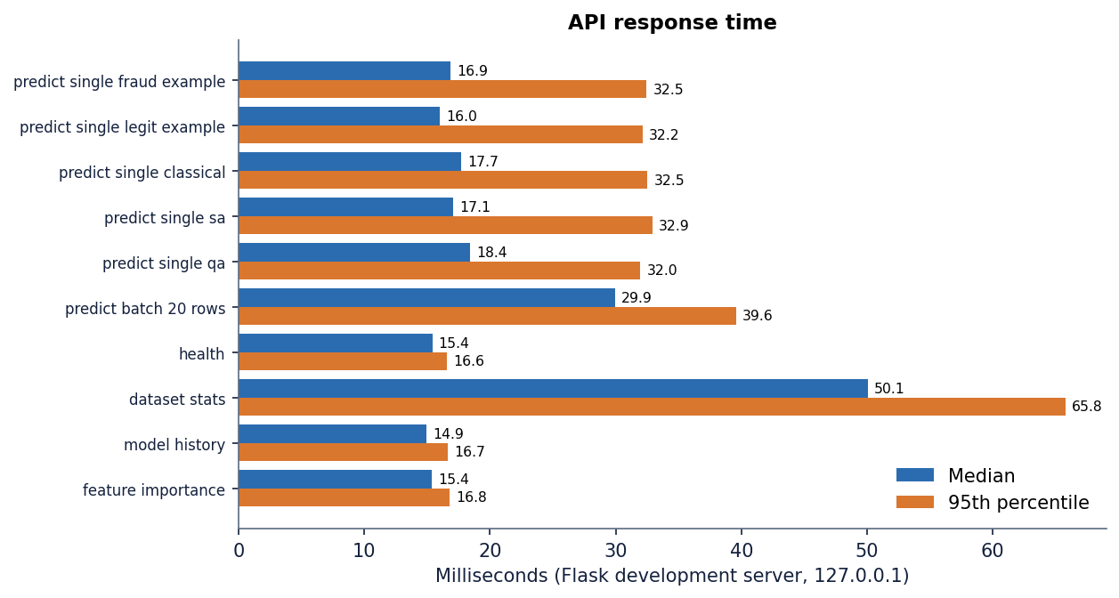
Figure 17: Median and 95th-percentile response time of each API route (127.0.0.1, Flask development server, this PC).
These timings say nothing about concurrent load. Training time was measured separately: with the 8,000-row sample a 20-epoch run takes about 4 s for PCD, 5 s for SAS and 4 s for QS, and on the full 39,000-row file 19 s, 6 s and 4 s. The base paper reports minutes to hours for the same three procedures [1]; the difference reflects the simplified, subsampled samplers used here, not a faster algorithm.

7.8 User acceptance
No user study was carried out: no analysts, questionnaire or timed task, so nothing can be said about usability for real users. The team walked through the 22 screenshots (landing, six screens in two themes, phone layouts, offline and error states); that shows each screen renders with real data and the main tasks can be completed, which is evidence of completeness, not of acceptance.

7.9 Limits of the testing
• The data are synthetic and come from one generator for training and testing, so no test shows behaviour on real card traffic or drifting fraud [6].
• There is no unit-test suite; only the 20 route checks would notice a broken internal function, and they assert that a response is well-formed, not that its probability is right (that was checked offline in Section 8.9).
• Probes were hand-picked; no fuzzing or load tests were run. Security testing was a code review and a few probes, so the application should not be exposed beyond localhost.
• No user study, accessibility audit or cross-browser test was done; screenshots used one browser engine.

CHAPTER 8: RESULTS AND OUTPUT SCREENS

8.1 Output screens
The screens below were captured from the running application at 1440 x 900 pixels with its real data: the 39,000-row synthetic file, the three trained models and the pipeline rebuilt from the 8,000-row sample. The landing page, the other Analytics tabs, the dark theme, phone layouts and the offline and error states are in Appendix C.
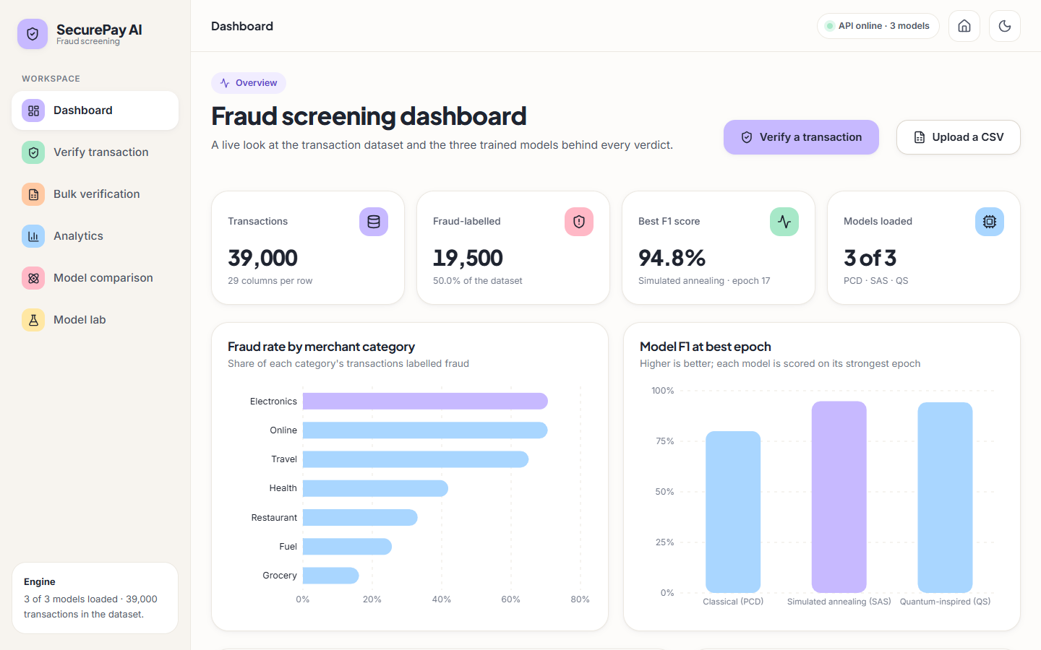  Figure 18: Dashboard: dataset counts, best F1, loaded models and fraud rate by merchant category. | Figure 19: Verify: the high-risk example scored by the ensemble, with the risk meter and each model's probability.

The dashboard shows 39,000 transactions in 29 columns, 19,500 fraud-labelled rows (50.0 %), the best F1 and the number of models loaded; merchant categories are ranked by their share of fraud-labelled rows (Electronics and Online highest), which describes the synthetic generator, not real merchants. On the Verify screen the user enters an amount, merchant, channel, card-present and country-match flags and a time, plus three optional signal fields (friendly names for synthetic features V3, V14, V17), and picks the ensemble or one model. The capture shows the high-risk example: ensemble probability 68.4%, a MEDIUM band with the action Challenge with 3-D Secure; PCD 50.9%, QS 59.5%, SAS 94.7%. The verdict flips to fraud above 50 %, whereas the action bands are 40 % and 70 %.
Figure 20: Bulk verification: the 20-row sample file after upload, with 20 of 20 rows flagged and 50.0 % accuracy. | 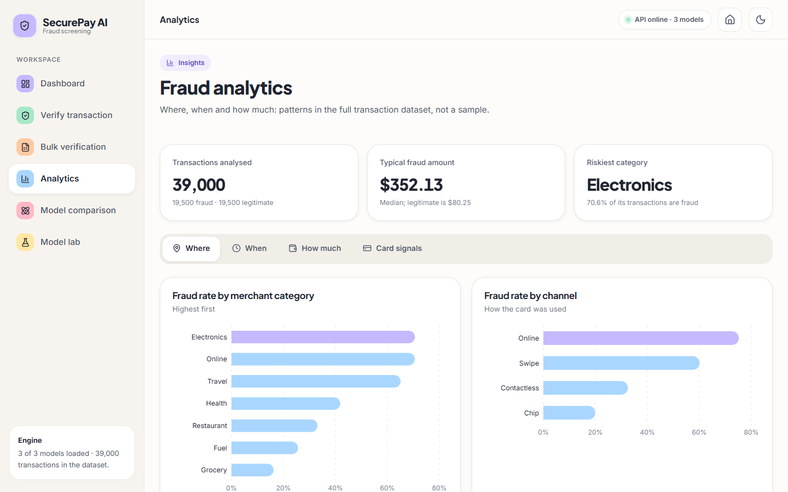  Figure 21: Analytics, tab Where: fraud rate by merchant category and by channel.

The Bulk screen screens a CSV in three steps. With the bundled sample_batch.csv (10 fraud and 10 legitimate rows) it reports every row as fraud, 50.0 % accuracy, 100 % recall and F1 66.7 %, and itself warns that every row was flagged. This is not a model result but the batch-route scaling defect of Section 8.9, shown because it is what the delivered application does. The Analytics screen has four tabs that read the full dataset; Where ranks Electronics highest (70.6 % labelled fraud). The When tab is flat at about 50 % per hour, as a generator that draws timestamps uniformly for both classes must produce, so it confirms the synthetic nature of the data.
Figure 22: Model comparison, Comparison tab: metrics at each model's best epoch, with the paper's training time and the time measured here. | 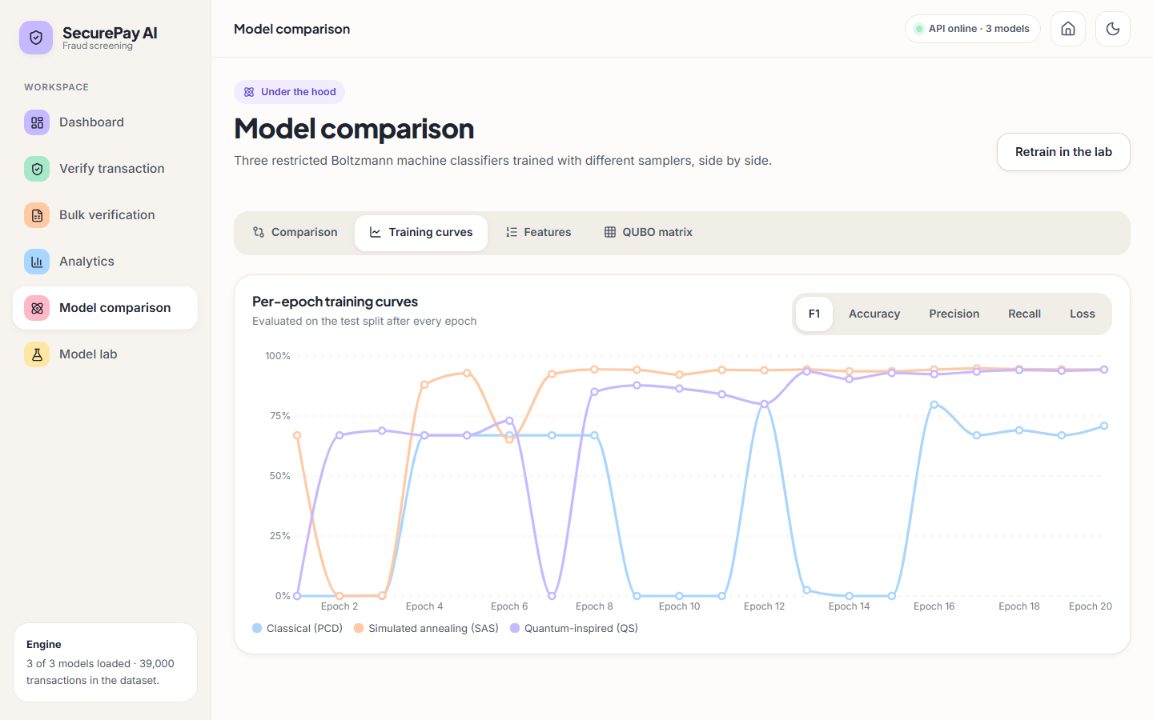  Figure 23: Model comparison, Training curves tab: per-epoch F1 of PCD, SAS and QS.

The comparison tab tabulates the best-epoch metrics beside the training time the paper reports (a quotation) and the time measured here. The curves tab shows why a best-epoch view is generous: PCD alternates between predicting everything legitimate (F1 0) and everything fraud (F1 66.9 %) and reaches 80.0% only at epoch 12; SAS climbs from epoch 4 and settles near 94 %; QS oscillates until epoch 12 and then settles.
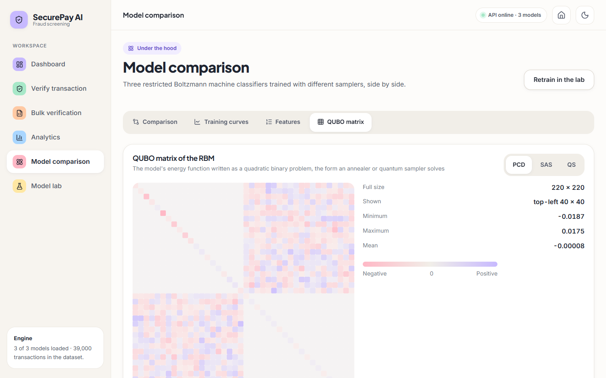  Figure 24: Model comparison, QUBO matrix tab: the 220 x 220 matrix of the PCD model, top-left 40 x 40 block. |   Figure 25: Model lab: training state of each model and the three steps dataset, preprocessing and training.

The QUBO tab draws the energy function of the PCD model as a 220 x 220 matrix (18 visible, 2 label and 200 hidden units), the form a quantum annealer would accept; it visualises the weights and is not used for prediction. The Model lab regenerates the dataset, re-runs preprocessing (manual undersampling, SMOTE or Tomek links) and retrains the selected models; its cards show 20 epochs each and, for PCD, a last accuracy of 58.8 % beside a recall of 100 %, the signature of a model that flags nearly everything. Retraining overwrites the files in models/, so a run was captured separately in Appendix C and the files were then restored.

8.2 Data and pipeline
All results come from one synthetic dataset of 39,000 rows, half of them fraud-labelled, created by backend/synthetic_data.py to imitate the 39-thousand-row balanced set of the base paper [1]. The backend works on an 8,000-row random sample of it: one-hot encoding, z-scoring of 24 numeric columns, a correlation filter at 0.95 (nothing was removed), random undersampling to equal classes, a random-forest ranking that keeps the 18 most important features, and a stratified 80/20 split into 6,400 training and 1,600 test rows, of which 805 are fraud.
Figure 26: Synthetic dataset: class balance, amount distribution by class and fraud rate by merchant category and channel.
Random-forest importance ranks Amount far ahead of V3, Card_Present, V17 and V7; the generator shifts exactly these signals for fraud, so a classifier that finds them has learned the generator. This is the first reason the numbers below must not be read as a forecast for real transactions.

8.3 Model performance on the held-out split
The table gives the shipped models (final epoch of 20) on the 1,600-row test split at the application's threshold of 0.5.
Table 34: Shipped models on the 1,600-row held-out split (threshold 0.5)
Model | Hidden units | Accuracy | Precision | Recall | F1 | ROC-AUC
PCD (classical) | 200 | 58.8% | 54.9% | 100.0% | 70.9% | 0.986
SAS (annealing) | 65 | 94.5% | 96.7% | 92.2% | 94.4% | 0.986
QS (quantum-inspired) | 65 | 94.3% | 94.5% | 94.2% | 94.3% | 0.986
Ensemble (mean of three) | - | 94.6% | 96.5% | 92.5% | 94.5% | 0.986

SAS and QS are close (F1 94.4% and 94.3%) and the ensemble is marginally above both (94.5%); SAS errs towards missed fraud (63 false negatives against 25 false alarms), QS is more balanced (47 against 44). PCD has recall 100.0% but 660 false alarms among 795 legitimate rows (precision 54.9%, accuracy 58.8%). All three share ROC-AUC 0.986: they rank equally well, and PCD is wrong only about where to put the threshold.
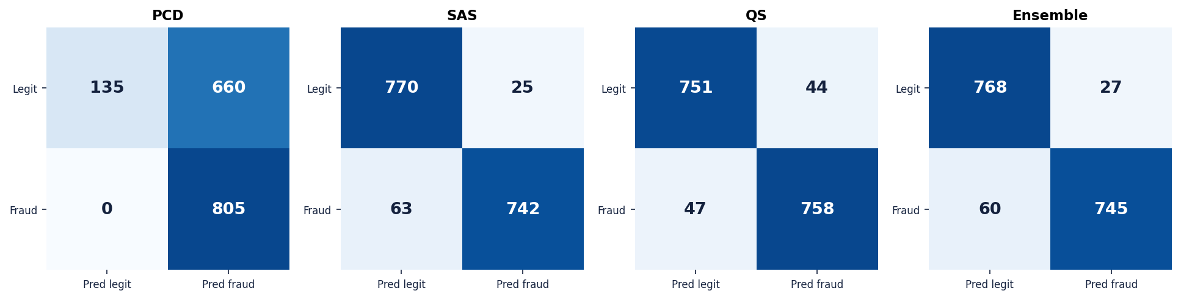
Figure 27: Confusion matrices of the three shipped models and the ensemble on the 1,600-row test split.

8.4 Threshold and calibration
For the ensemble a threshold of 0.4 gives precision 72.8% and recall 99.6%; at 0.5 they are 96.5% and 92.5%; at 0.6 precision rises to 99.8% but recall falls to 67.5%. At 0.7 and above no transaction qualifies, so the HIGH band is never triggered on this data: the probabilities are compressed around 0.5 and not calibrated.
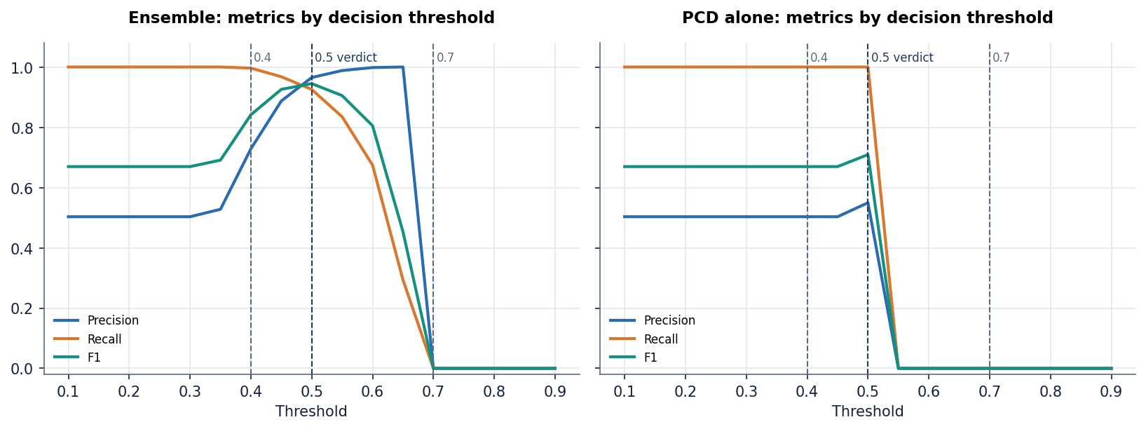
Figure 28: Precision, recall and F1 against the decision threshold for the ensemble and the PCD model.
PCD is more compressed still: its probabilities lie between about 0.4 and 0.6, so 0.5 puts most on the fraud side (accuracy 58.8%) and 0.6 puts all on the other (recall 0 %). The ROC-AUC is high while every fixed threshold performs badly, which argues for calibrating (Platt or isotonic scaling on a validation set); undersampling also shifts probabilities [11].

8.5 Training behaviour and stability
The shipped models come from one run, so training was repeated for five seeds (20 epochs, same split, final epoch); a single seed would hide the instability the curves hint at.
Table 35: GRBMC retrained over five seeds (final epoch, mean +/- standard deviation, percent)
Trainer | Accuracy | Precision | Recall | F1 | Best-epoch F1 | Seconds
PCD | 75.7 +/- 14.5 | 89.9 +/- 15.7 | 67.5 +/- 33.2 | 69.2 +/- 23.1 | 92.6 +/- 1.4 | 4.0
SAS | 94.5 +/- 0.1 | 96.8 +/- 0.2 | 92.2 +/- 0.4 | 94.4 +/- 0.1 | 94.5 +/- 0.1 | 4.9
QS | 92.7 +/- 1.5 | 91.9 +/- 4.7 | 94.2 +/- 2.7 | 92.9 +/- 1.2 | 94.3 +/- 0.2 | 4.2

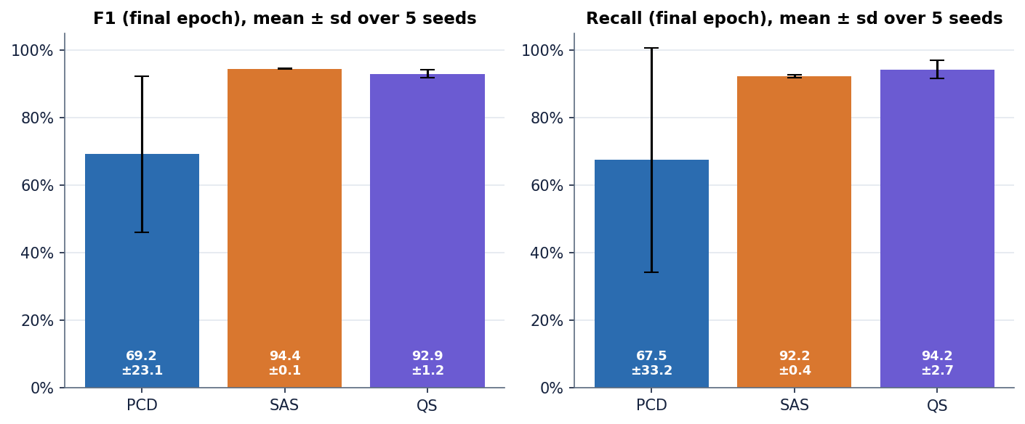
Figure 29: Final-epoch F1 and recall of the three trainers over five seeds.
SAS is stable (F1 94.4 +/- 0.1), QS is acceptable (F1 92.9 +/- 1.2) and PCD is not: its final-epoch F1 varies by 23 points between seeds, from a model that finds most fraud to one that finds almost none, even though the best epoch of every seed is good (92.6 +/- 1.4). A model whose result depends on the epoch read is not deployable unless a validation set chooses the epoch; the best-epoch columns are selected on the test split and are optimistic by construction.
Training took 4 to 5 s per run and 19, 6 and 4 s (PCD, SAS, QS) on the full file. The paper's hours are not reproduced: the SAS and QS trainers use ten sweeps and 16 reads on a 3,000-row subsample per epoch and a single averaged vector for the negative phase, far cheaper than annealing the whole model.

8.6 Comparison with standard classifiers
Logistic Regression, Random Forest and XGBoost (batch objective 4) are not part of the application; scripts/run_experiments.py trained them on the same 6,400 rows and 18 features and scored them on the same 1,600 test rows (defaults except 100 trees with leaf size 2 for the forest, 200 trees of depth 4 for XGBoost).
Table 36: Standard classifiers and the RBM models on the same balanced split
Model | Accuracy | Precision | Recall | F1 | ROC-AUC
Logistic Regression | 96.7% | 96.3% | 97.1% | 96.7% | 0.995
Random Forest | 96.2% | 96.3% | 96.3% | 96.3% | 0.994
XGBoost | 96.5% | 97.0% | 96.0% | 96.5% | 0.995
RBM, SAS | 94.5% | 96.7% | 92.2% | 94.4% | 0.986
RBM, QS | 94.3% | 94.5% | 94.2% | 94.3% | 0.986
RBM ensemble | 94.6% | 96.5% | 92.5% | 94.5% | 0.986

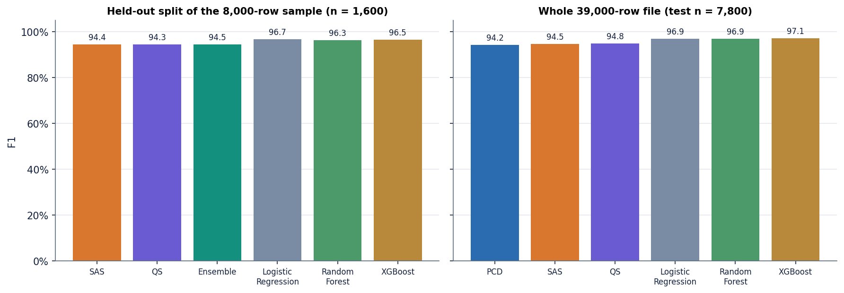
Figure 30: F1 of the RBM models and the standard classifiers on the 1,600-row split and on the 39,000-row file.
The simple classifiers win on this data. Logistic Regression reaches F1 96.7% and ROC-AUC 0.995 against 94.5% and 0.986 for the RBM ensemble, and it fits in 6 ms. A linear model suffices because the synthetic classes differ by mean shifts. On the full 39,000-row file the order is the same (XGBoost F1 97.1%, Logistic Regression 96.9%, SAS 94.5%, QS 94.8%), and the gap is about two to three points. This agrees with the literature in which tree ensembles are strong baselines on tabular fraud data [2], [3], [4].

8.7 Behaviour when fraud is rare
The balanced file hides the central difficulty, so the generator was rerun with 1 % fraud (39,000 rows), split first (stratified 80/20) and balanced on the training rows only. Each test set has 7,800 rows with 78 fraud; the table gives means over five splits for no resampling, SMOTE [12] and random undersampling [1], [15].
Table 37: 1 % fraud variant: precision, recall, F1, PR-AUC and mean error counts per 7,800 test rows (threshold 0.5)
Model | Strategy | Precision | Recall | F1 | PR-AUC | FP | FN
Logistic Regression | none | 0.946 | 0.805 | 0.869 | 0.922 | 3.6 | 15.2
Random Forest | none | 0.991 | 0.659 | 0.790 | 0.872 | 0.4 | 26.6
XGBoost | none | 0.953 | 0.751 | 0.838 | 0.893 | 3.0 | 19.4
Logistic Regression | undersample | 0.203 | 0.979 | 0.336 | 0.891 | 301.8 | 1.6
Random Forest | undersample | 0.223 | 0.969 | 0.362 | 0.883 | 266.0 | 2.4
XGBoost | undersample | 0.192 | 0.956 | 0.320 | 0.857 | 313.6 | 3.4
XGBoost | SMOTE | 0.900 | 0.826 | 0.861 | 0.909 | 7.2 | 13.6
GRBMC (SA) | undersample | 0.950 | 0.595 | 0.721 | 0.734 | 3.0 | 31.6
Rule: 3 of 4 risk signals | - | 0.557 | 0.421 | 0.478 | - | 27.0 | 45.2

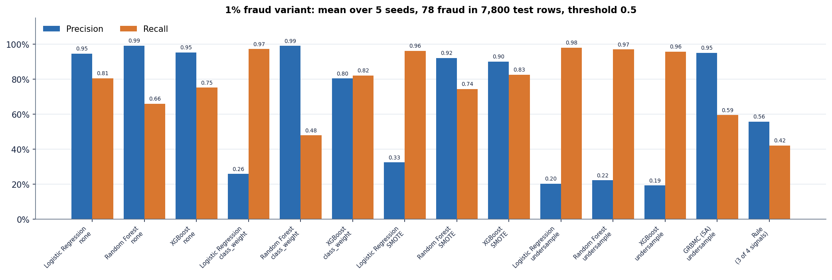
Figure 31: Precision and recall by model and balancing strategy when fraud is 1 % of the stream.
Three findings follow. Undersampling, the strategy the base paper settled on, gives the highest recall (above 0.96) but precision falls to 0.19 to 0.22: an analyst would review roughly 3.5 to 4.2 false alerts per fraud found. With no resampling the same models keep precision at 0.95 or better and find 0.66 to 0.81 of the fraud, the best F1 (Logistic Regression 0.869); SMOTE and class weights give XGBoost a balanced F1 (0.86 and 0.81) but push Logistic Regression towards the undersampling pattern. The RBM trained on undersampled data (SAS) has precision 0.95 but recall only 0.59, and PR-AUC 0.73 against 0.92 for Logistic Regression. The illustrative rule (three of four risk signals) reaches F1 0.48, so learned models clearly beat a fixed rule. This matches the base paper's finding that SMOTE and Tomek links did poorly when the minority class is very small and that undersampling distorts probabilities [1], [11]; real streams hold about 0.01 % to 4 % fraud [1], [3], so models scored on a balanced set give an optimistic picture.

8.8 Comparison with the base paper
The table sets the results beside Table 1 of the base paper. They are not comparable: the paper used about 145 million real transactions balanced to 39 thousand rows, 50 epochs and real or simulated D-Wave sampling; this project used a synthetic file of the same size, 20 epochs, subsampled classical samplers and no quantum hardware. No improvement is claimed.
Table 38: Base paper (real data) and this project (synthetic data), best epoch by F1
Method | Source | Accuracy | Precision | Recall | F1 | Training time
PCD | paper | 84 % | 86 % | 81 % | 83 % | 2 minutes
PCD | this project | 74.9% | 66.8% | 99.6% | 80.0% | 4.4 s
SAS | paper | 85 % | 94 % | 82 % | 88 % | 4 hours
SAS | this project | 94.8% | 95.6% | 94.0% | 94.8% | 4.2 s
QS | paper | 85 % | 91 % | 79 % | 84 % | 1.8 hours
QS | this project | 94.3% | 94.5% | 94.2% | 94.3% | 3.4 s

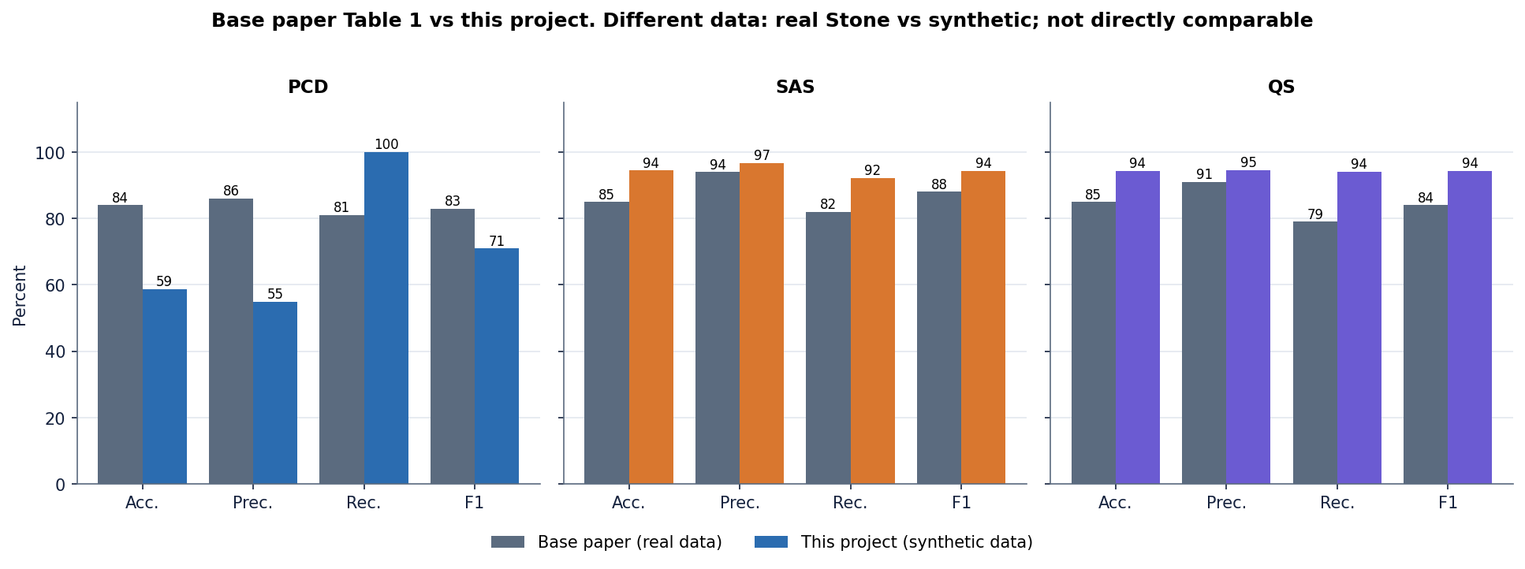
Figure 32: F1 of the base paper (real Stone data) and of this project (synthetic data). The data differ, so the bars are not directly comparable.
The paper's ordering is partly reproduced: the annealing-based trainers beat classical PCD in both studies and SAS is best or tied. Two things are not: the paper's quantum sampling is slightly below SAS whereas here they are equal within noise, and the paper's PCD is a reasonable 84 % classifier whereas the PCD model here is unstable. The synthetic data are easier (a linear model scores 96.7 %), which is why accuracy exceeds the paper's even for a simplified sampler.

8.9 Sample inputs and outputs, and the serving defect
The table gives the real responses of /api/predict_single for three transactions beside the probabilities computed offline with correct scaling; they are identical to full precision, so the single-transaction route is correct. The high-risk example is flagged (MEDIUM band), the low-risk one approved, and the middle one is a coin toss at 52.6 %.
Table 39: Live responses of the single-transaction route and offline recomputation
Example | PCD | SAS | QS | Ensemble | Verdict, band | Offline ensemble
High-risk example | 50.9% | 94.7% | 59.5% | 68.4% | FRAUD, MEDIUM | 68.4%
Low-risk example | 50.1% | 21.4% | 47.2% | 39.5% | LEGITIMATE, LOW | 39.5%
Middle example | 50.3% | 56.5% | 51.0% | 52.6% | FRAUD, MEDIUM | 52.6%

Inputs: high-risk = 1,200, Online, Online, card not present, country mismatch, time 54,000 s, V3 1.8, V14 -1.1, V17 1.4; low-risk = 80, Grocery, Chip, card present, country match, V3/V14/V17 = 0; middle = 350, Electronics, Contactless, card present, country match, V3 0.8, V14 -0.4, V17 0.6.
The batch route behaves differently: predict_batch reduces the columns to the 18 selected features and only then scales; the scaler was fitted on 24 numeric columns, so scaler.transform on the remaining 13 raises an error that a bare except: pass hides, and the models receive unscaled values. The next table measures the effect on a fresh 2,000-row balanced batch (new seed), as served and with correct scaling.
Table 40: Batch route: fresh 2,000-row balanced batch, as served and with correct scaling (ensemble)
Condition | Accuracy | Precision | Recall | F1 | ROC-AUC | FP | FN
As served (no scaling) | 50.2% | 50.1% | 100.0% | 66.8% | 0.893 | 995 | 0
With scaling | 94.8% | 97.3% | 92.3% | 94.7% | 0.986 | 26 | 77

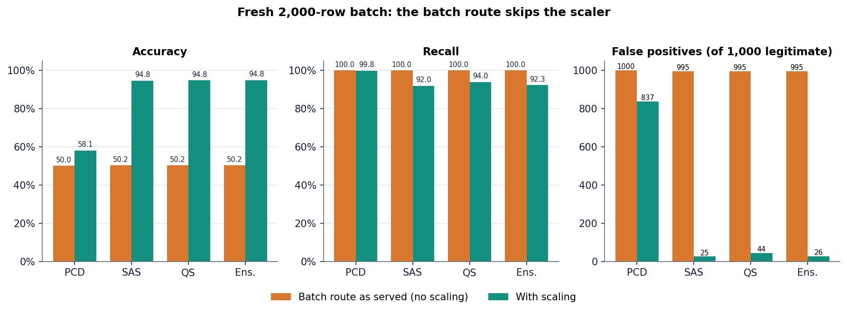
Figure 33: Effect of the skipped scaling in the batch route: accuracy, recall and false alarms as served and with correct scaling.
As served, the batch route flags essentially every row (accuracy 50.2%, recall 100.0%, 995 false alarms among 1000 legitimate rows); with scaling it matches the offline result (94.8%). The bundled sample file shows it too: 20 of 20 rows are flagged as served, 11 when scaled (the file holds 10 fraud rows). The defect is documented and deliberately not fixed: the repair is one line (scale the full numeric block before selecting columns), but the report describes the system as built. The smoke test, which only checks that a response exists, did not catch it.

8.10 Success and failure analysis
Where the system works. SAS and QS separate the synthetic classes with ROC-AUC 0.986 and F1 about 94 %, the ensemble is at least as good as its members, the single-transaction route is numerically correct and a check takes a median of 17 ms, with the whole workflow exposed in the interface.
Where it fails. The concrete failure cases are these:
• The PCD model flags almost everything. At the application's threshold it has 660 false alarms against 135 correct approvals; its ranking is good (ROC-AUC 0.986) but it is not calibrated, and it is unstable across seeds.
• The batch route is broken by the scaling defect. Accuracy falls to 50.2% and the sample file is flagged 20 of 20 (Section 8.9).
• An extreme amount produces NaN. An amount of 1,000,000 yields a probability that is not a number and an LOW-risk approval (Section 7.6).
• Precision collapses when fraud is rare. With undersampling and 1 % fraud every model, standard or RBM, either raises hundreds of false alarms or misses a large part of the fraud (Section 8.7).
• The HIGH band never fires. The ensemble probabilities stay below 0.7 on this data, so decline and alert is unreachable in practice (Section 8.4).
• Oscillation of the annealed trainers. The per-epoch F1 of SAS and QS moves by several points between neighbouring epochs and SAS drops to 0.0% in the early epochs; choosing the last epoch, as done here, is safe only because the curves have settled by about epoch 13.
• The simple models are better. On this data Logistic Regression, Random Forest and XGBoost beat the RBM ensemble by about two points of F1, so the benefit of the base paper's method is not shown by this project.

8.11 Limitations of the results
• The data are synthetic, built from simple mean shifts, so results are easier than on real transactions and do not transfer to a bank.
• The quantum sampler is a classical simulation (ten sweeps, subsampled epoch); no quantum hardware or D-Wave simulator was used, so nothing here tests quantum advantage.
• Best-epoch figures are chosen on the test split; the primary figures are final-epoch values. Scaling, balancing and feature ranking were fitted on the 8,000-row sample before the split, a mild leak that the 1 % experiment avoids.
• There is one dataset, one split for the shipped models and no confidence intervals beyond the five-seed spread; latency was measured on one PC with a development server.

8.12 Objectives versus outcomes
The six objectives of the proposal against what was achieved:
Table 41: Objectives and measured outcomes
No. | Objective | Outcome | Evidence
1 | Acquire a benchmark dataset and quantify the imbalance | Partly met: a synthetic file, not a public benchmark; imbalance quantified by the 50/50 file and a 1 % variant | Sections 8.2, 8.7
2 | Scaling, feature selection, stratified split | Met: z-score, correlation filter, RF top-18, stratified 80/20; mild leak noted | Section 8.2
3 | Compare SMOTE with random undersampling | Met in experiments (not in the product UI, which offers it only through the lab): undersampling lifts recall and wrecks precision at 1 % fraud | Section 8.7
4 | Train Logistic Regression, Random Forest and XGBoost | Met in scripts/run_experiments.py; not shipped inside the application | Section 8.6
5 | Evaluate with precision, recall, F1 and ROC-AUC | Met: all four, plus PR-AUC and confusion matrices | Sections 8.3-8.7
6 | Deploy the best model behind an interface that flags a transaction | Met with defects: the interface flags transactions in a median 17 ms; the deployed model is the RBM ensemble, not the best model, and the batch route is mis-scaled | Sections 8.1, 8.9

CHAPTER 9: CONCLUSION

9.1 Summary of the work
This project set out to build and measure a credit card fraud detector based on the quantum-assisted restricted Boltzmann machine of the base paper [1]. We implemented the Gaussian-Bernoulli RBM classifier in NumPy with three trainers, built the preprocessing pipeline the paper describes, wrapped the models in a Flask API with 16 routes and a React interface, and measured everything on a synthetic, balanced file of 39,000 transactions. The quantum trainer is a classical simulation, so the system is quantum-inspired, not quantum.
On the 1,600-row held-out split the ensemble reaches accuracy 94.6%, precision 96.5%, recall 92.5%, F1 94.5% and ROC-AUC 0.986. The annealing and quantum-inspired models reach F1 94.4% and 94.3%. The classical PCD model, at its shipped state, flags nearly every transaction (accuracy 58.8%, recall 100.0%). A single check takes a median 17 ms and a 20-row batch 30 ms.

9.2 Objectives against outcomes
Table 42: The six objectives and what was achieved
# | Objective | Outcome | Status
1 | Acquire a benchmark dataset and quantify the imbalance | No public benchmark was used. A synthetic file of 39,000 rows (50/50) was generated and a 1%-fraud variant was built to quantify the effect of imbalance | Partly met
2 | Preprocessing: scaling, feature selection, stratified split | One-hot, z-score, correlation filter, importance-based top-18 selection and a stratified 80/20 split | Met (selection before the split)
3 | Balance with SMOTE and compare with random undersampling | Compared in scripts/run_experiments.py on the 1% variant (XGBoost precision is 0.90 with SMOTE and 0.19 with undersampling); the product supports SMOTE and Tomek links in the Lab | Met in the experiment script
4 | Train Logistic Regression, Random Forest and XGBoost | Trained on the same split (F1 96.7%, 96.3%, 96.5%); they are not part of the shipped application, which serves the RBM models | Met as baselines
5 | Evaluate with precision, recall, F1 and ROC-AUC | All four metrics, confusion matrices, a threshold sweep, five seeds and PR-AUC at low fraud | Met
6 | Deploy the best model behind an interface | The interface and API work (20/20 smoke checks pass), but the batch route skips scaling, and the deployed models are not the best models measured | Met with a defect

9.3 Key findings
1. On this synthetic data, ordinary classifiers are better than the RBM. Logistic regression, random forest and XGBoost reach F1 96.7%, 96.3% and 96.5%; the best RBM ensemble reaches 94.5%. The data are easy, so this does not say what would happen on real data.
2. The three trainers differ in reliability more than in best score. SAS is stable (F1 94.4 +/- 0.1 over five seeds), QS is less so (92.9 +/- 1.2), and PCD is unstable (69.2 +/- 23.1).
3. Ranking quality and decision quality are separate. All three models have ROC-AUC near 0.986, but at 0.5 the PCD model is almost useless; the threshold, not the model, is the problem.
4. Imbalance strategy matters more than the model. At 1% fraud, random undersampling drops the precision of all three baselines to between 0.19 and 0.22, while no resampling keeps precision high and recall of 0.66 to 0.81.
5. Silent failure is the main engineering risk. A swallowed exception in the batch route reduced accuracy from 94.8% to 50.2% without any visible error.
6. The base paper's training times (hours) were not reproduced: with a simplified sampler an epoch takes well under a second.

9.4 Comparison with the base paper
The base paper reports F1 of 83 %, 88 % and 84 % for PCD, SAS and QS on real data [1]. Our final-epoch F1 values are 70.9%, 94.4% and 94.3% on synthetic data. The two sets of numbers cannot be compared directly: the data, the epoch count, the hyper-parameter search and the samplers all differ, and on our synthetic data even logistic regression reaches F1 96.7%. What can be said is qualitative. In both studies simulated annealing is the strongest trainer and classical PCD the weakest. Unlike the paper, our quantum-inspired sampler is about as good as the annealing sampler (F1 94.3% against 94.4%), but it is less stable across seeds (92.9 +/- 1.2 against 94.4 +/- 0.1). We did not reproduce the paper's training times, because the samplers here are simplified and run on a CPU, and we make no claim about quantum hardware.

9.5 Practical applications
• A teaching and demonstration tool for how restricted Boltzmann machines classify, how samplers change training, and why accuracy misleads on imbalanced data.
• A starting point for a risk-operations screening screen: single check, bulk file screening, analytics and model views are already wired to an API.
• A template for auditing a model service: the experiment script shows how to compare shipped behaviour with offline behaviour.

9.6 Known limitations
The conclusions rest on synthetic data, one split, one machine and a simulated quantum sampler. The serving defect, the optimistic best-epoch display, the pre-split selection, the lack of authentication and the lack of a regression test are all documented in Chapter 8 and in the limitations document. Until the defect is fixed and the models are checked on real data, SecurePay AI should be treated as a prototype and not as a payment control.

CHAPTER 10: FUTURE SCOPE

10.1 Improvements to the existing system
1. Fix the scaling defect and add a regression test. Transform with all columns of scaler.feature_names_in_ before selecting features, remove the bare except, and compare served probabilities with offline ones in a test that fails if they differ (served accuracy is 50.2% today).
2. Choose the threshold on validation data. Split the data three ways, pick the operating point on the validation part for the cost of a miss against a false alarm, and calibrate the PCD output (for example with isotonic regression).
3. Remove the evaluation leaks. Split first, then scale, resample and select features on the training part only, and report final-epoch or validation-selected figures only.
4. Make the training reproducible and stable. Search the hyper-parameters, average several seeds or use early stopping on a validation split, and report the spread.
Fixing the scaling defect is the single most valuable change, and its effect is already measured offline: with the scaler applied, ensemble accuracy on a fresh batch is 94.8% and false positives fall from 995 to 26. A regression test would send the bundled sample file through the running API and through the offline pipeline and assert that the two probability vectors agree within a tolerance; because it compares by column name, it would also catch a future change of feature order.

10.2 Additional features
• Real-data pilot with a partner's anonymised transactions, with a held-out time period instead of a random split.
• A gradient-boosting champion model beside the RBMs: XGBoost reaches F1 96.5% here and trains in a fraction of a second, so it is the obvious reference for any RBM claim.
• Cost-sensitive decisions and an alert budget, so the three actions reflect money and analyst capacity rather than fixed 0.4 and 0.7 cut-offs.
• Explanations for each decision (feature contributions for the single check), and storage of every prediction for audit.
• A model-monitoring screen with drift statistics and a scheduled retraining job.

10.3 Scalability and deployment
• Replace the Flask development server with a production server behind HTTPS, with authentication and role-based access (analyst and administrator).
• Containerise the API and the web build with Docker, read configuration from the environment and move model files to versioned storage.
• Keep predictions and model versions in a database instead of CSV and pickle files, and make the batch route write per-request files.
• Vectorise scoring for batches (it already is) and load-test with concurrent clients; the measured median of 17 ms per check is for one client.

10.4 Further research
• Replace the simplified samplers with a faithful path-integral simulated-annealing sampler, and obtain cloud access to a quantum annealer to test whether the effects reported in the base paper appear on real hardware.
• Study the Gaussian-Bernoulli RBM with learned variances and with a binary expansion of the visible units, as the paper's QUBO formulation requires.
• Compare the RBM classifier with a deep belief network, as the paper proposes as future work, and with tabular deep models.
• Evaluate on public benchmarks with realistic imbalance, reporting AUPRC and cost curves as recommended for rare-event problems [16], [34].

10.5 Suggested roadmap
Table 43: Roadmap from prototype to pilot
Phase | Work | Evidence of success
1. Repair | Fix scaling, remove bare exceptions, add the regression test, split before selecting features | Served and offline probabilities agree; test passes in continuous integration
2. Re-measure | Rerun scripts/run_experiments.py with validation-selected thresholds and final-epoch reporting; add the cost-sensitive layer | Updated tables in the report; a stated cost assumption
3. Harden | Authentication, HTTPS, production server, containers, stored predictions | Security checklist passed; deployment from a clean machine
4. Pilot | Score a partner's anonymised, time-ordered transactions; compare RBM, XGBoost and rules at a fixed alert budget | Precision at the budget and recall measured on real data

REFERENCES
[1] J. M. C. de Albuquerque Neto, G. C. do Amaral and G. P. Temporao, "Fraud detection in credit card transactions using quantum-assisted restricted Boltzmann machines," IEEE Access, vol. 14, pp. 62923-62932, 2026, doi: 10.1109/ACCESS.2026.3683308.
[2] A. H. M. Aburbeian and H. I. Ashqar, "Credit card fraud detection using enhanced random forest classifier for imbalanced data," arXiv:2303.06514, Mar. 2023.
[3] X. Han and C. Wu, "Validation-stage combinatorial fusion analysis for imbalanced credit-card fraud detection," arXiv:2606.10393, Jun. 2026.
[4] J. Shi, "Credit card fraud detection based on ANN and XGBoost," in Proc. 1st Int. Conf. E-commerce and Artificial Intelligence (ECAI), SciTePress, 2024, pp. 195-199, doi: 10.5220/0013212700004568.
[5] S. Bhattacharyya, S. Jha, K. Tharakunnel and J. C. Westland, "Data mining for credit card fraud: A comparative study," Decision Support Systems, vol. 50, no. 3, pp. 602-613, 2011.
[6] A. Dal Pozzolo, G. Boracchi, O. Caelen, C. Alippi and G. Bontempi, "Credit card fraud detection: A realistic modeling and a novel learning strategy," IEEE Trans. Neural Netw. Learn. Syst., vol. 29, no. 8, pp. 3784-3797, Aug. 2018.
[7] "Research on credit card fraud detection based on PySpark," in Proc. 3rd Int. Conf. Computer Science and Mechatronics, 2025. [Listed in the batch literature survey; authors and pages could not be verified, so it is not cited in the text.]
[8] "Enhancing e-commerce security: A novel approach to credit card fraud detection," 2025. [Listed in the batch literature survey; venue and authors could not be verified, so it is not cited in the text.]
[9] "Credit card fraud detection," Int. J. Research Publication and Reviews, 2025. [Listed in the batch literature survey; authors and volume could not be verified, so it is not cited in the text.]
[10] F. Carcillo, Y.-A. Le Borgne, O. Caelen, Y. Kessaci, F. Oble and G. Bontempi, "Combining unsupervised and supervised learning in credit card fraud detection," Information Sciences, vol. 557, pp. 317-331, 2021.
[11] A. Dal Pozzolo, O. Caelen, R. A. Johnson and G. Bontempi, "Calibrating probability with undersampling for unbalanced classification," in Proc. IEEE Symp. Series on Computational Intelligence (SSCI), 2015, pp. 159-166.
[12] N. V. Chawla, K. W. Bowyer, L. O. Hall and W. P. Kegelmeyer, "SMOTE: Synthetic minority over-sampling technique," J. Artif. Intell. Res., vol. 16, pp. 321-357, Jun. 2002.
[13] I. Tomek, "Two modifications of CNN," IEEE Trans. Syst., Man, Cybern., vol. SMC-6, no. 11, pp. 769-772, Nov. 1976.
[14] H. He and E. A. Garcia, "Learning from imbalanced data," IEEE Trans. Knowl. Data Eng., vol. 21, no. 9, pp. 1263-1284, Sep. 2009.
[15] A. Fernandez, S. Garcia, M. Galar, R. C. Prati, B. Krawczyk and F. Herrera, Learning From Imbalanced Data Sets. Cham, Switzerland: Springer, 2018.
[16] T. Saito and M. Rehmsmeier, "The precision-recall plot is more informative than the ROC plot when evaluating binary classifiers on imbalanced datasets," PLoS ONE, vol. 10, no. 3, Art. no. e0118432, 2015.
[17] T. Fawcett, "An introduction to ROC analysis," Pattern Recognition Letters, vol. 27, no. 8, pp. 861-874, 2006.
[18] D. M. W. Powers, "Evaluation: From precision, recall and F-measure to ROC, informedness, markedness and correlation," arXiv:2010.16061, 2020.
[19] L. Breiman, "Random forests," Machine Learning, vol. 45, no. 1, pp. 5-32, 2001.
[20] T. Chen and C. Guestrin, "XGBoost: A scalable tree boosting system," in Proc. 22nd ACM SIGKDD Int. Conf. Knowledge Discovery and Data Mining, 2016, pp. 785-794.
[21] J. T. Hancock and T. M. Khoshgoftaar, "CatBoost for big data: An interdisciplinary review," J. Big Data, vol. 7, no. 1, p. 94, Dec. 2020.
[22] G. E. Hinton, S. Osindero and Y.-W. Teh, "A fast learning algorithm for deep belief nets," Neural Computation, vol. 18, no. 7, pp. 1527-1554, Jul. 2006.
[23] G. E. Hinton, "Training products of experts by minimizing contrastive divergence," Neural Computation, vol. 14, no. 8, pp. 1771-1800, Aug. 2002.
[24] T. Tieleman, "Training restricted Boltzmann machines using approximations to the likelihood gradient," in Proc. 25th Int. Conf. Machine Learning (ICML), 2008, pp. 1064-1071.
[25] G. E. Hinton, "A practical guide to training restricted Boltzmann machines," in Neural Networks: Tricks of the Trade, 2nd ed. Berlin, Germany: Springer, 2012, pp. 599-619.
[26] A. Fischer and C. Igel, "Training restricted Boltzmann machines: An introduction," Pattern Recognition, vol. 47, no. 1, pp. 25-39, 2014.
[27] H. Larochelle, M. Mandel, R. Pascanu and Y. Bengio, "Learning algorithms for the classification restricted Boltzmann machine," J. Mach. Learn. Res., vol. 13, pp. 643-669, 2012.
[28] R. Liao, S. Kornblith, M. Ren, D. J. Fleet and G. Hinton, "Gaussian-Bernoulli RBMs without tears," arXiv:2210.10318, 2022.
[29] S. Kirkpatrick, C. D. Gelatt Jr. and M. P. Vecchi, "Optimization by simulated annealing," Science, vol. 220, no. 4598, pp. 671-680, 1983.
[30] S. H. Adachi and M. P. Henderson, "Application of quantum annealing to training of deep neural networks," arXiv:1510.06356, 2015.
[31] A. Ajagekar and F. You, "Quantum computing assisted deep learning for fault detection and diagnosis in industrial process systems," Computers & Chemical Engineering, vol. 143, Art. no. 107119, Dec. 2020.
[32] F. Pedregosa et al., "Scikit-learn: Machine learning in Python," J. Mach. Learn. Res., vol. 12, pp. 2825-2830, 2011.
[33] G. Lemaitre, F. Nogueira and C. K. Aridas, "Imbalanced-learn: A Python toolbox to tackle the curse of imbalanced datasets in machine learning," J. Mach. Learn. Res., vol. 18, no. 17, pp. 1-5, 2017.
[34] J. Davis and M. Goadrich, "The relationship between precision-recall and ROC curves," in Proc. 23rd Int. Conf. Machine Learning (ICML), 2006, pp. 233-240.

APPENDIX A: IMPORTANT CODE
The listings are copied from the repository (8.ProjectCode) in the state in which the results of this report were measured.

A.1 Preprocessing pipeline (`backend/preprocessing.py`)
def full_pipeline(df, method='manual', top_k=22, corr_threshold=0.95):
"""
Apply full pipeline and return X_train, X_test, y_train, y_test, scaler, feature_importance, dropped_cols
"""
# One-hot
df_enc = one_hot_encode(df.copy())
# Z-score for numeric (after one-hot numeric still there)
numeric_after = [c for c in NUMERICAL_COLS if c in df_enc.columns]
# also include binary? keep as is but scaler handles
df_enc, scaler = zscore_normalize(df_enc, numeric_after)
# Correlation filter (exclude Class)
feature_cols = [c for c in df_enc.columns if c != 'Class']
df_features = df_enc[feature_cols]
df_filtered, dropped = correlation_filter(df_features, threshold=corr_threshold)
df_filtered['Class'] = df_enc['Class'].values

# Balancing BEFORE split? Paper balances then splits 80-20
if method == 'smote':
df_balanced = balancing_smote(df_filtered)
elif method == 'tomek':
df_balanced = balancing_tomek(df_filtered)
elif method == 'manual':
df_balanced = balancing_manual_undersampling(df_filtered)
else:
df_balanced = df_filtered

# Feature importance filtering
y = df_balanced['Class']
df_final, feat_imp = feature_importance_filter(df_balanced, y, top_k=top_k)

X = df_final.drop(columns=['Class']).astype(float)
y = df_final['Class'].astype(int)

X_train, X_test, y_train, y_test = train_test_split(X, y, test_size=0.2, random_state=42, stratify=y)

return {
'X_train': X_train, 'X_test': X_test, 'y_train': y_train, 'y_test': y_test,
'scaler': scaler, 'feature_importance': feat_imp, 'dropped_corr': dropped,
'columns': list(X.columns), 'df_processed': df_final
}

A.2 Prediction by free energy (`backend/rbm_classifier.py`)
def predict_proba(self, X):
n = X.shape[0]
# try both label hypotheses and compute free energy
# Free energy F(v,y) = -c^T v/sigma - d^T y - sum softplus(b + W^T v/sigma + U^T y)
# we compute for y=0 and y=1 and softmax over -F
y0 = np.zeros((n, self.n_label)); y0[:,0]=1
y1 = np.zeros((n, self.n_label)); y1[:,1]=1
def free_energy(v, y):
# visible term
term_v = -np.sum((v * self.c)/ (self.sigma), axis=1) # approximate
term_y = -(y * self.d).sum(axis=1)
hidden_act = self.b + (v @ self.W)/self.sigma + (y @ self.U)
term_h = -np.sum(np.log(1+np.exp(hidden_act)), axis=1)
return term_v + term_y + term_h
f0 = free_energy(X, y0)
f1 = free_energy(X, y1)
# p(y=1|v) = exp(-f1) / (exp(-f0)+exp(-f1))
# use log softmax
maxf = np.maximum(-f0, -f1)
e0 = np.exp(-f0 - maxf)
e1 = np.exp(-f1 - maxf)
prob1 = e1/(e0+e1+1e-12)
prob0 = 1-prob1
return np.vstack([prob0, prob1]).T

def predict(self, X):
proba = self.predict_proba(X)
return (proba[:,1] > 0.5).astype(int)

A.3 Simplified annealing sampler (`backend/samplers.py`)
# annealing schedule
betas = np.linspace(beta_start, beta_end, n_sweeps)
for beta in betas:
# propose flip for each h_j with probability derived from energy delta (Metropolis)
# compute hidden field: b + W^T v/sigma + U^T y
# use average v_data for field approx (faster)
v_avg = v_data.mean(axis=0)
for _ in range(2): # sweeps over all hidden
field = model.b + (v_avg @ model.W)/sigma + (y_samples @ model.U) # (n_reads, n_hidden)
prob = 1/(1+np.exp(-2*beta*field)) # scaled by beta
# Flip with probability
flip = model.rng.random(h_samples.shape) < 0.05 # minor random flip then accept via prob
# simpler: sample new h from prob
h_new = (model.rng.random(h_samples.shape) < prob).astype(float)
# Metropolis acceptance: blend
h_samples = np.where(flip, h_new, h_samples)
# update y via softmax biased
logits = model.d + h_samples @ model.U.T # (n_reads, n_label)
# beta scaling
scaled = logits * beta
e = np.exp(scaled - np.max(scaled, axis=1, keepdims=True))
p = e / e.sum(axis=1, keepdims=True)
for i in range(n_reads):
if model.rng.random() < 0.3:
choice = model.rng.choice(n_label, p=p[i])
y_samples[i] = 0; y_samples[i, choice]=1

A.4 Ensemble decision and risk band (`predict_single`) and the scaling step that fails silently (`predict_batch`)
probas = []
for mdl in models.values():
probas.append(mdl.predict_proba(x))
avg_proba = np.mean(probas, axis=0)
pred = int(avg_proba[0,1] > 0.5)
fraud_prob = float(avg_proba[0,1])
individual = {k: float(v.predict_proba(x)[0,1]) for k,v in models.items()}
return jsonify({
"prediction": pred, "fraud_probability": fraud_prob,
"label": "FRAUD" if pred==1 else "LEGITIMATE",
"individual_models": individual,
"risk_level": "HIGH" if fraud_prob>0.7 else "MEDIUM" if fraud_prob>0.4 else "LOW"
})

# handle extra columns not in expected: drop
df_enc = df_enc[columns]
numeric_after = [c for c in NUMERICAL_COLS if c in df_enc.columns]
try:
df_enc[numeric_after] = scaler.transform(df_enc[numeric_after])
except:
pass
X = df_enc.values.astype(float)

APPENDIX B: INSTALLATION AND USER GUIDE

B.1 Requirements and installation
Windows 10 or 11 (also expected to work on Linux and macOS), Python 3.11 with the packages in requirements.txt (Flask 3.1.0, Flask-Cors 5.0.0, NumPy 1.26.4, pandas 2.2.2, scikit-learn 1.5.0, imbalanced-learn 0.12.4 and others), and Node.js 18 or newer with npm for the Vite front end. About 4 GB of memory is enough; no GPU or internet connection is needed after installation.
1. Open 8.ProjectCode in a terminal and optionally create a virtual environment (python -m venv venv).
2. Install the Python packages with pip install -r requirements.txt and the front-end packages once with cd frontend, npm install (run.bat does this when frontend\node_modules is missing).
3. Check that data/creditcard_synthetic.csv (39,000 rows) and the files in models/ exist; if not, run python backend/synthetic_data.py and python seed_models.py.

B.2 Starting the application
Double-click run.bat (or run .\run.ps1): it installs the packages, starts the Flask API on port 8304 and the Vite server on port 5304, and opens the browser at http://127.0.0.1:5304. To start them by hand, run python backend/app.py and, in frontend, npm run dev -- --host 127.0.0.1. The ports can be changed in .env. Keep both windows open and press Ctrl+C in each to stop.

B.3 Using the screens
• Dashboard: tiles for transactions, fraud-labelled rows, best recorded F1 (chosen on the test split, so higher than the final-epoch figures in this report) and models loaded; bar charts of fraud rate by merchant category and F1 by model; the first dataset rows.
• Verify transaction: pick an example or fill amount, merchant, channel, card present, country match, time and the signals V3, V14, V17; choose Ensemble or one model and press Run fraud check. The result shows the verdict, a risk bar with bands at 40 % and 70 %, the recommended action and each model's probability. The single check scales its input correctly.
• Bulk verification: drop a CSV with the 28 feature columns (or Try the sample file), press Upload and analyse, read the counts, the metrics when a Class column is present and the preview, and download the result CSV. In this build the bulk route skips scaling (Chapter 8).
• Analytics: four tabs (Where, When, How much, Card signals) over the whole file.
• Model comparison: metrics at each model's best epoch, training curves, feature importance and the QUBO matrix heat-map; Retrain in the lab opens the lab.
• Model lab: regenerate the dataset, rebuild the pipeline (manual undersampling, SMOTE or Tomek links, 5 to 30 features) and retrain any of the three models. Training overwrites the files in models/, so copy that folder first.

B.4 Troubleshooting and reproducing the measurements
Table 44: Common problems
Symptom | Fix
Dashboard cannot reach the API | Run python backend/app.py; check http://127.0.0.1:8304/api/health
Port already in use | Close the old window or change BACKEND_PORT / FRONTEND_PORT in .env
ModuleNotFoundError | Run pip install -r requirements.txt
pipeline.pkl fails to unpickle (StringDtype) | No action: the API rebuilds the same pipeline from the CSV at start-up
Every row in a bulk file is flagged | Known scaling defect of the bulk route (Chapter 8)

With the API running, python scripts/smoke_test.py, python scripts/measure_latency.py, python scripts/run_experiments.py and python scripts/make_report_facts.py regenerate the checks, latency, metrics and facts file used in this report.

APPENDIX C: ADDITIONAL SCREENS
These screens complement the output screens of Chapter 8; all were captured from the running application with the full dataset and the three trained models loaded (1440 x 900; mobile 360 x 780).

C.1 Landing page, dark theme and dashboard
  Figure 34: Landing page, dark theme. | 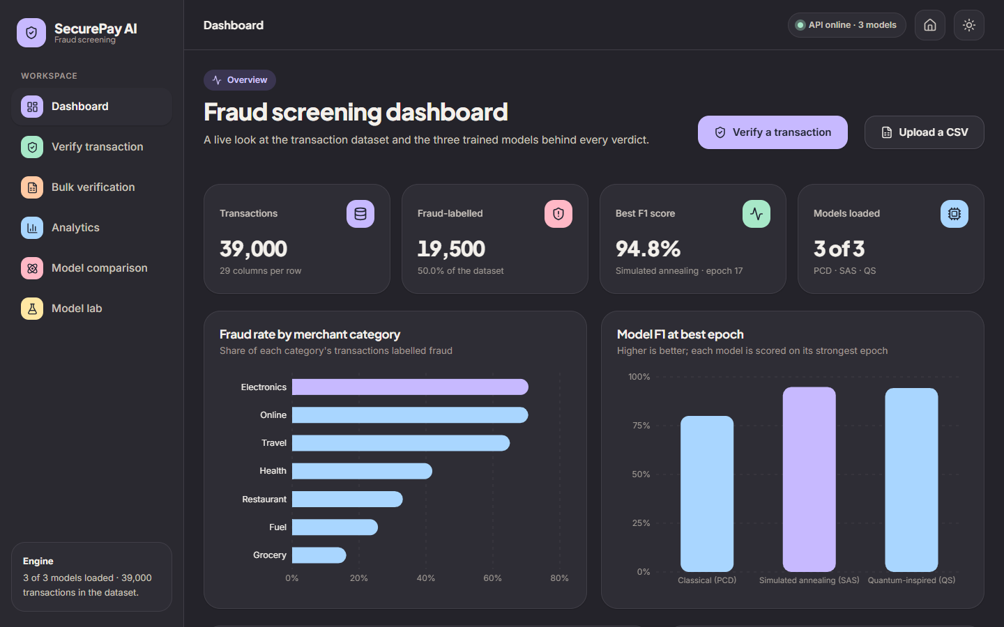  Figure 35: Dashboard, dark theme.

C.2 Analytics: time, amount and card signals
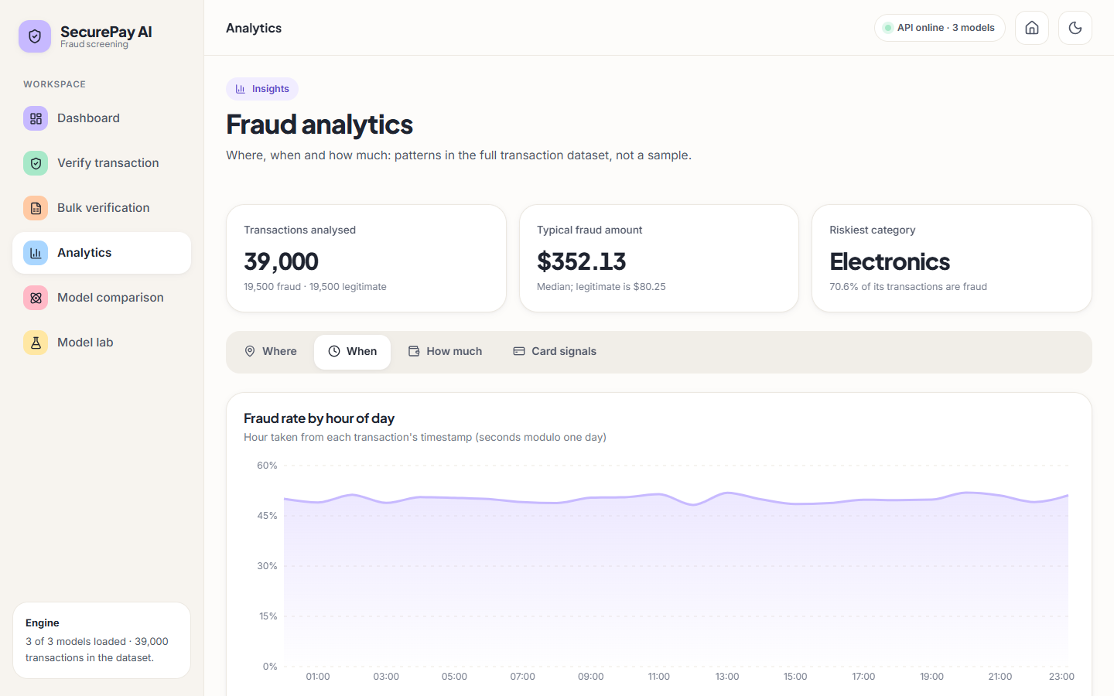  Figure 36: When: fraud rate by hour. | 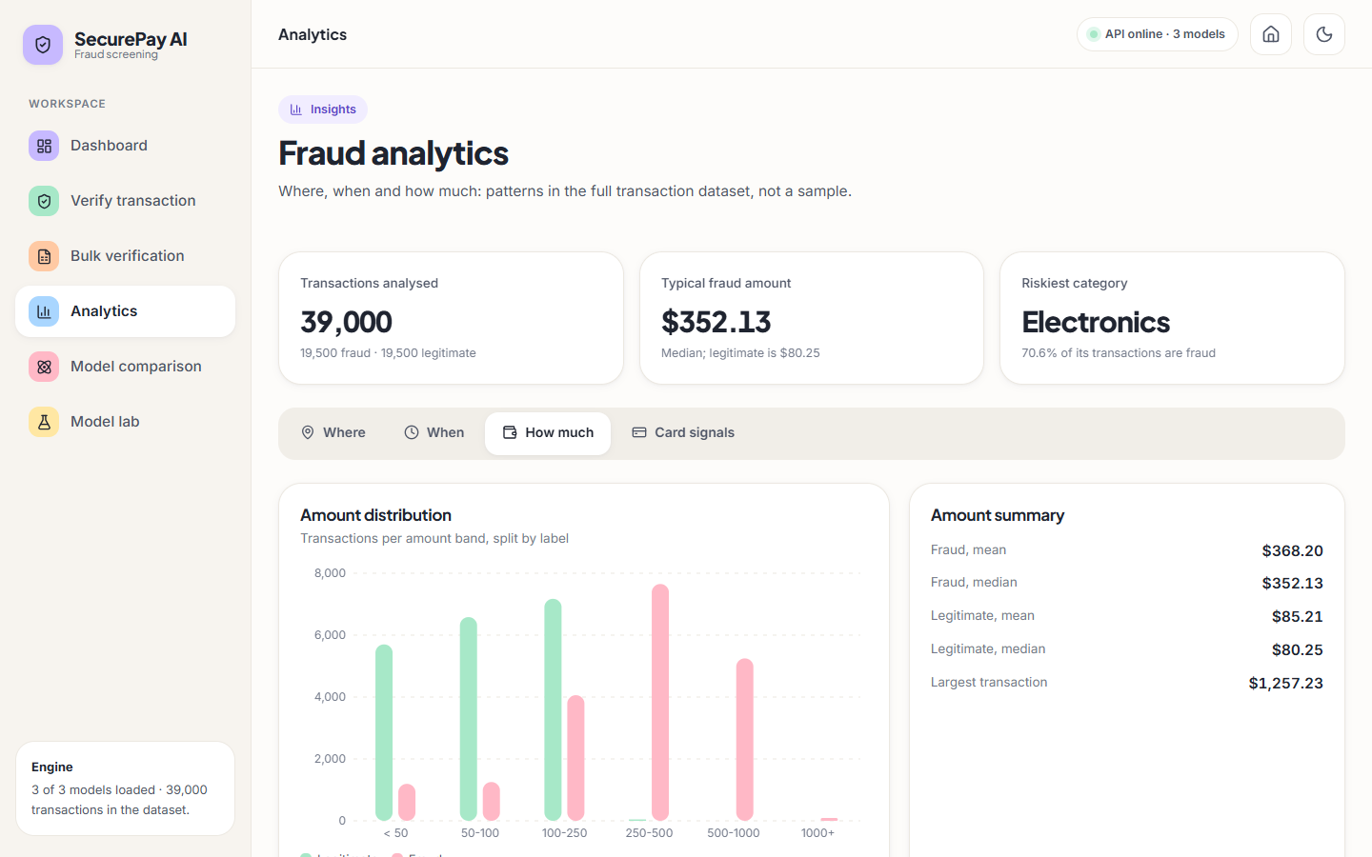  Figure 37: How much: amount bands. | 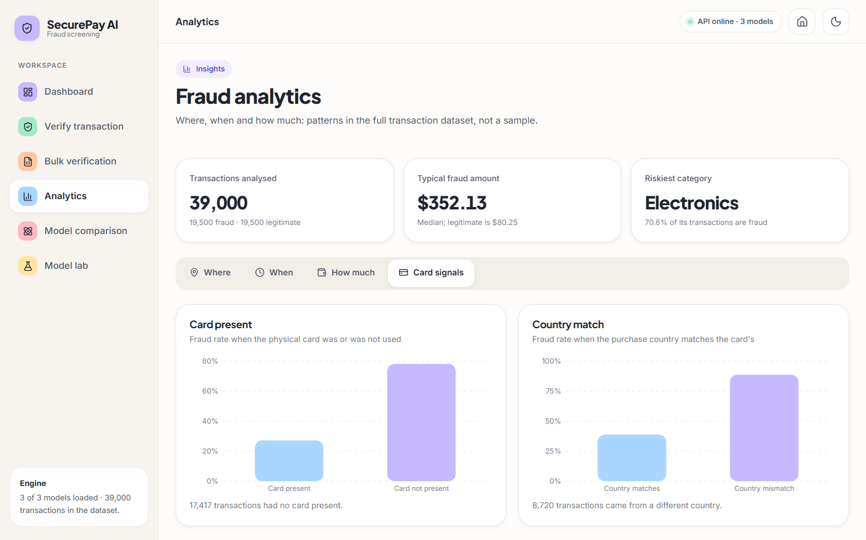  Figure 38: Card signals.

C.3 Feature importance and dark verify screen
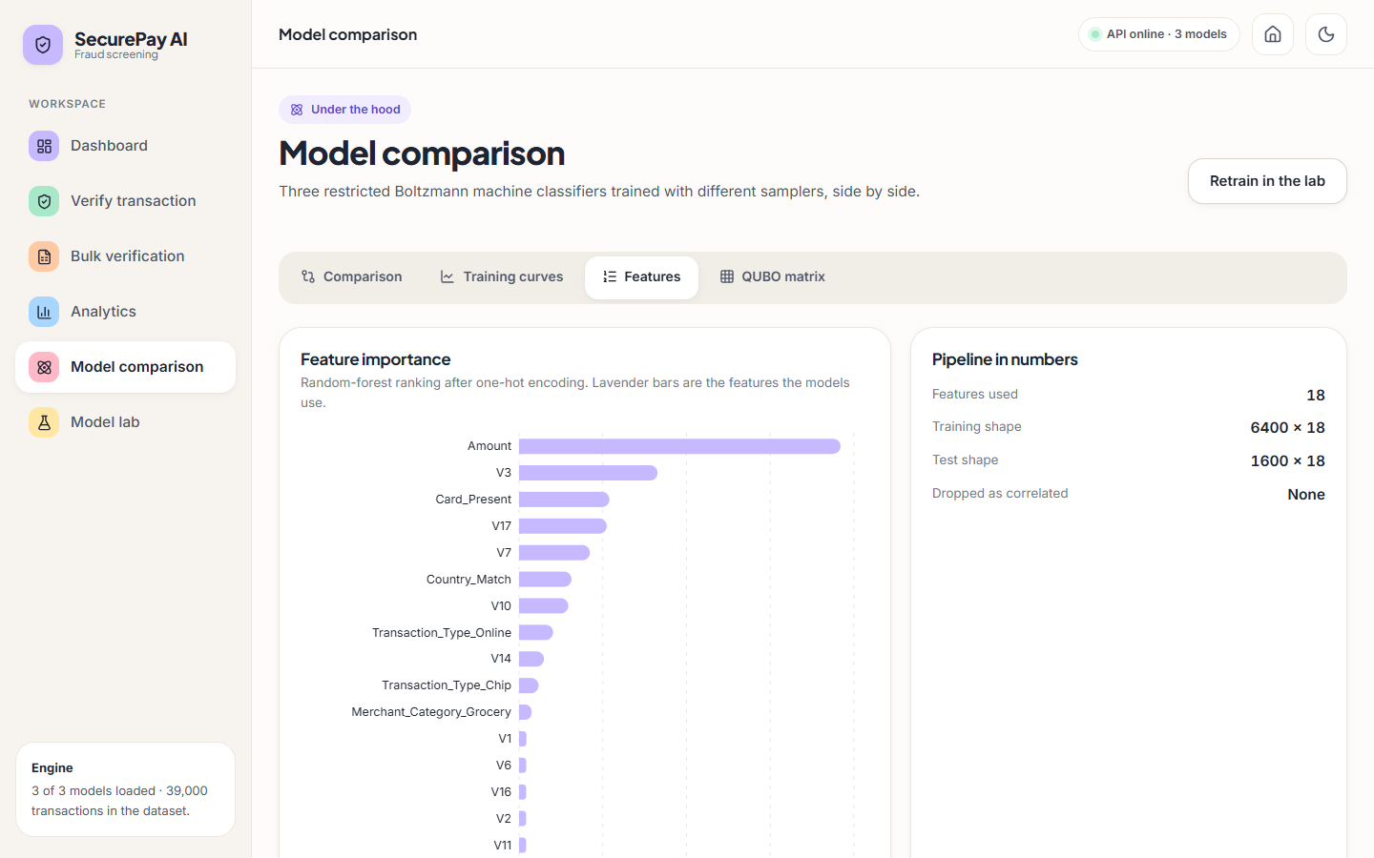  Figure 39: Features: importance of the 18 selected inputs. | 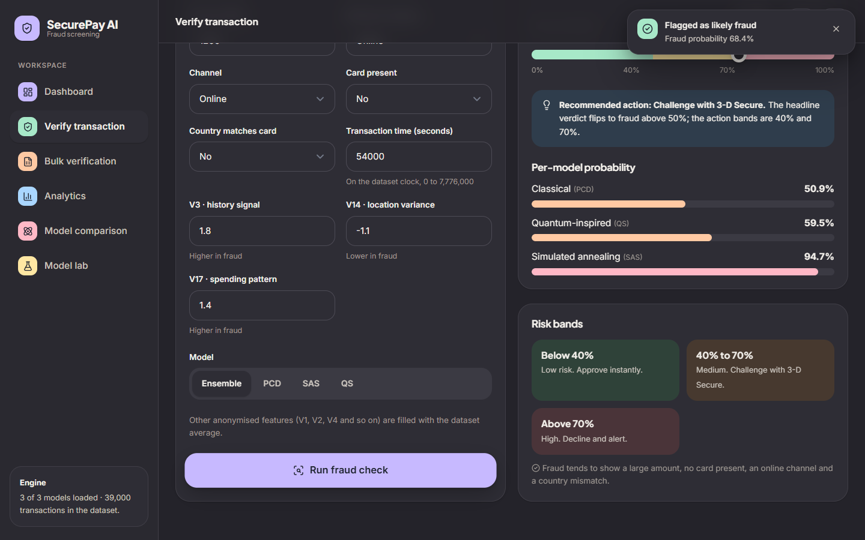  Figure 40: Verify, dark theme: 68.4 % (medium).

C.4 Model lab after a real retraining run
The three models were retrained through the lab with its default settings (10 epochs) and the original model files were restored afterwards. The classical model ended predicting every row legitimate, the other two reached F1 of about 92 % and 87 %: the instability measured in Chapter 8.
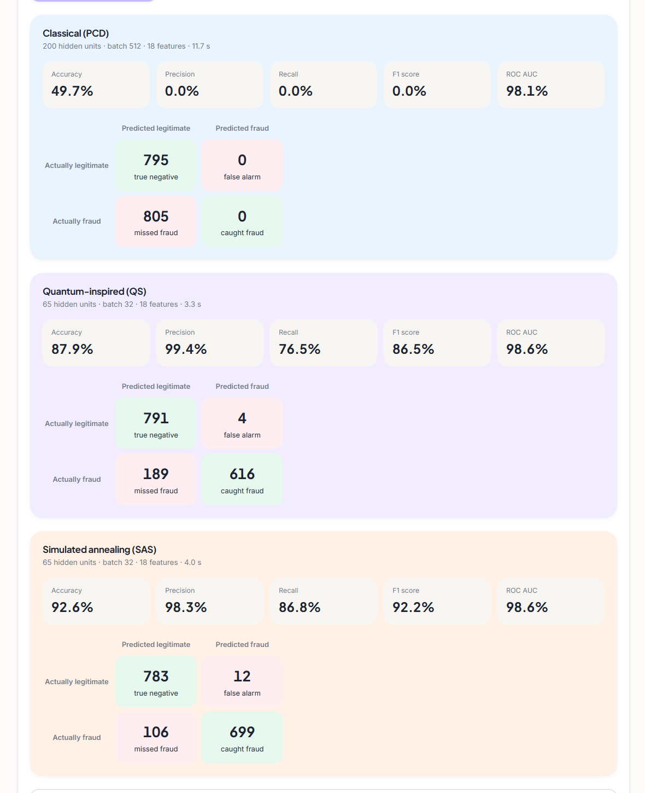
Figure 41: Model lab after retraining: metric tiles and confusion matrices; PCD predicts every row legitimate.

C.5 Error states and mobile layout
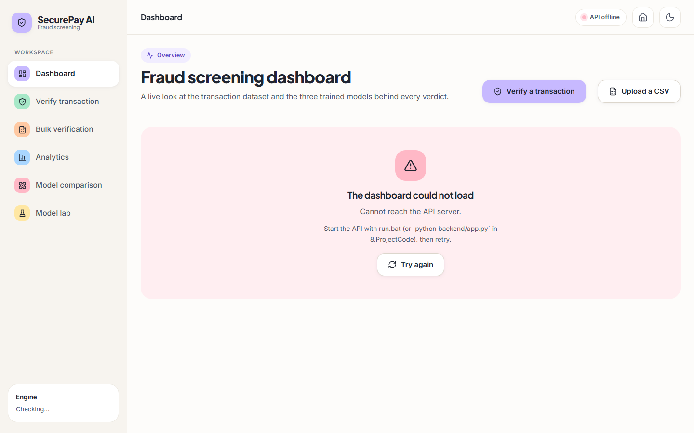  Figure 42: Dashboard with the API stopped. |   Figure 43: Bulk upload of an empty file.

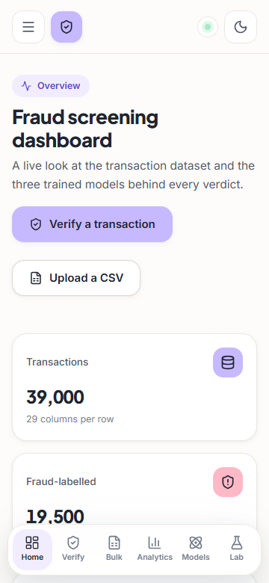  Figure 44: Mobile dashboard. | 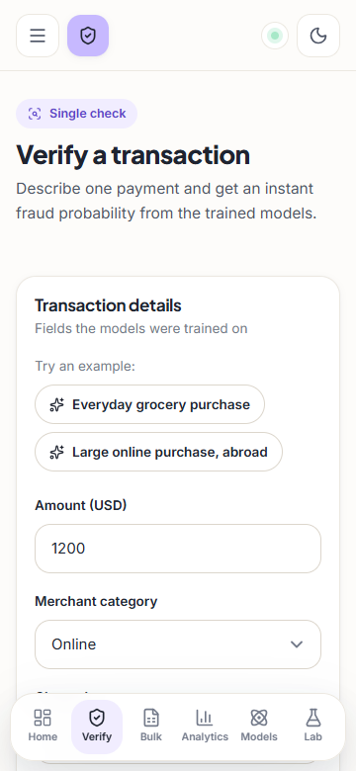  Figure 45: Mobile verify. | 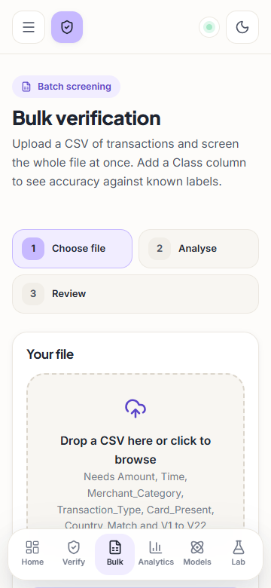  Figure 46: Mobile bulk.

